CMPE273: Enterprise Distributed Systems

Lab 1 Assignment: Using REST (Node.js) and Angular JS

Server 1 - “Calculator” to demonstrate Stateless web services

Introduction:

A calculator application that performs arithmetic operations such as addition, subtraction, multiplication and division of numbers is developed using REST(Node.js) and Angular JS.

Goal:

The application must perform all the basic operations of a calculator and must provide a way to handle exceptions that arise while performing these operations.

Purpose:

The server performs basic calculator operations on numbers without any errors and handles exceptions that arise.

System Design:

The calculator consists of necessary modules to :

* Perform tasks such as

1. Addition

2. Subtraction

3. Multiplication

4. Division

* Take care of exceptions such as

1. Division by zero :

When a number is divided by zero then the an error message is displayed as “Zero divided by zero is undefined”.

2. Handling NaN

When a element which is not a number is given as input instead of a number then an error message is displayed as “Invalid Input”.

3.Division by zero

When a non-zero number is divided by zero then “Division by zero is not defined” is displayed in the results.

Results:

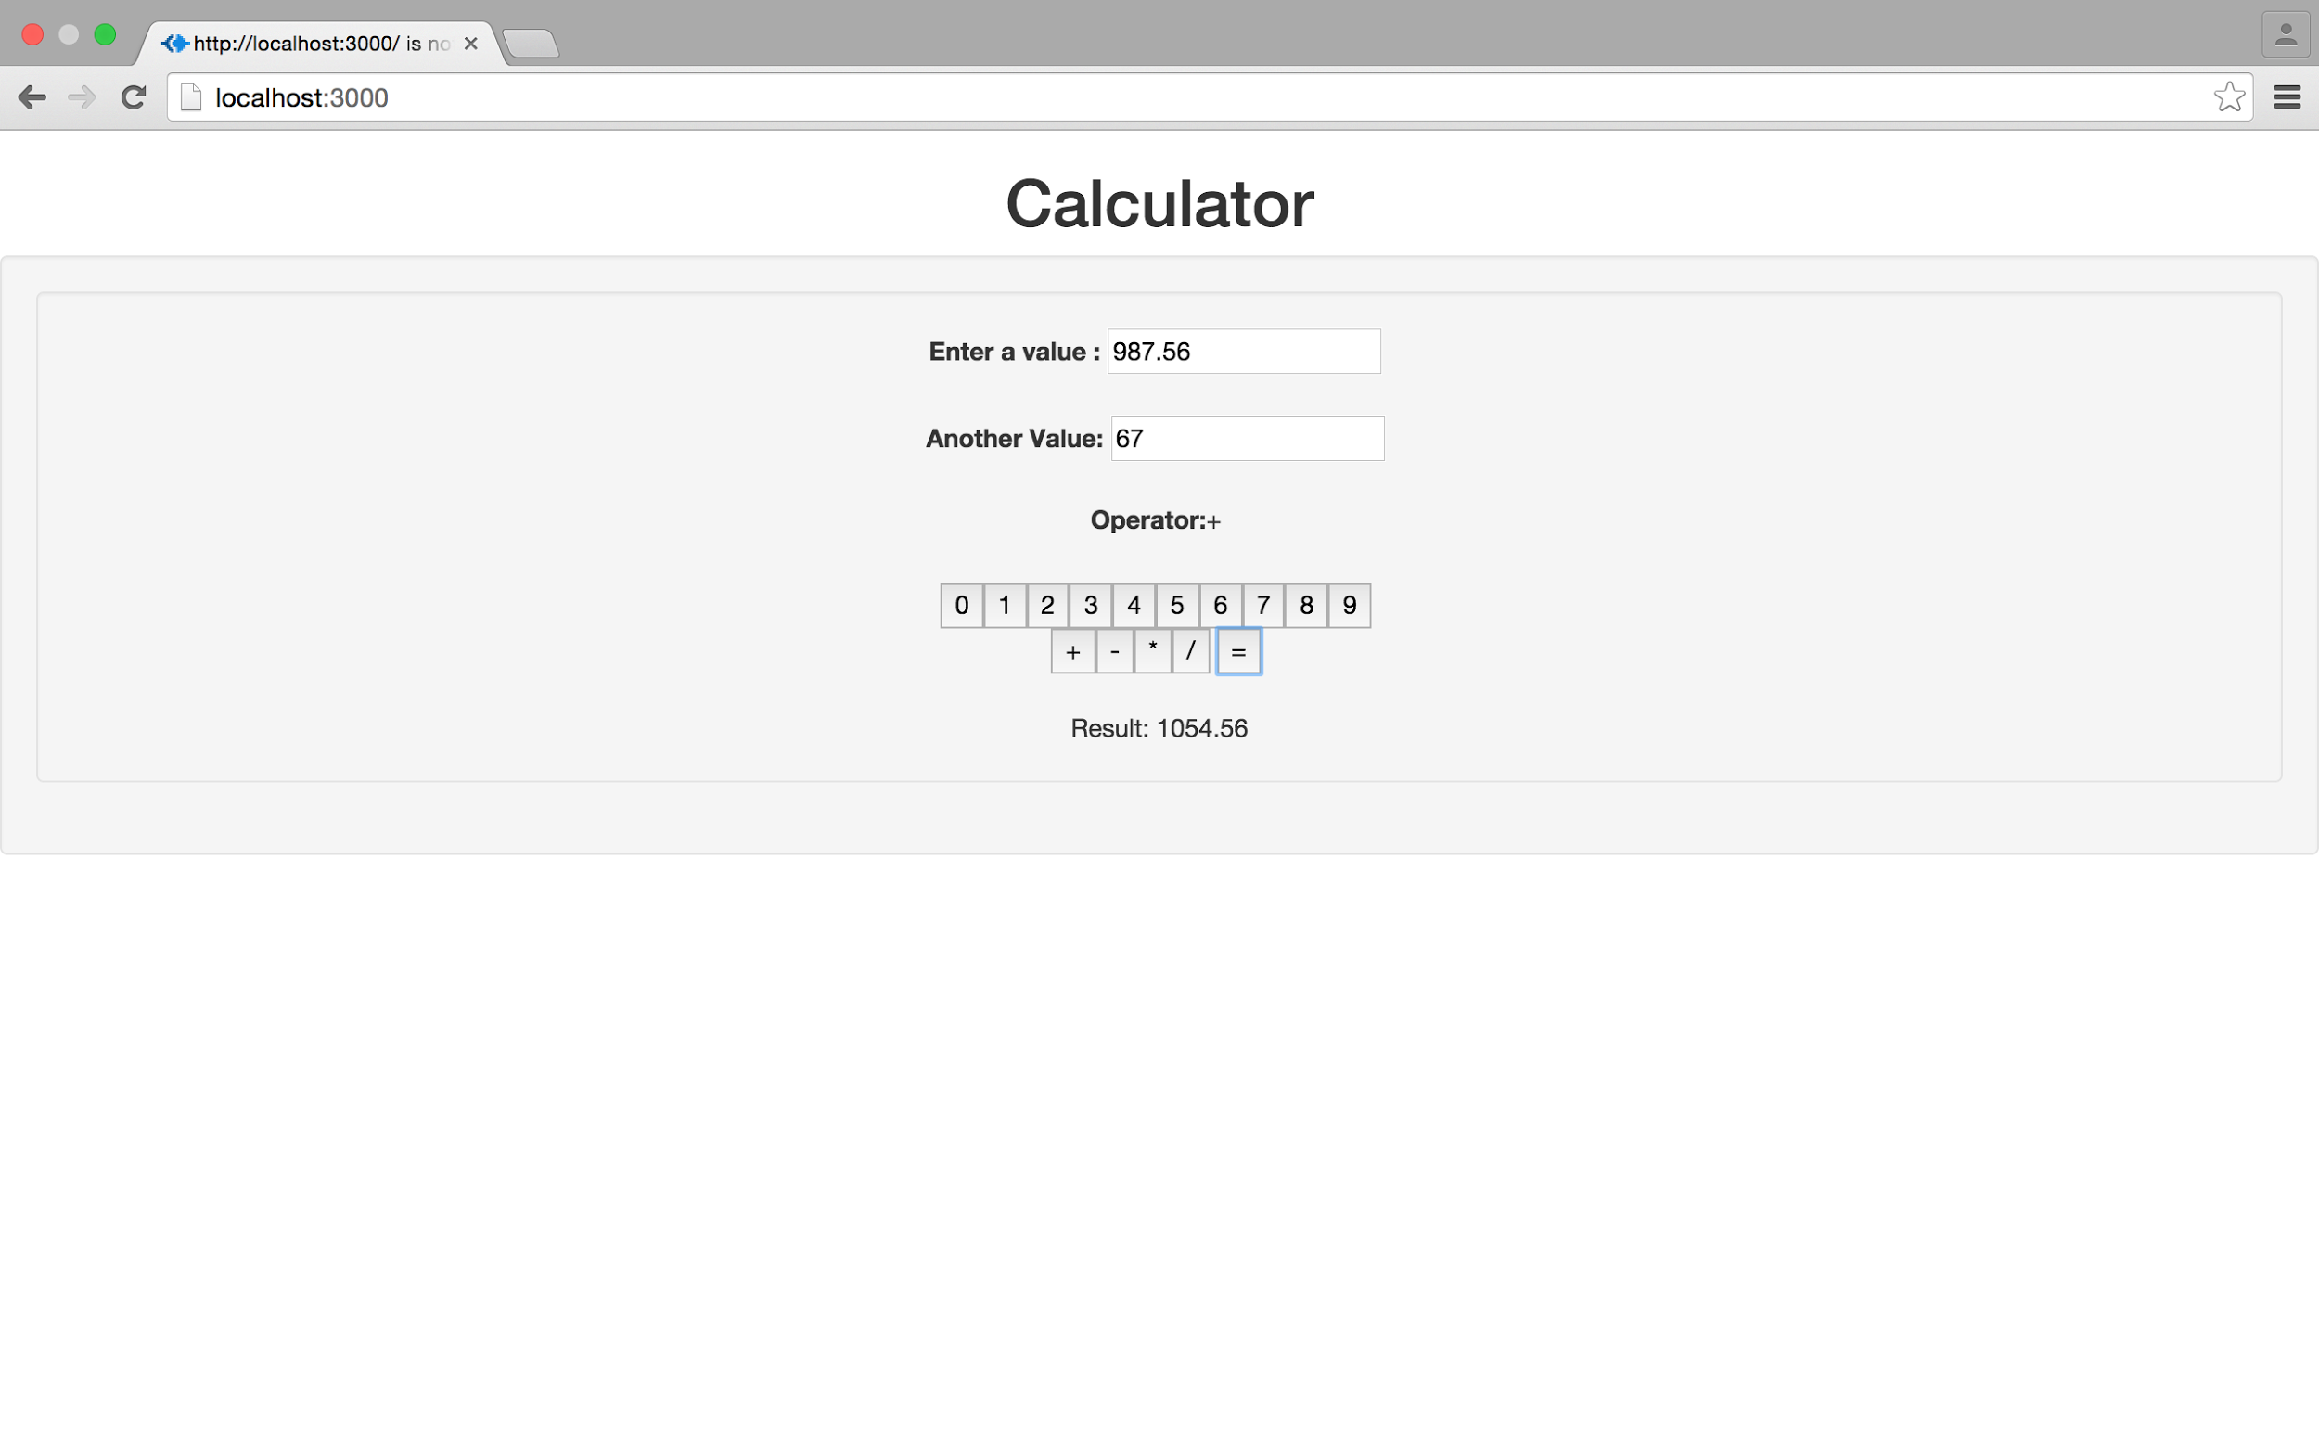

Screenshot: Addition of two numbers

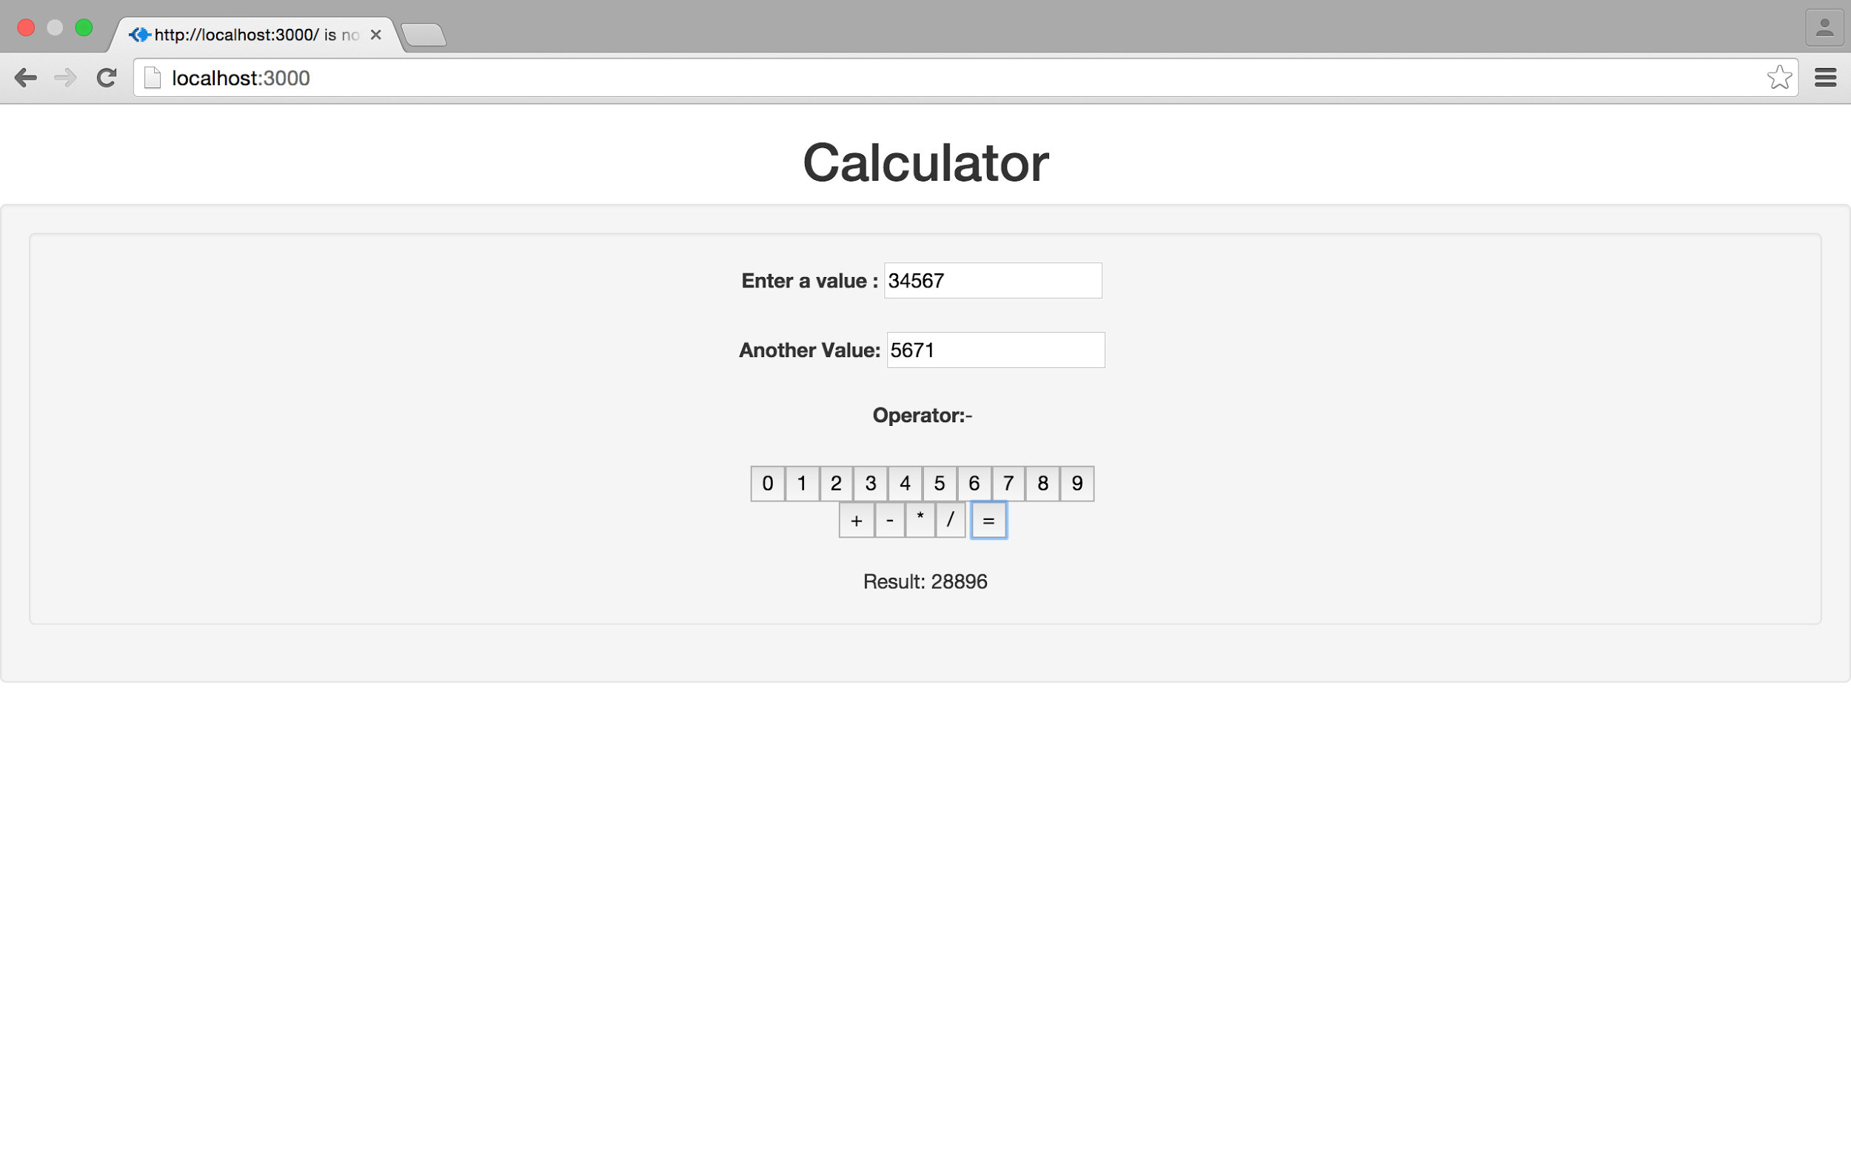

Screenshot: Subtraction of two numbers

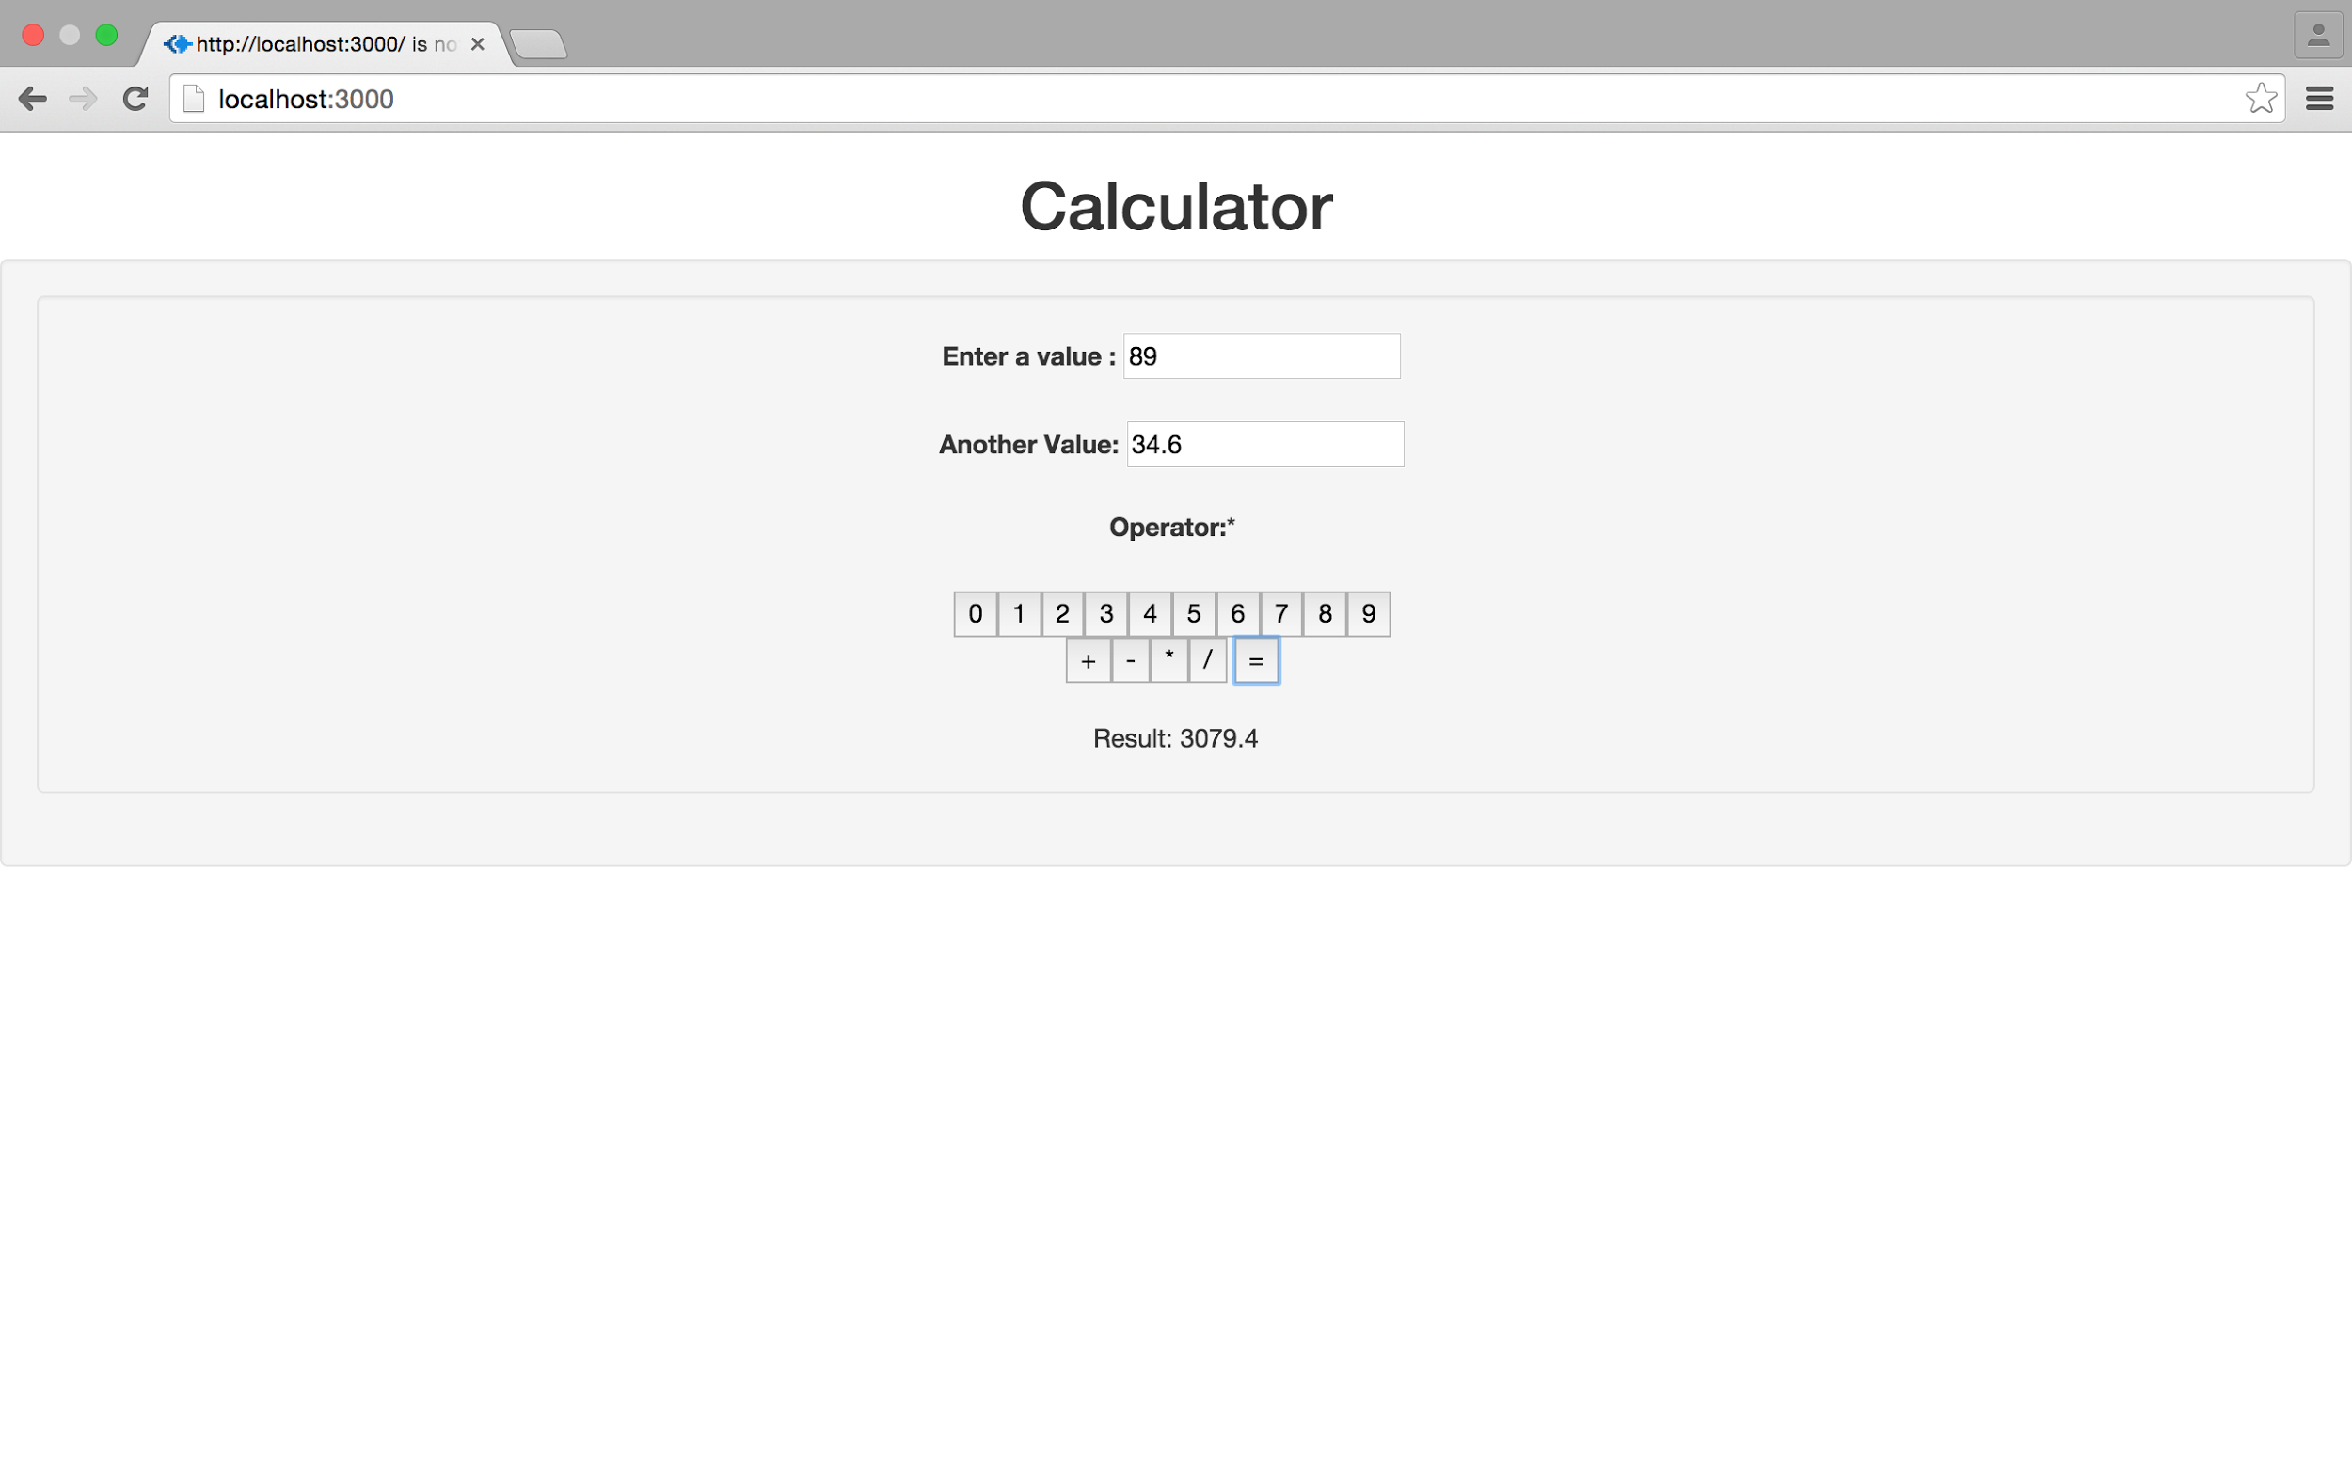

Screenshot: Multiplication of two numbers

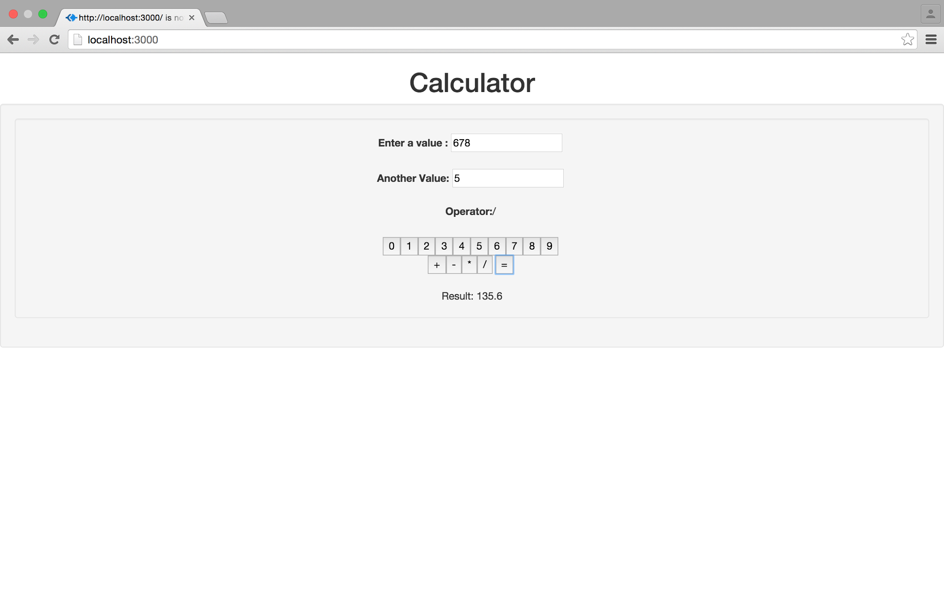

Screenshot: Division of two numbers

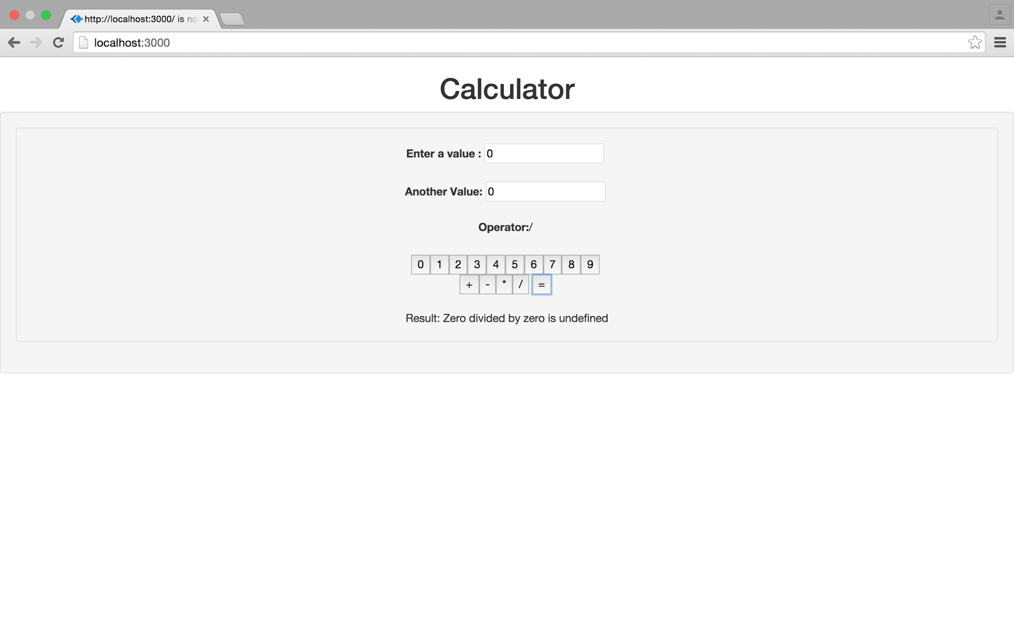

Screenshot:Zero divided by zero

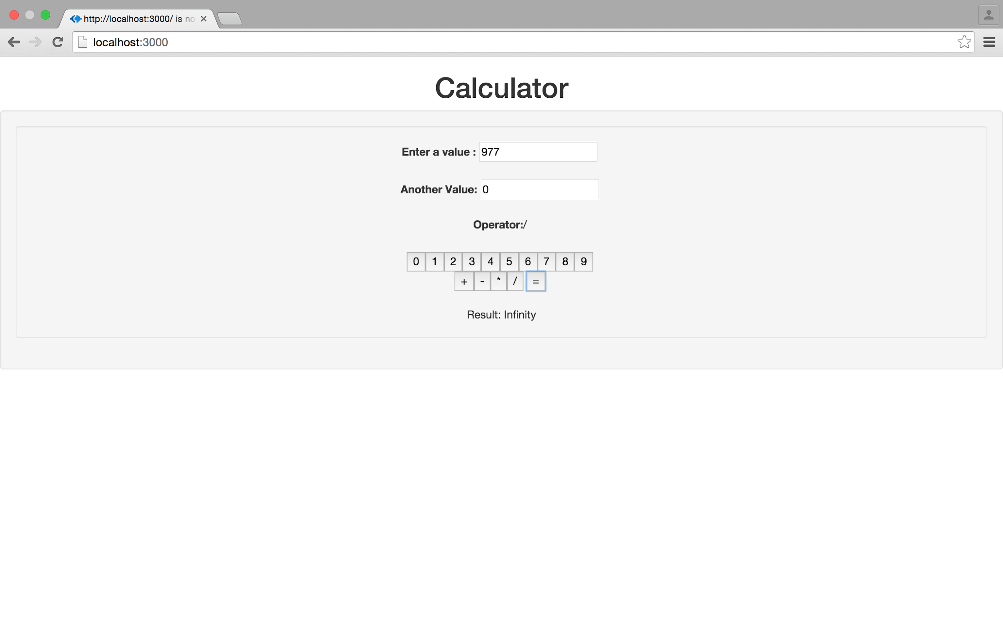

Screenshot: Number divided by zero

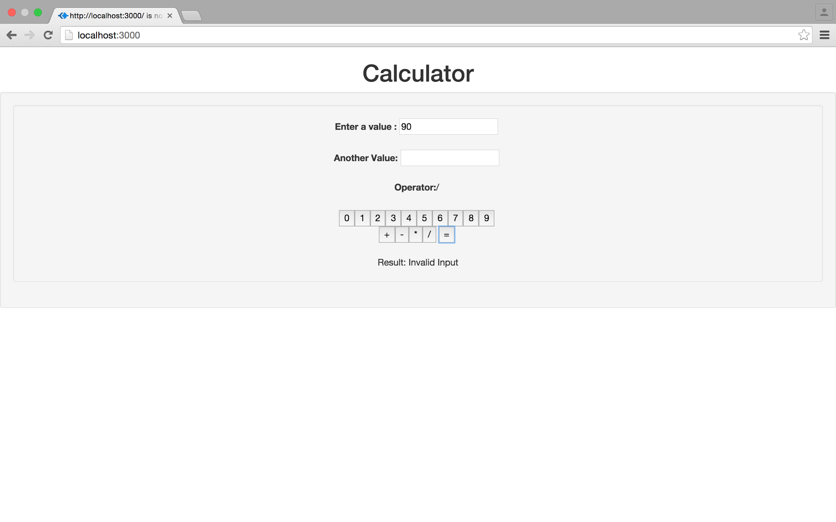

Screenshot: Invalid input to handle NaN

Performance Analysis:

1.Addition

Graph Results:

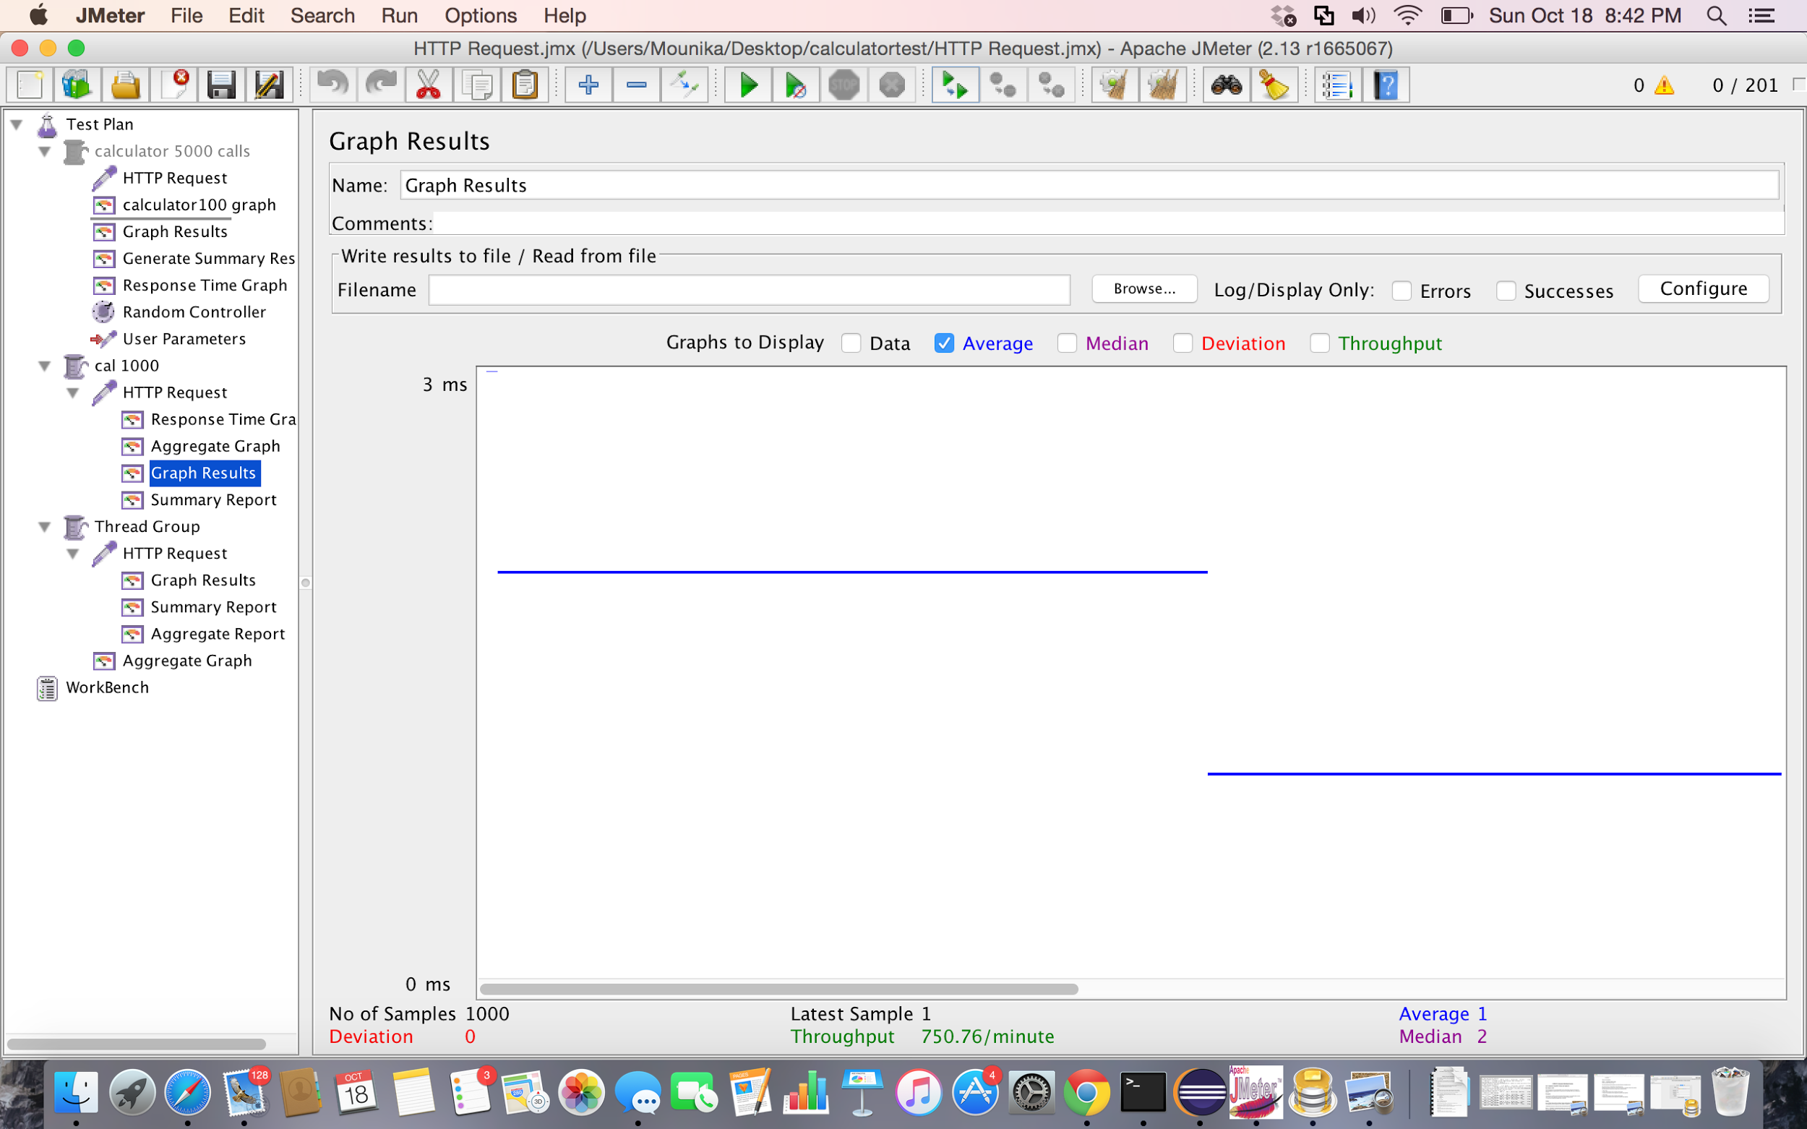

Screenshot: Graph Results for 1000 random calls using Apache JMeter

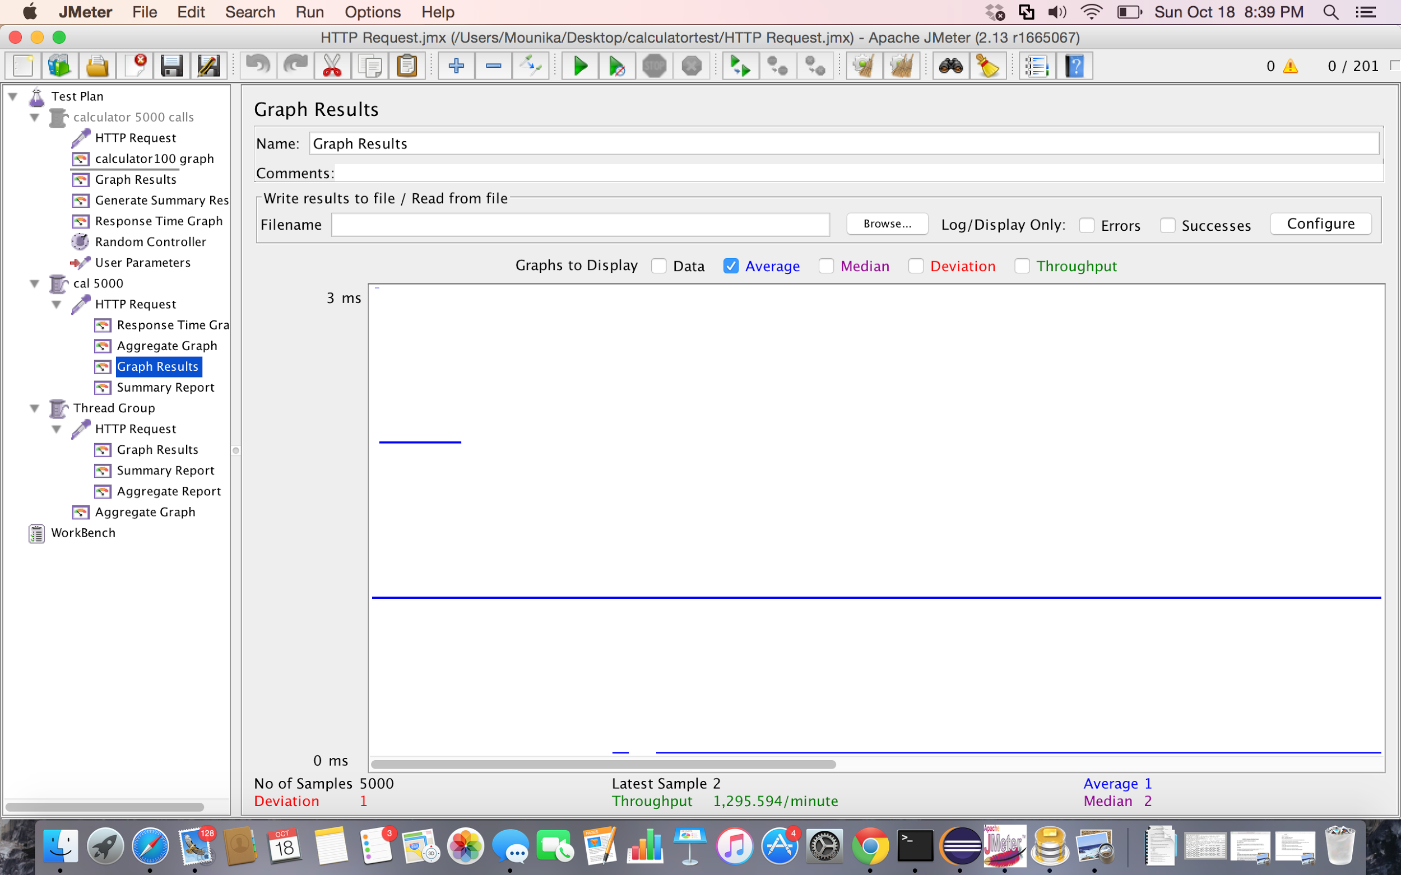

Screenshot: Graph Results for 5000 random calls using Apache JMeter

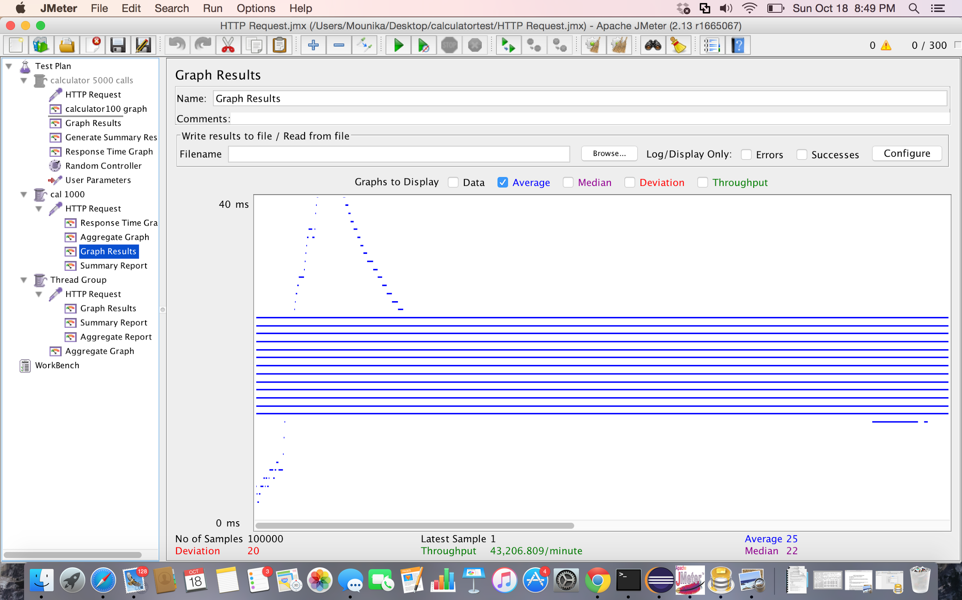

Screenshot: Graph Results for 1000 random calls with 100 concurrent users using Apache JMeter

2.Subtraction

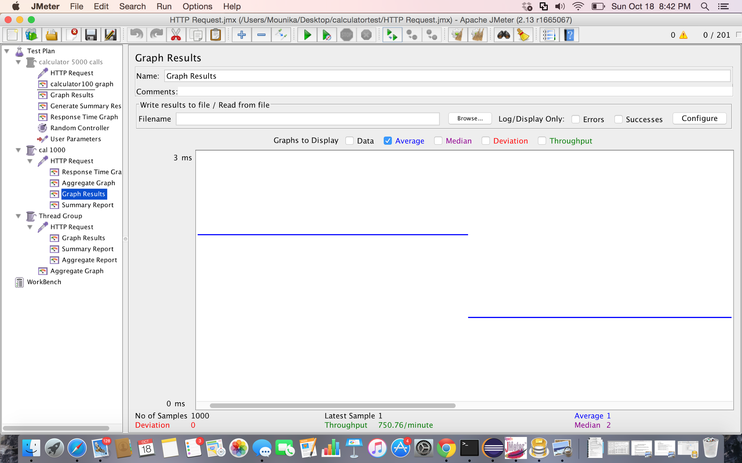

Screenshot: Graph Results for 1000 random calls using Apache JMeter

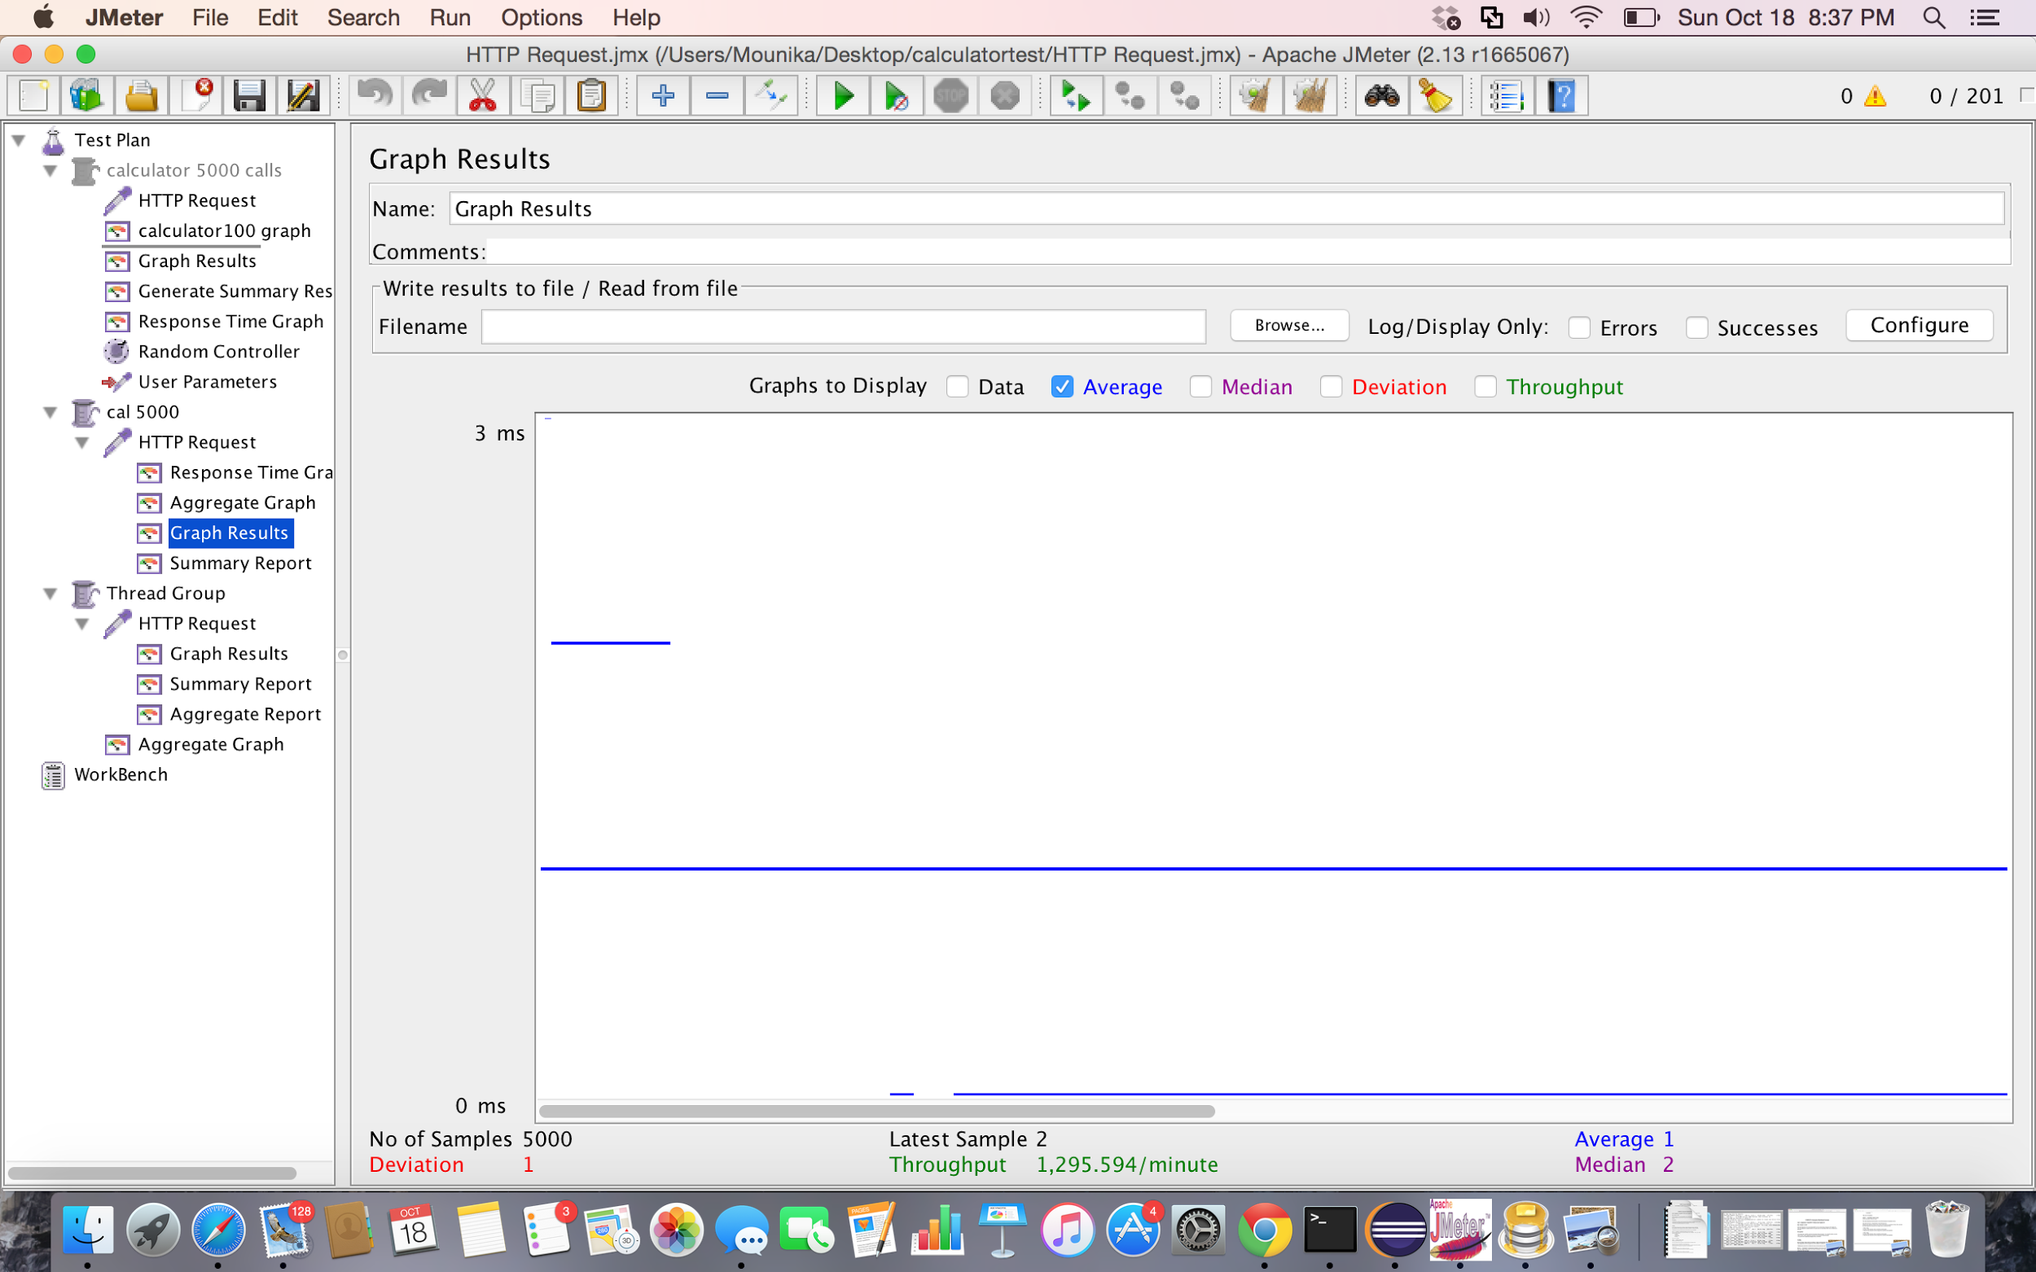

Screenshot: Graph Results for 5000 random calls using Apache JMeter

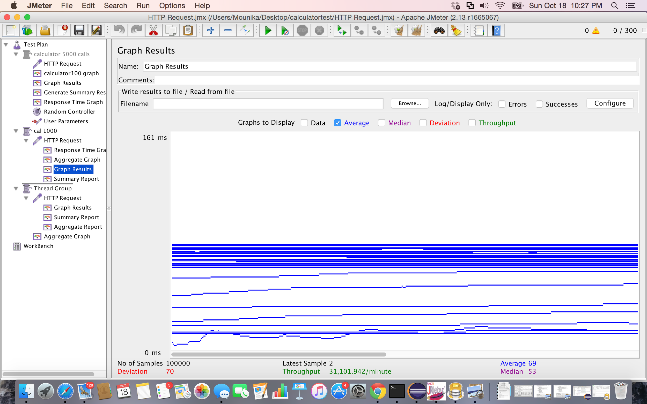

Screenshot: Graph Results for 1000 random calls with 100 concurrent users using Apache JMeter

3.Multiplication

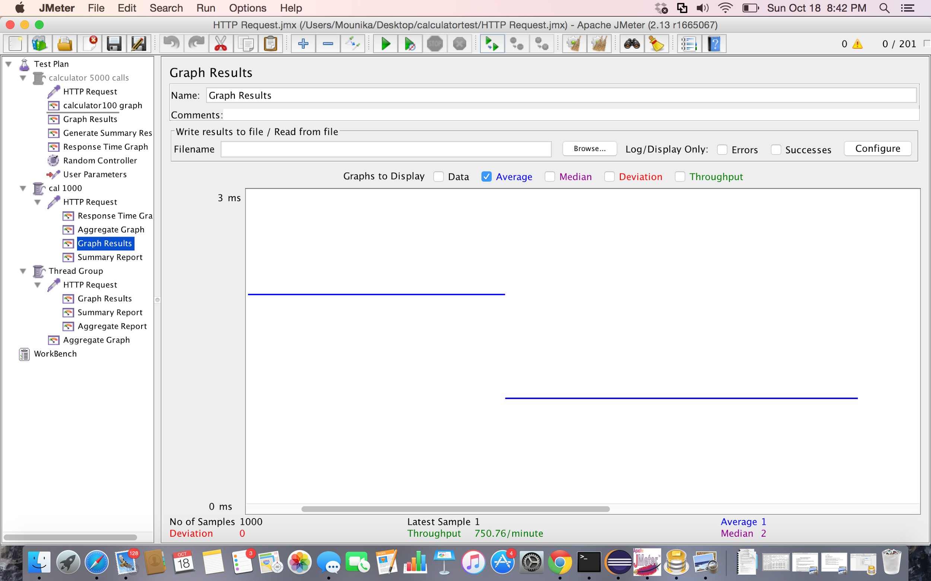

Screenshot: Graph Results for 1000 random calls using Apache JMeter

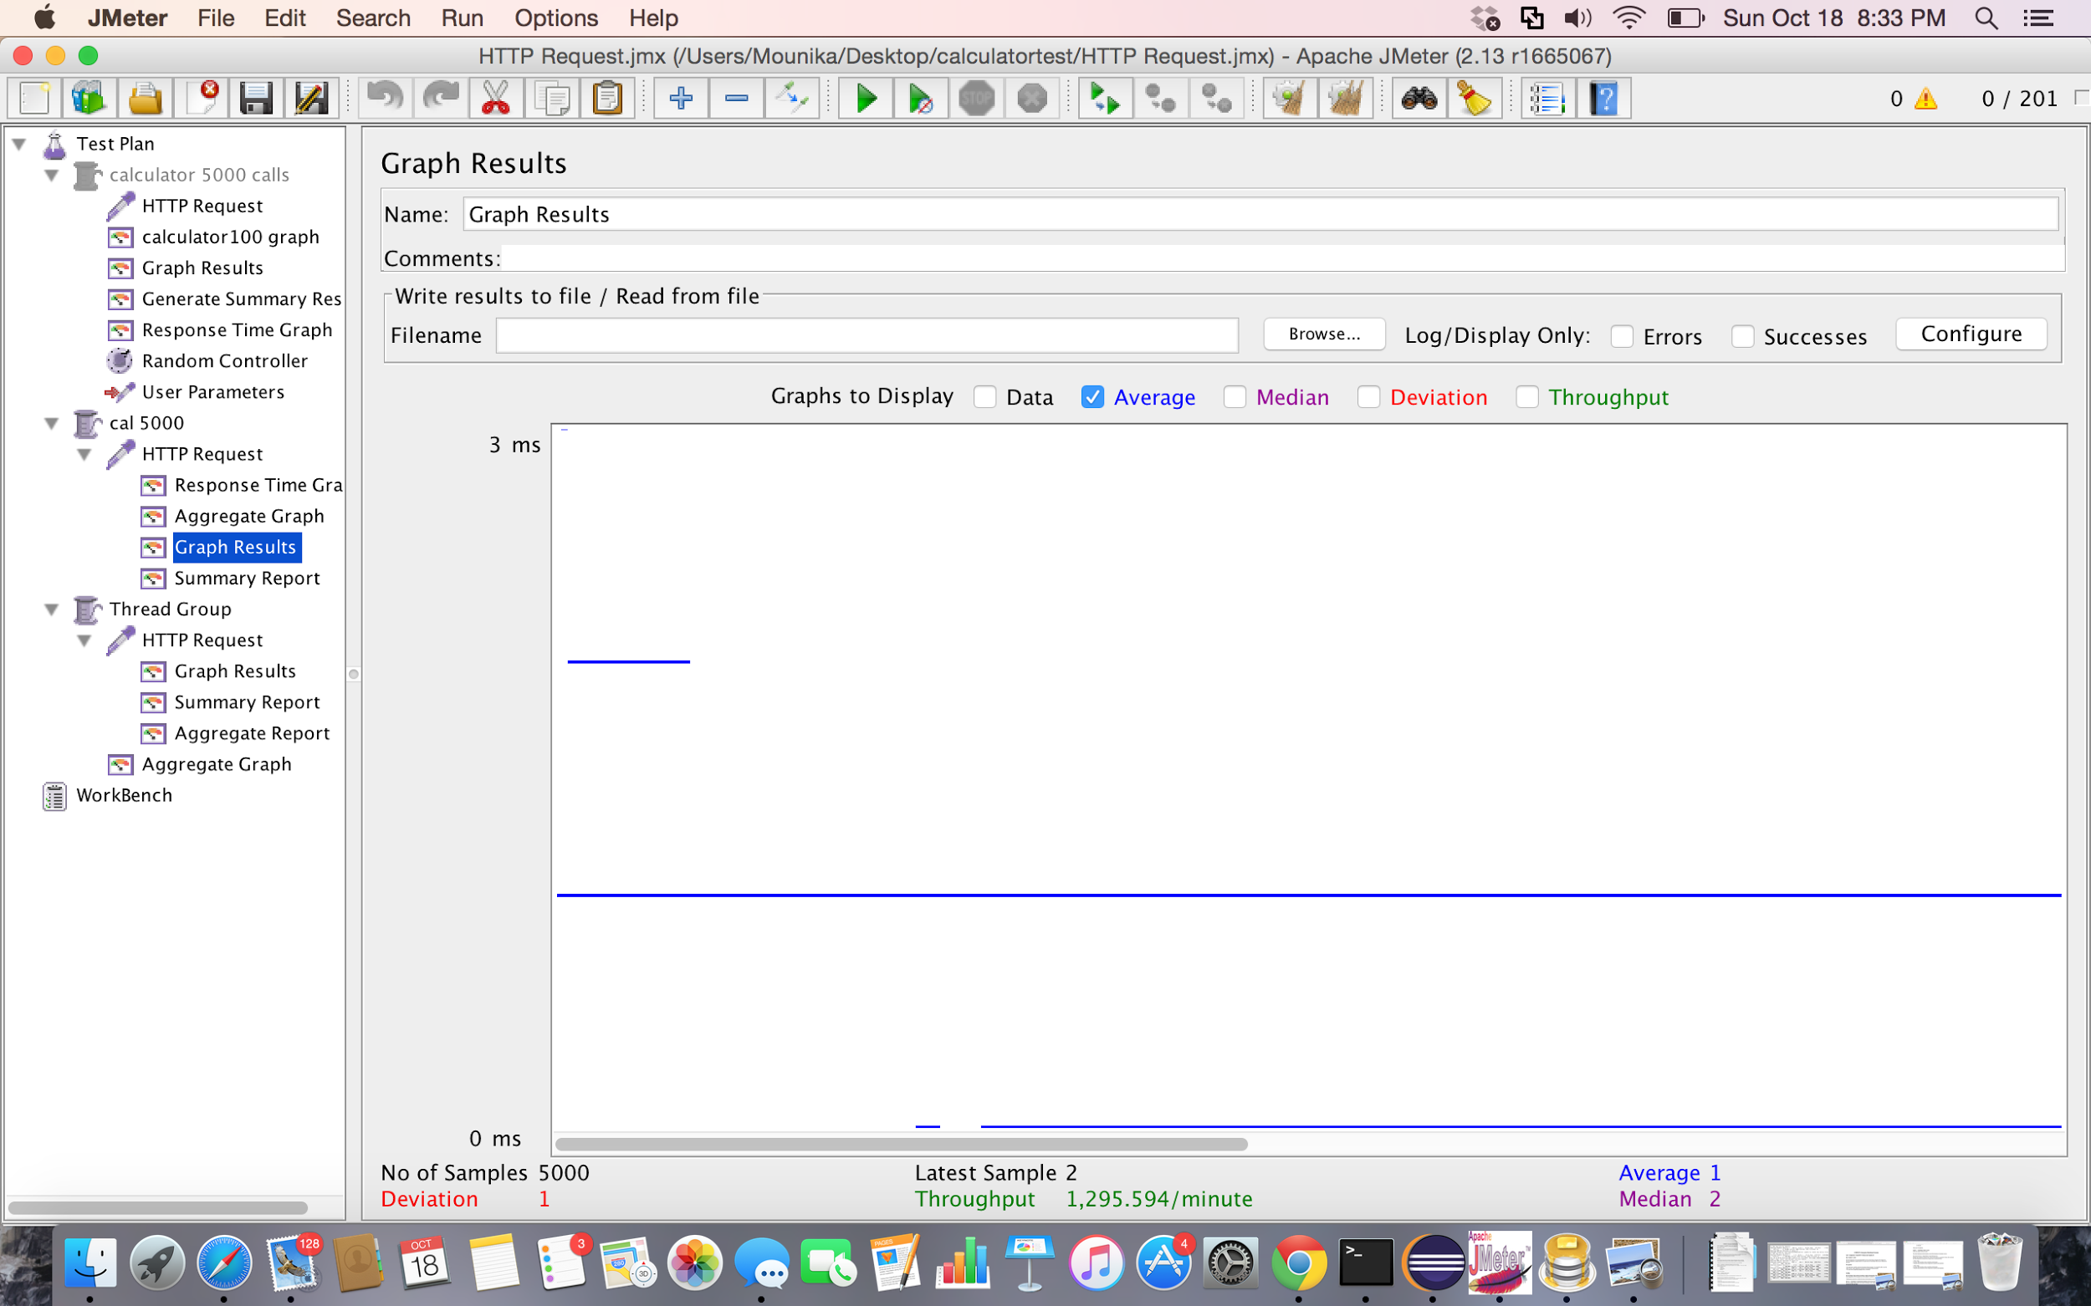

Screenshot: Graph Results for 5000 random calls using Apache JMeter

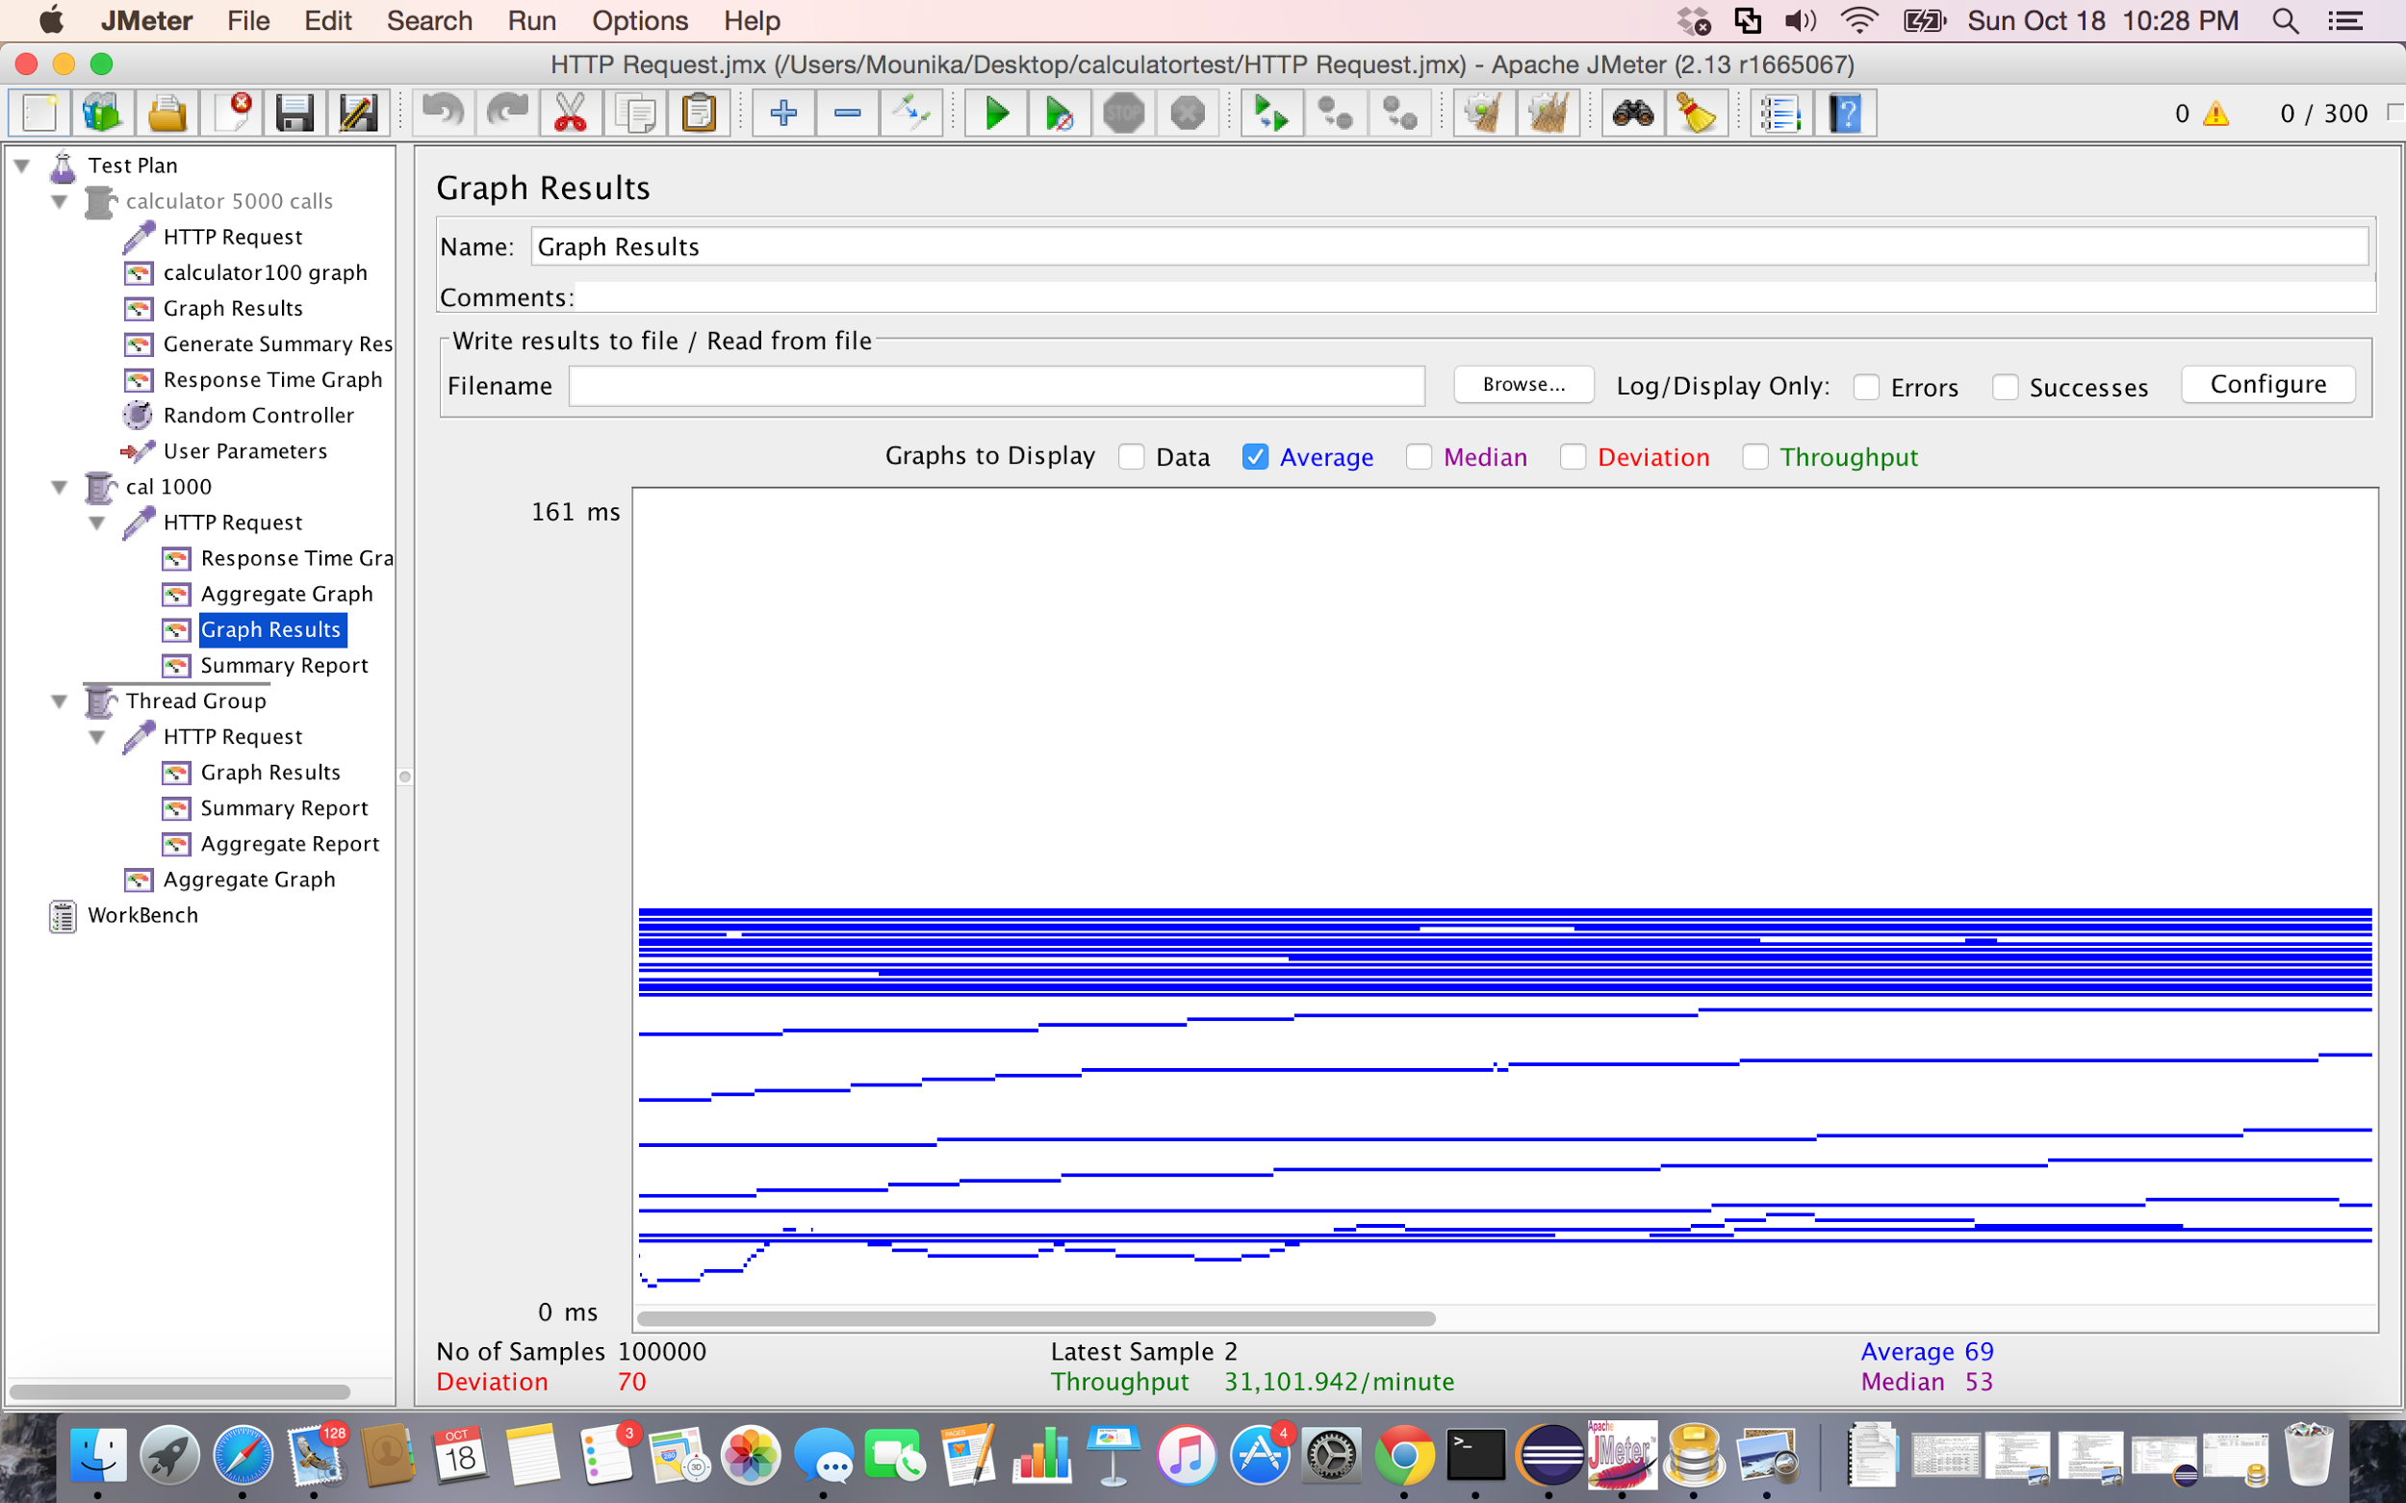

Screenshot: Graph Results for 1000 random calls with 100 concurrent users using Apache JMeter

4.Division

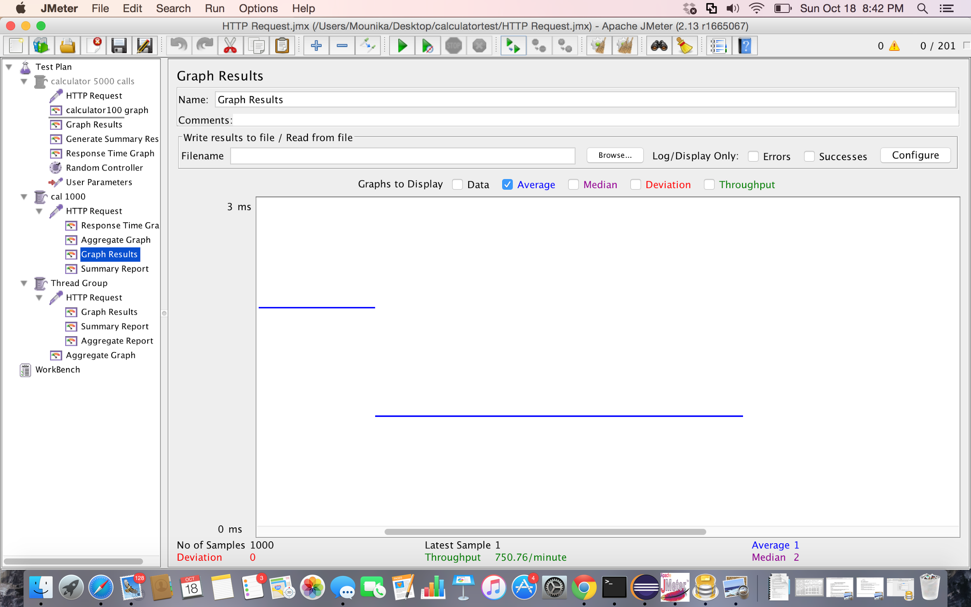

Screenshot: Graph Results for 1000 random calls using Apache JMeter

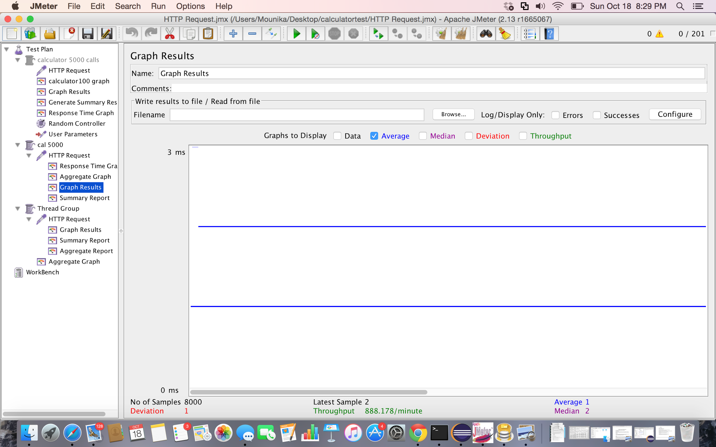

Screenshot: Graph Results for 5000 random calls using Apache JMeter

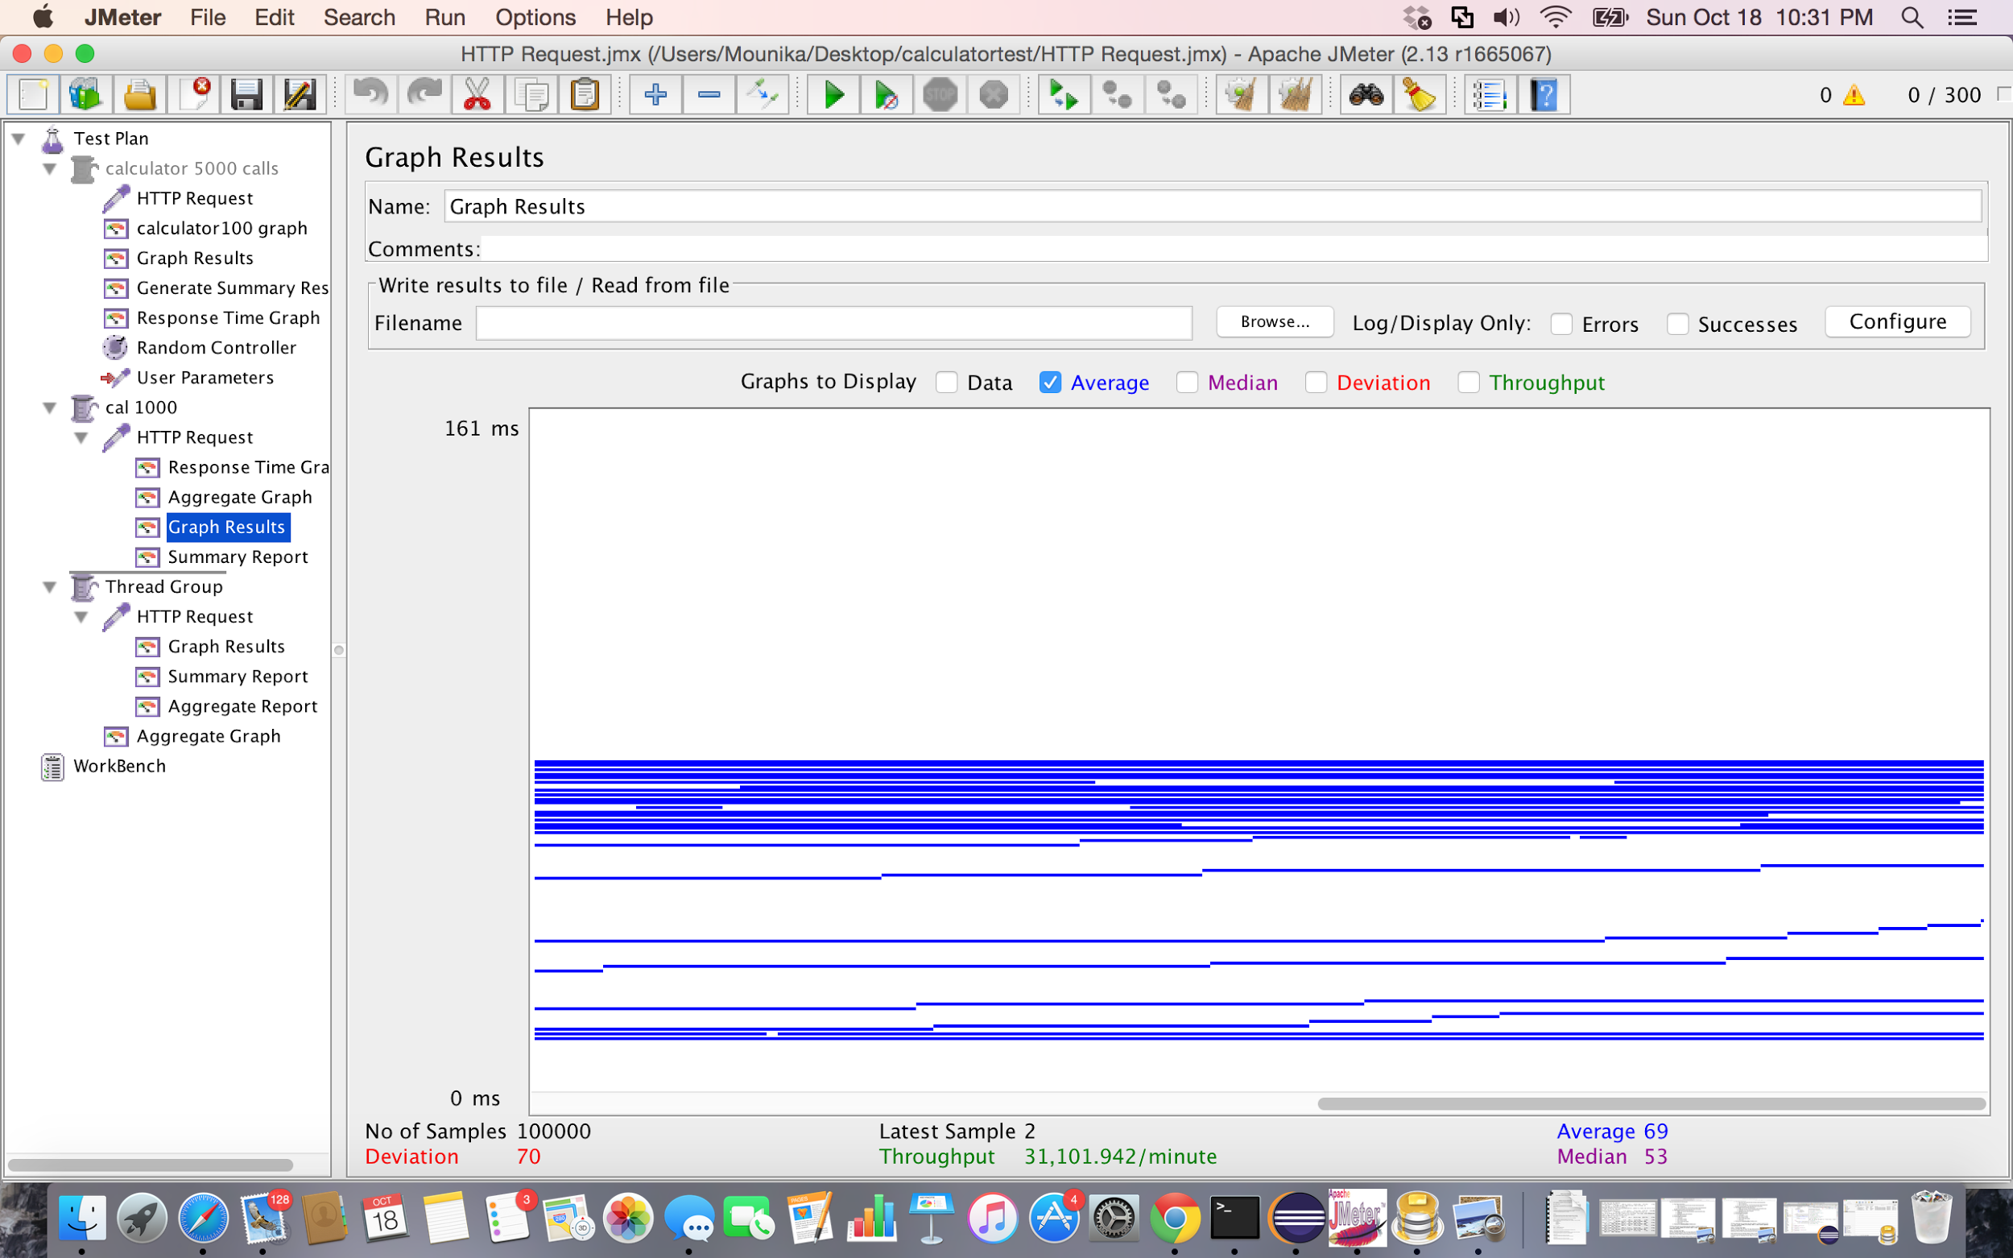

Screenshot: Graph Results for 1000 random calls with 100 concurrent users using Apache JMeter

Performance comparison graph:

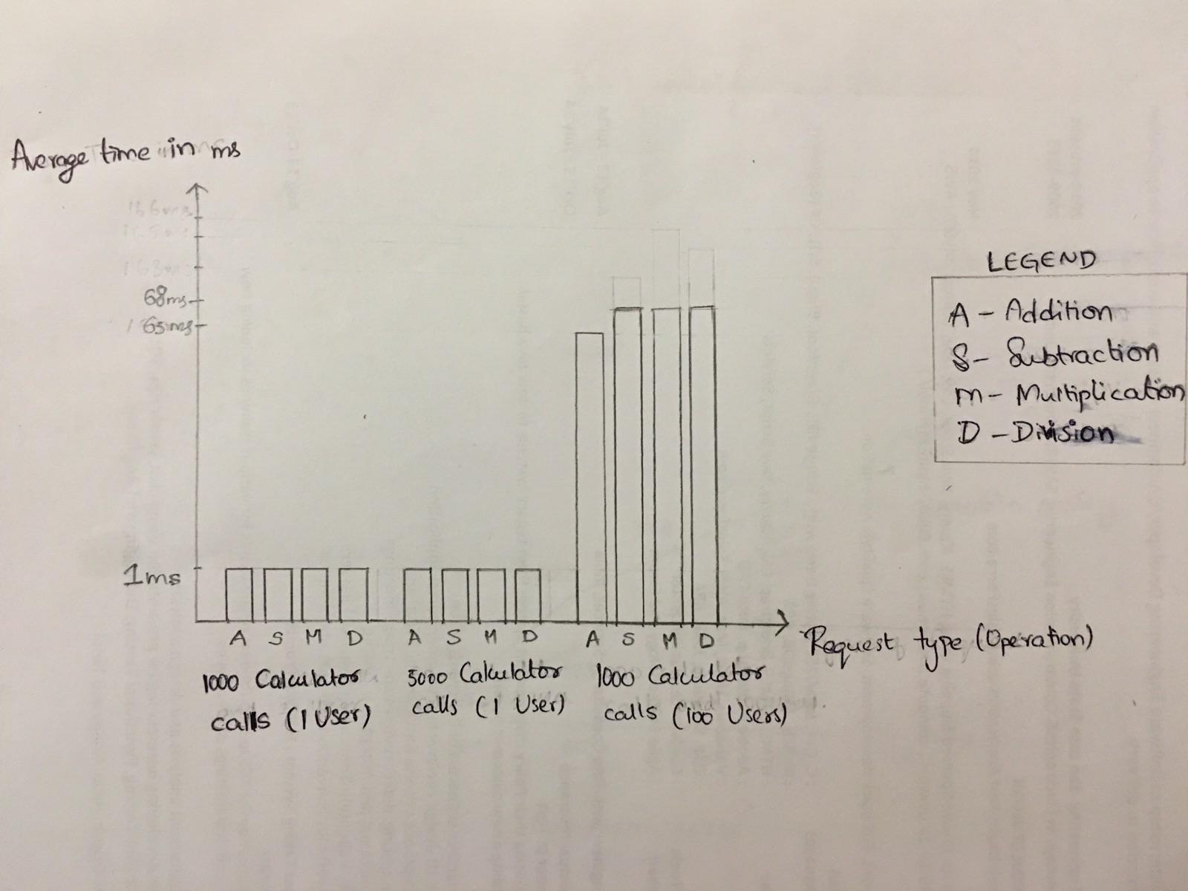

Screenshot: Performance comparison graph

Analysis from results:

From above results we can say that the number of random calls doesn’t influence the average time for each call. But increase in number of users will change the average time and also the performance. Hence our server is best suited to handle less number of concurrent users to deliver high performance.

Server 2 - “Facebook application” to demonstrate RESTful Services

Introduction:

This is a prototype of facebook application which is a social networking site that enables users to make friends and share posts etc after signing up.

Goal:

The goal is to make an application that resembles facebook using REST(Node.js) and Angular JS with required functionalities.

Purpose:

The server should perform following tasks :

* Basic user functionalities:

1. Sign up new user (with first name, last name,birthday, Email and password).
2. Sign in existing user.
3. Sign out.

* Users account should provide basic details such as:

1. About: User overview, Work and education, contact info and life events.
2. Friends list: Send friend request, accept friend request.
3. Interests like music, shows and sports.

* Provide news feed functionality.
* Provide Groups functionalities:

1. Create group
2. Join group, add member in group
3. Show members in group
4. Exit group,delete members from group
5. Delete group

* Connection pooling for database access is provided.
* Salt and Hash algorithms are used for password encryption.
* Client Sessions are used for handling the user data for a session.

Results:

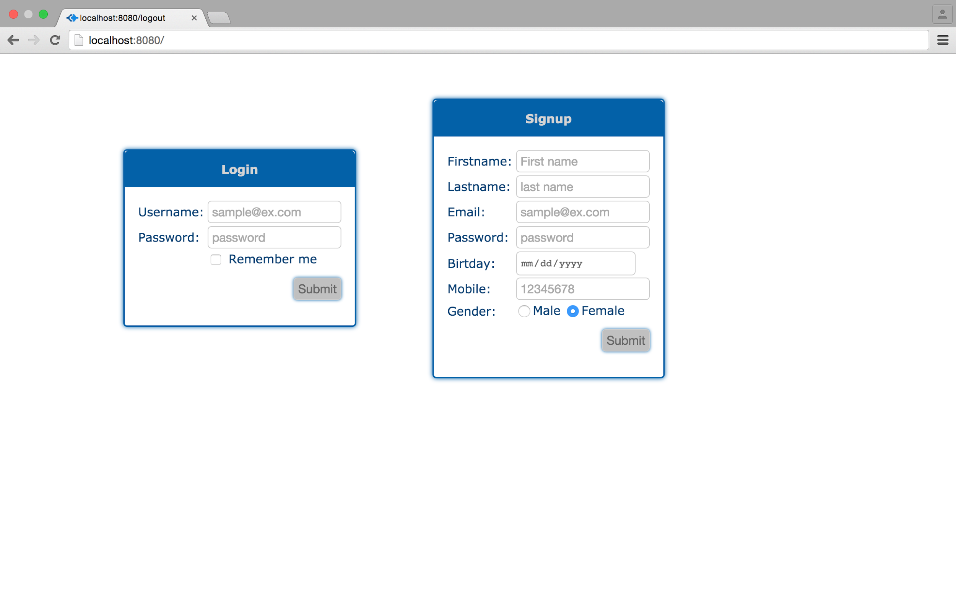

Screenshot: Login Screen

* Login screen is displayed after the application is opened.

* 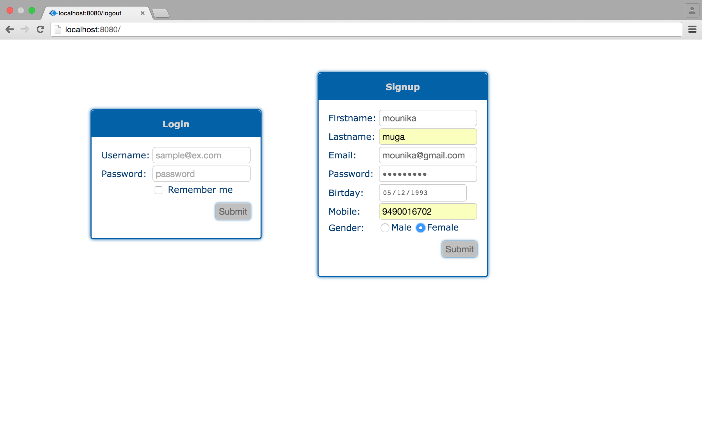

Screenshot: Signup by entering required details

* User needs to enter required details to sign up.
* If the details are entered in incorrect format , an error message is displayed.
* 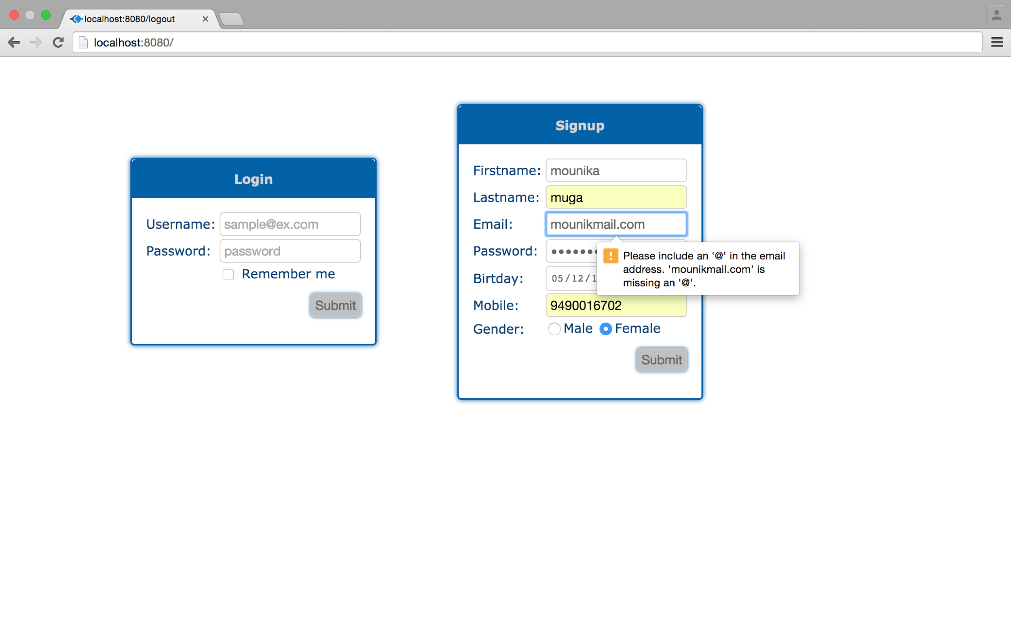

Screenshot:Error message displayed when credentials are entered in inappropriate format

* Once details are entered in appropriate format, user can signup by clicking on submit button.
* Password will be stored in the database after encryption.
* User will be redirected to login page after successful signup..

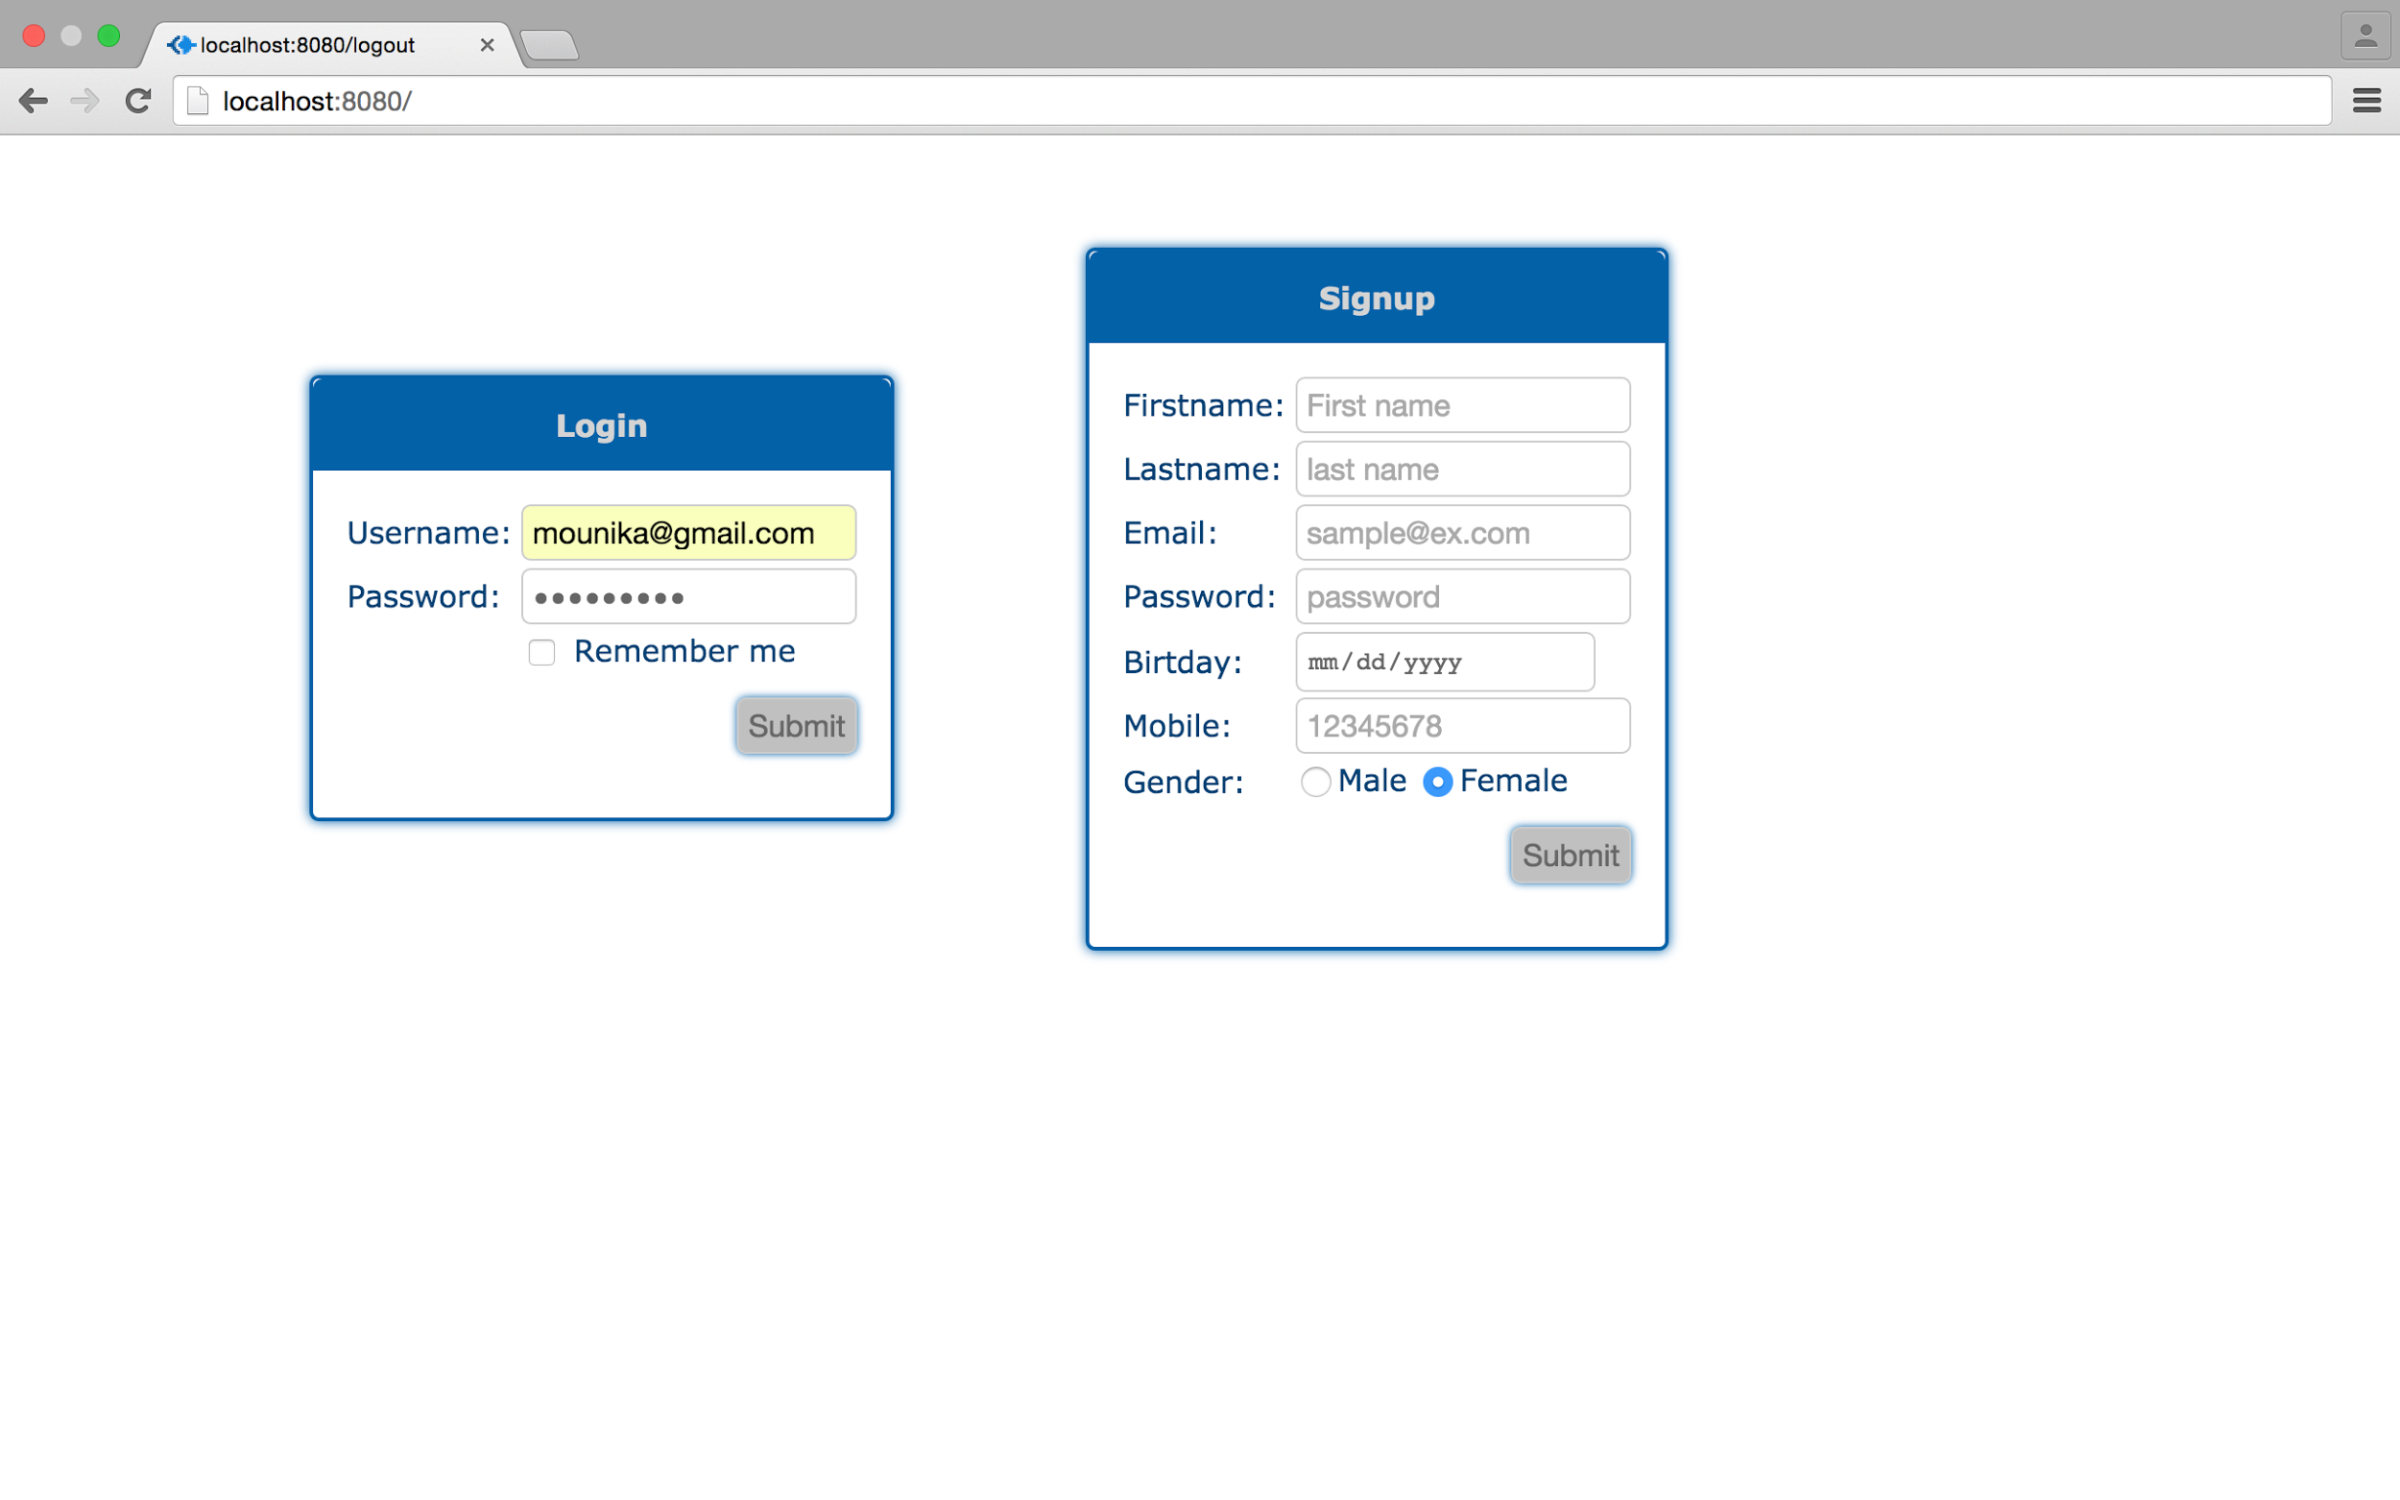

Screenshot:Enter login details to signin

* User enters login details to log in to the application.
* If the user enters correct credentials and press submit he will be directed to home page , else he will be redirected to login screen.

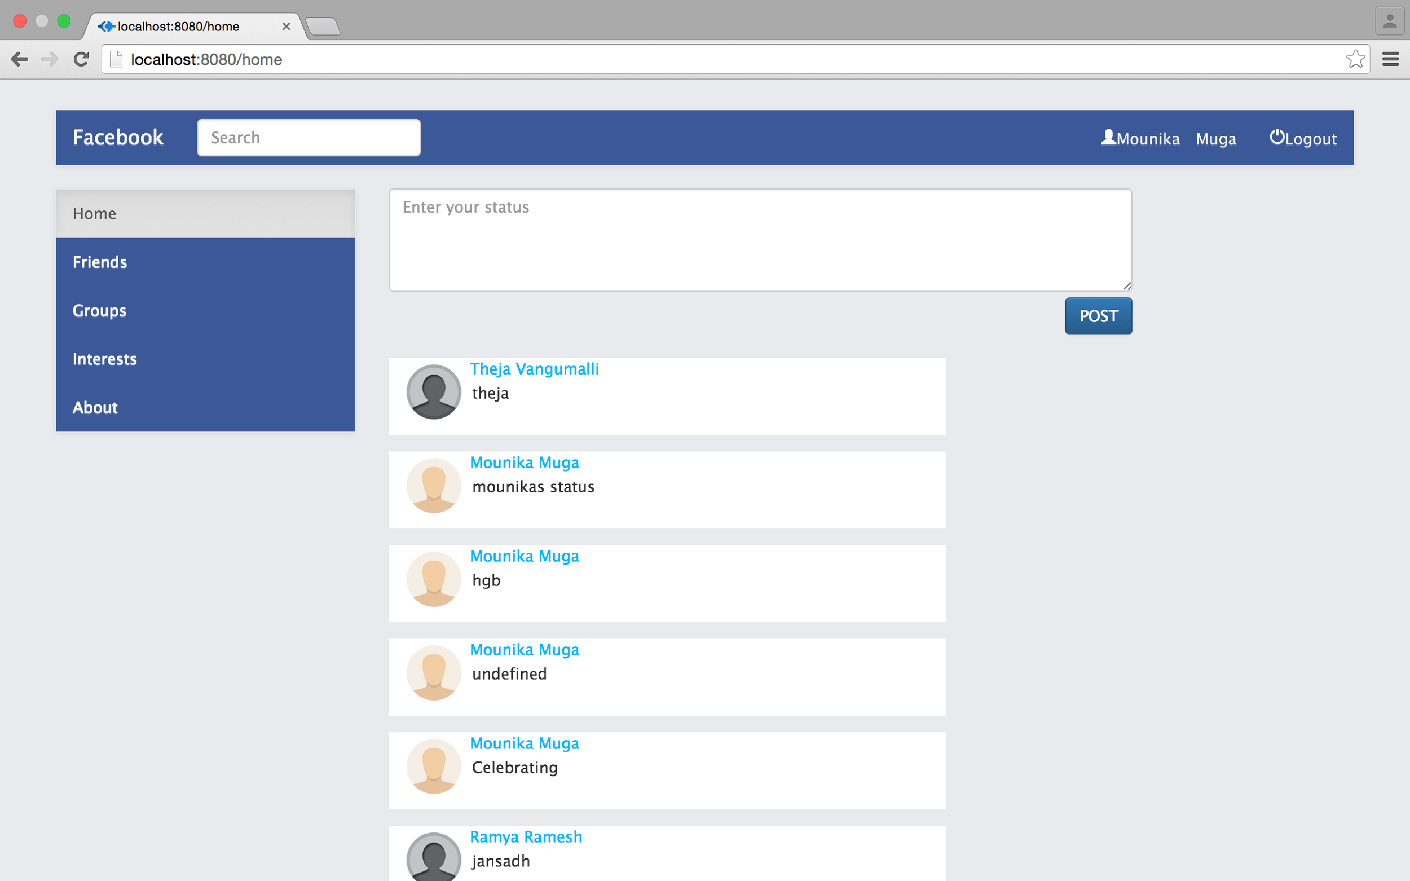

Screenshot:User’s homepage

* User’s home page displays the posts / news feed .
* User can enter the status and post it by clicking on Post button.
* User can view the posts of friends and those posted by the user.
* Latest posts are displayed first.

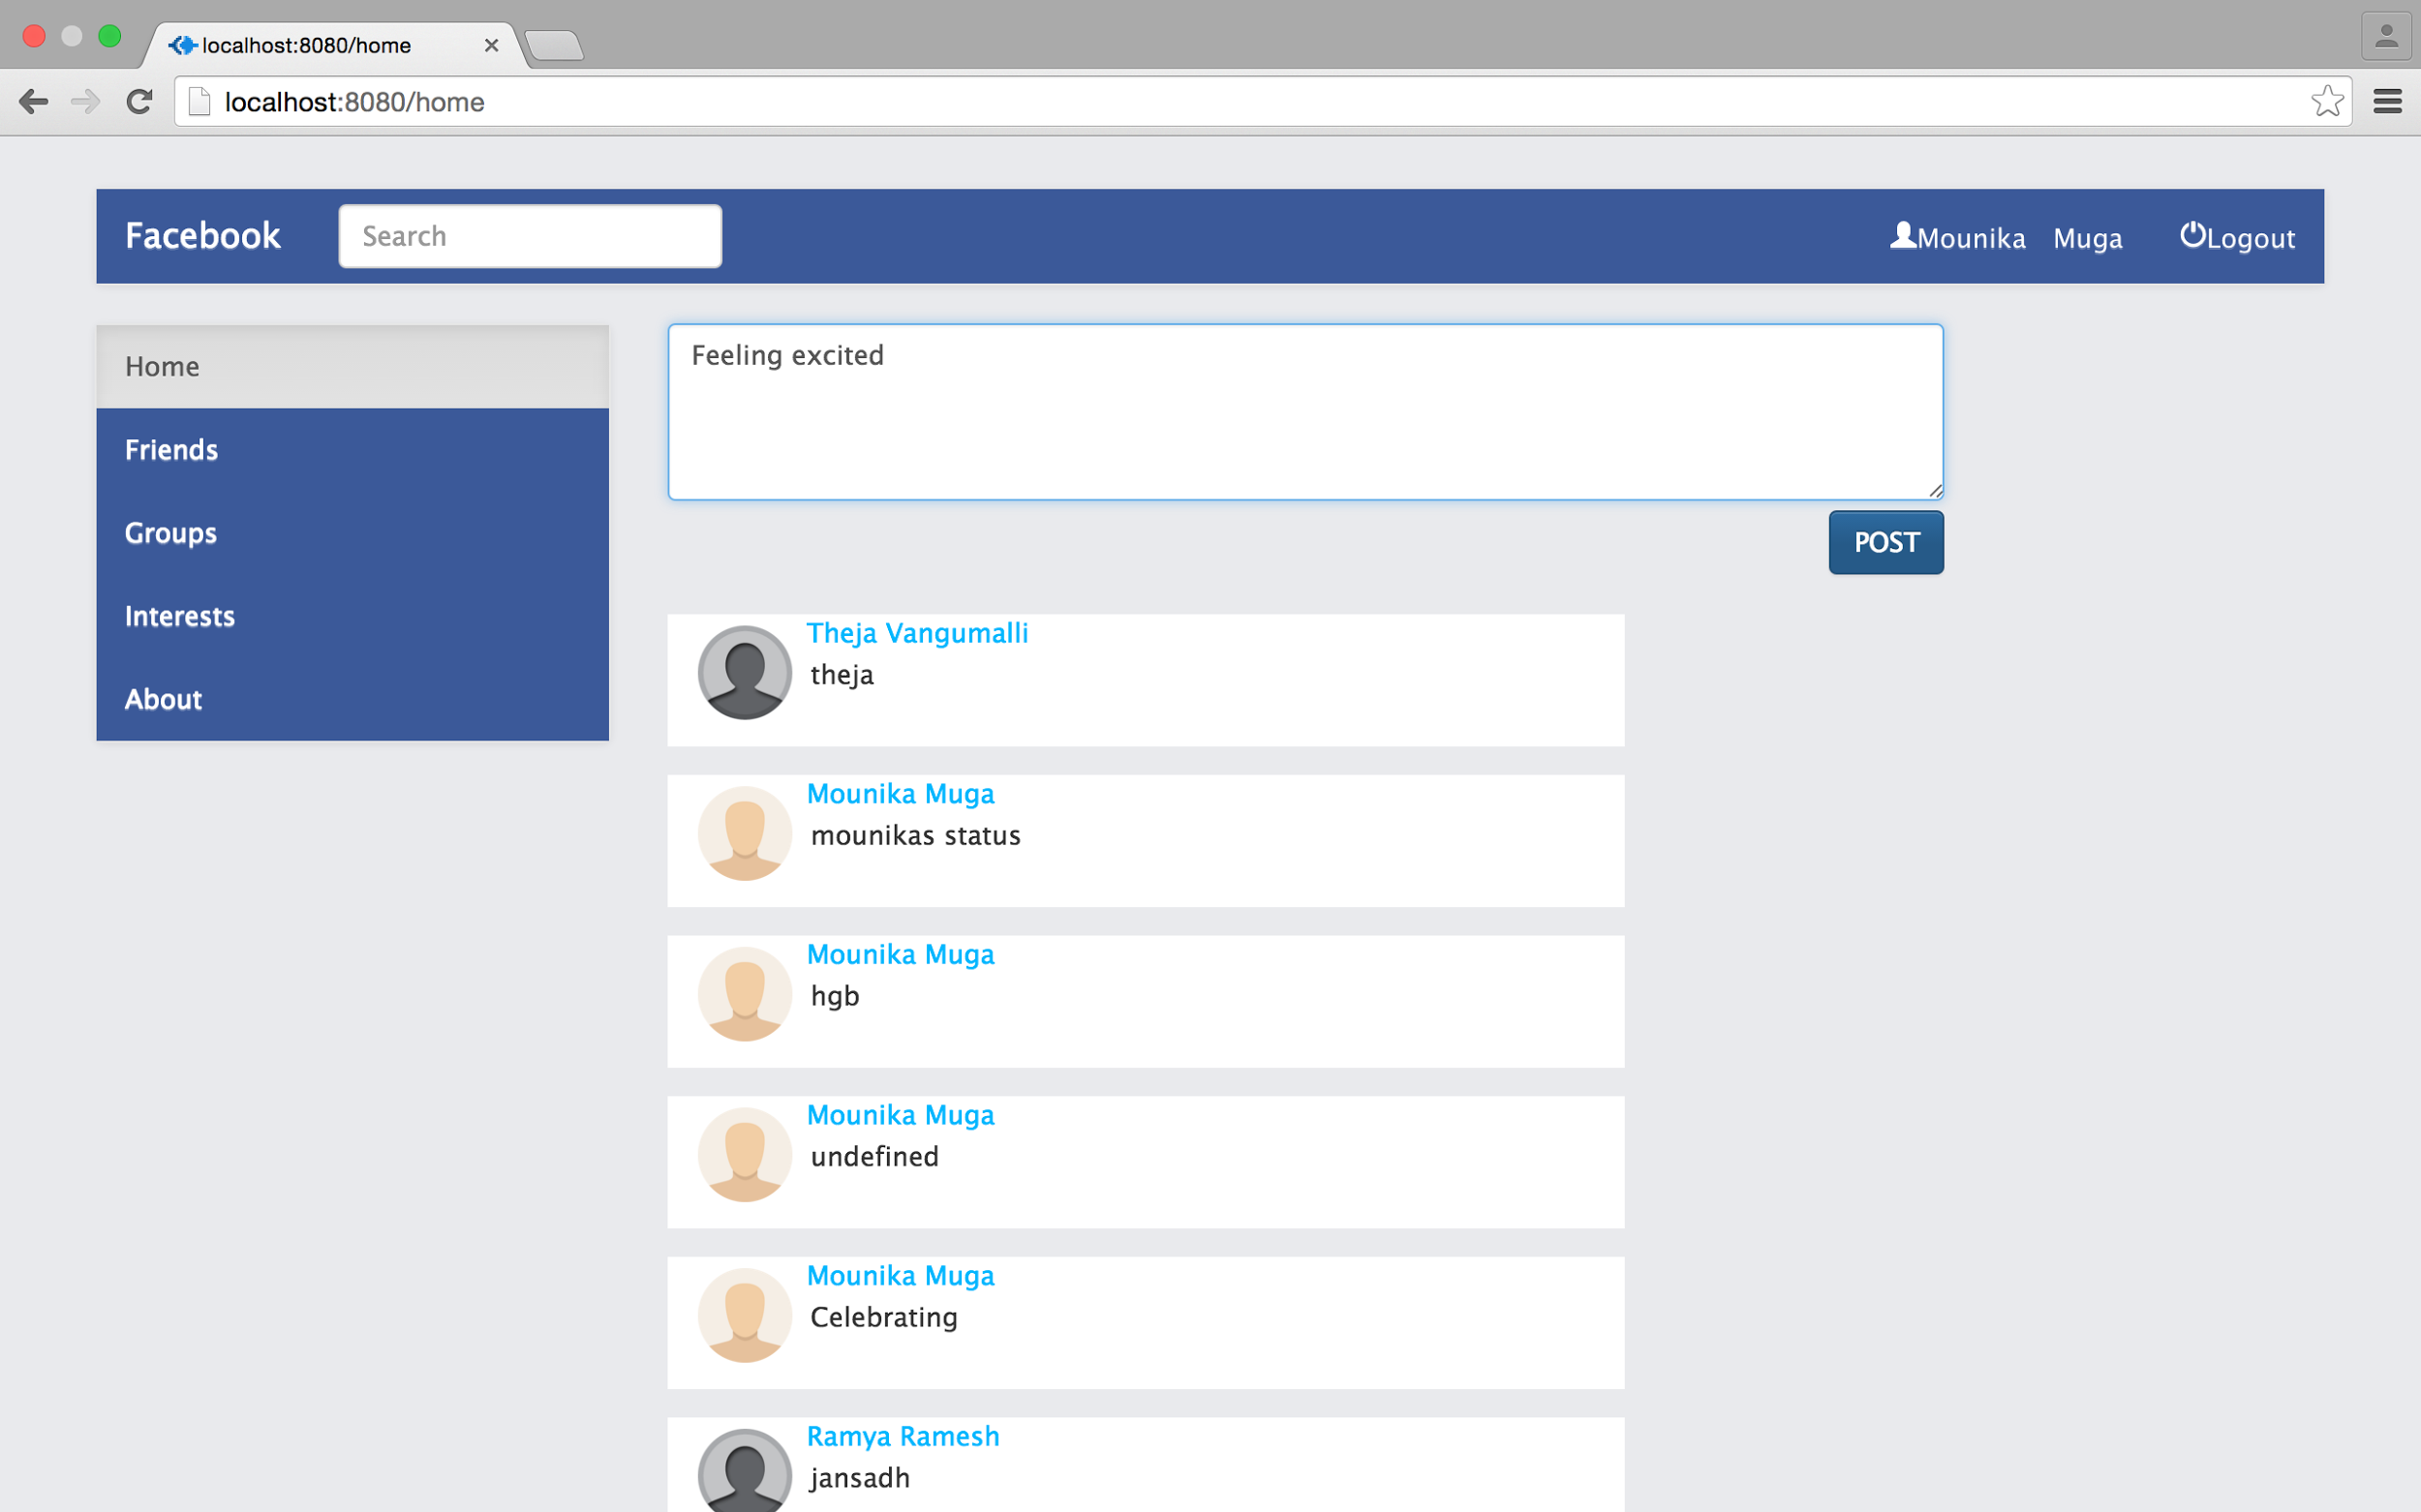

Screenshot:Entering status to post

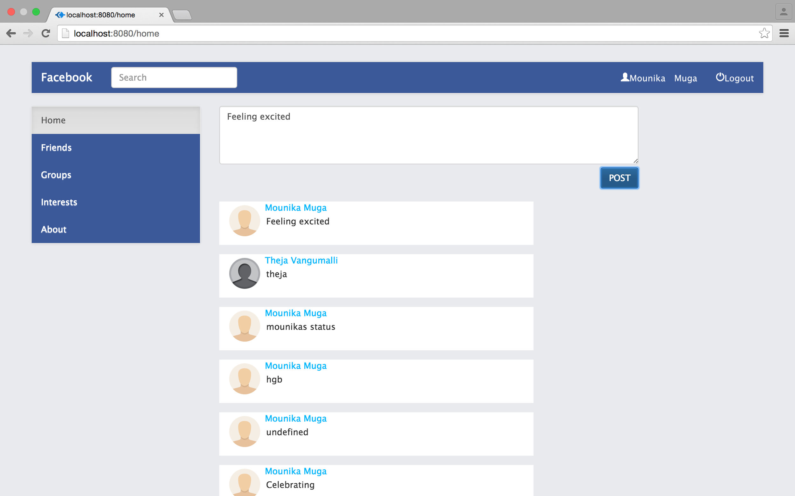

Screenshot:New post by the user

* User’s post will appear on the home screen after Post button is clicked.
* Home screen will display new posts as soon as they are posted ie., the posts are refreshed every few seconds to get new posts.
* Friends button in the home page will redirect the user to friends page where all the users who are friends to the user are displayed.

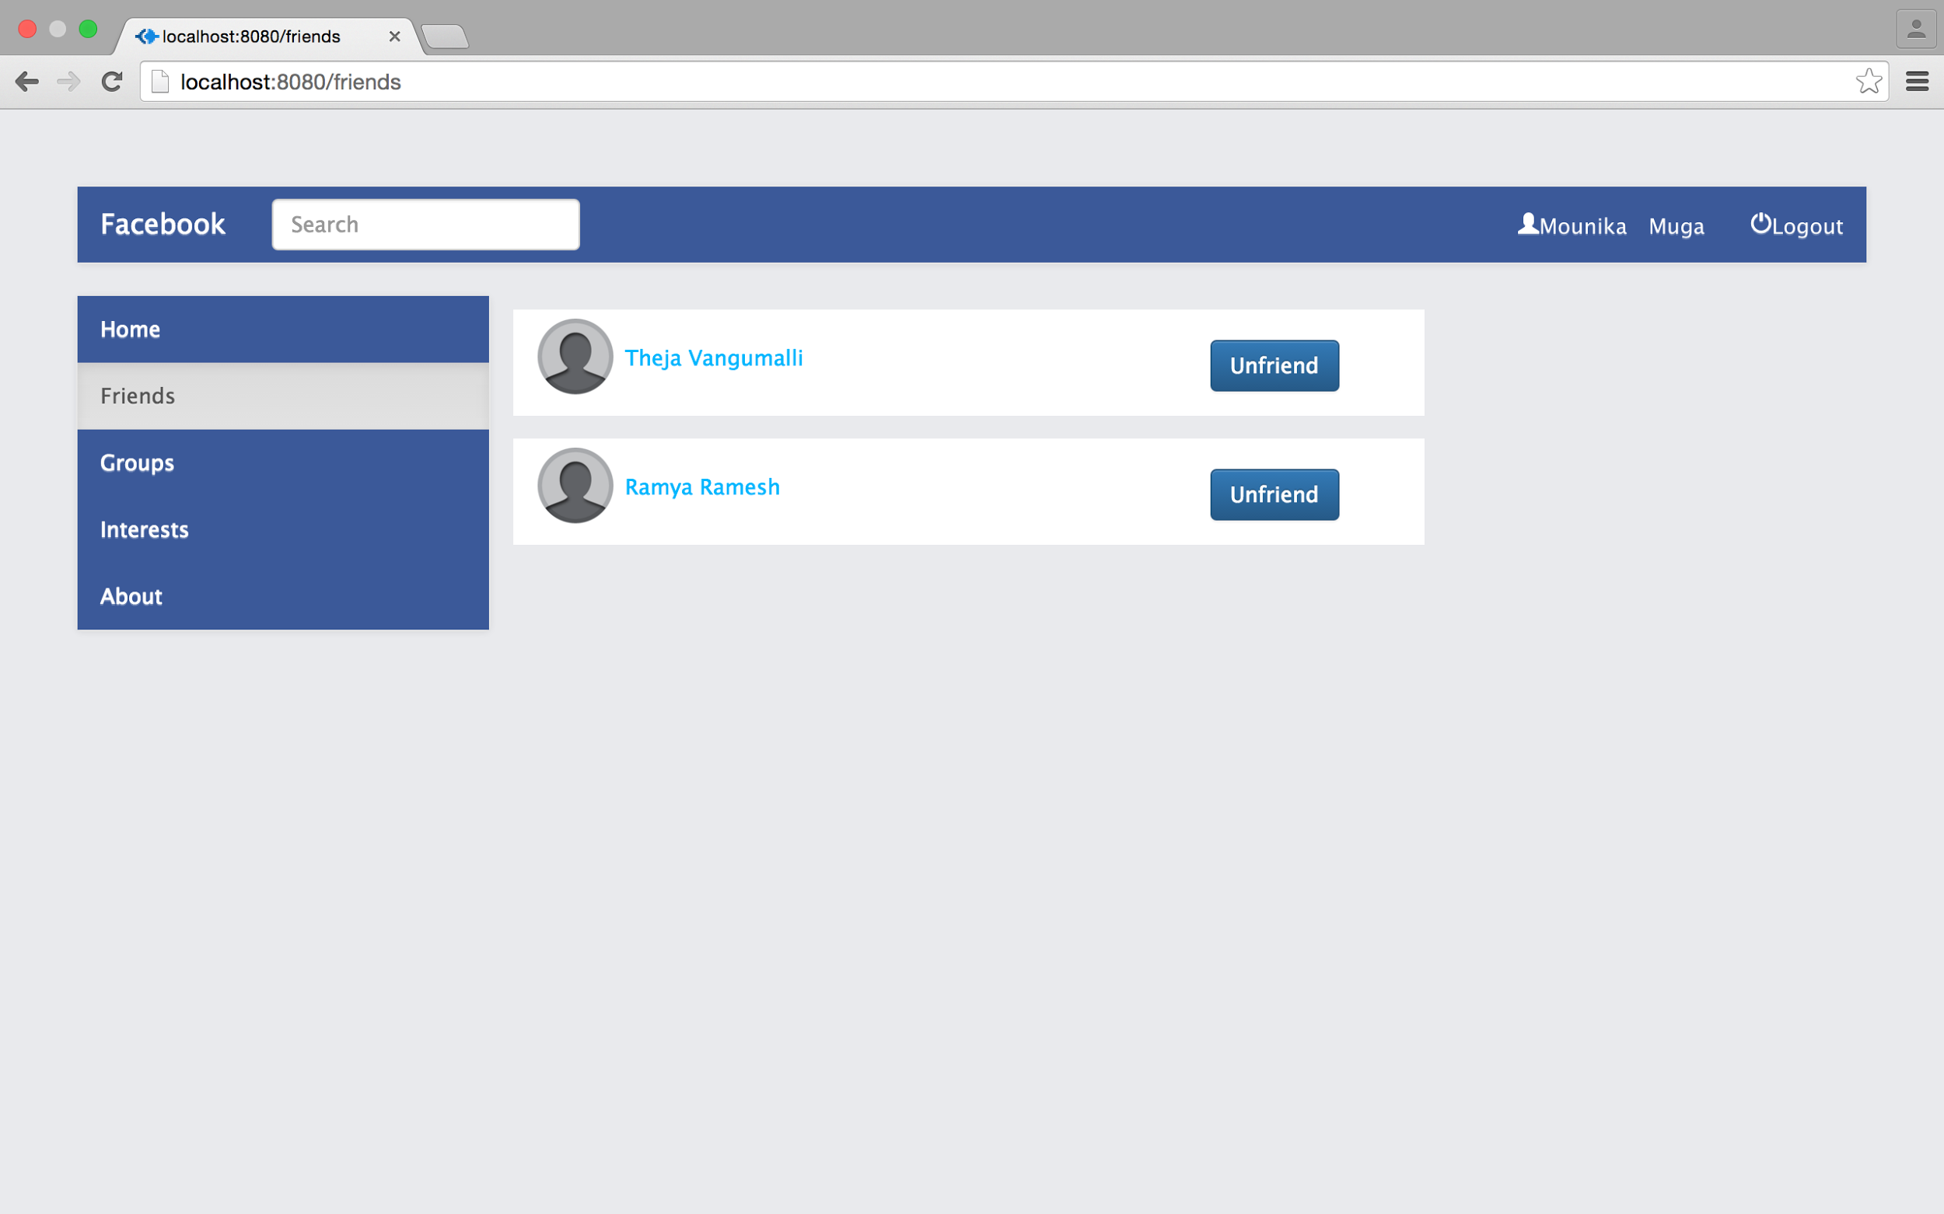

Screenshot:User’s Friends page

* It displays all the friends of the particular user.
* User can unfriend them by clicking on Unfriend button beside each friend.

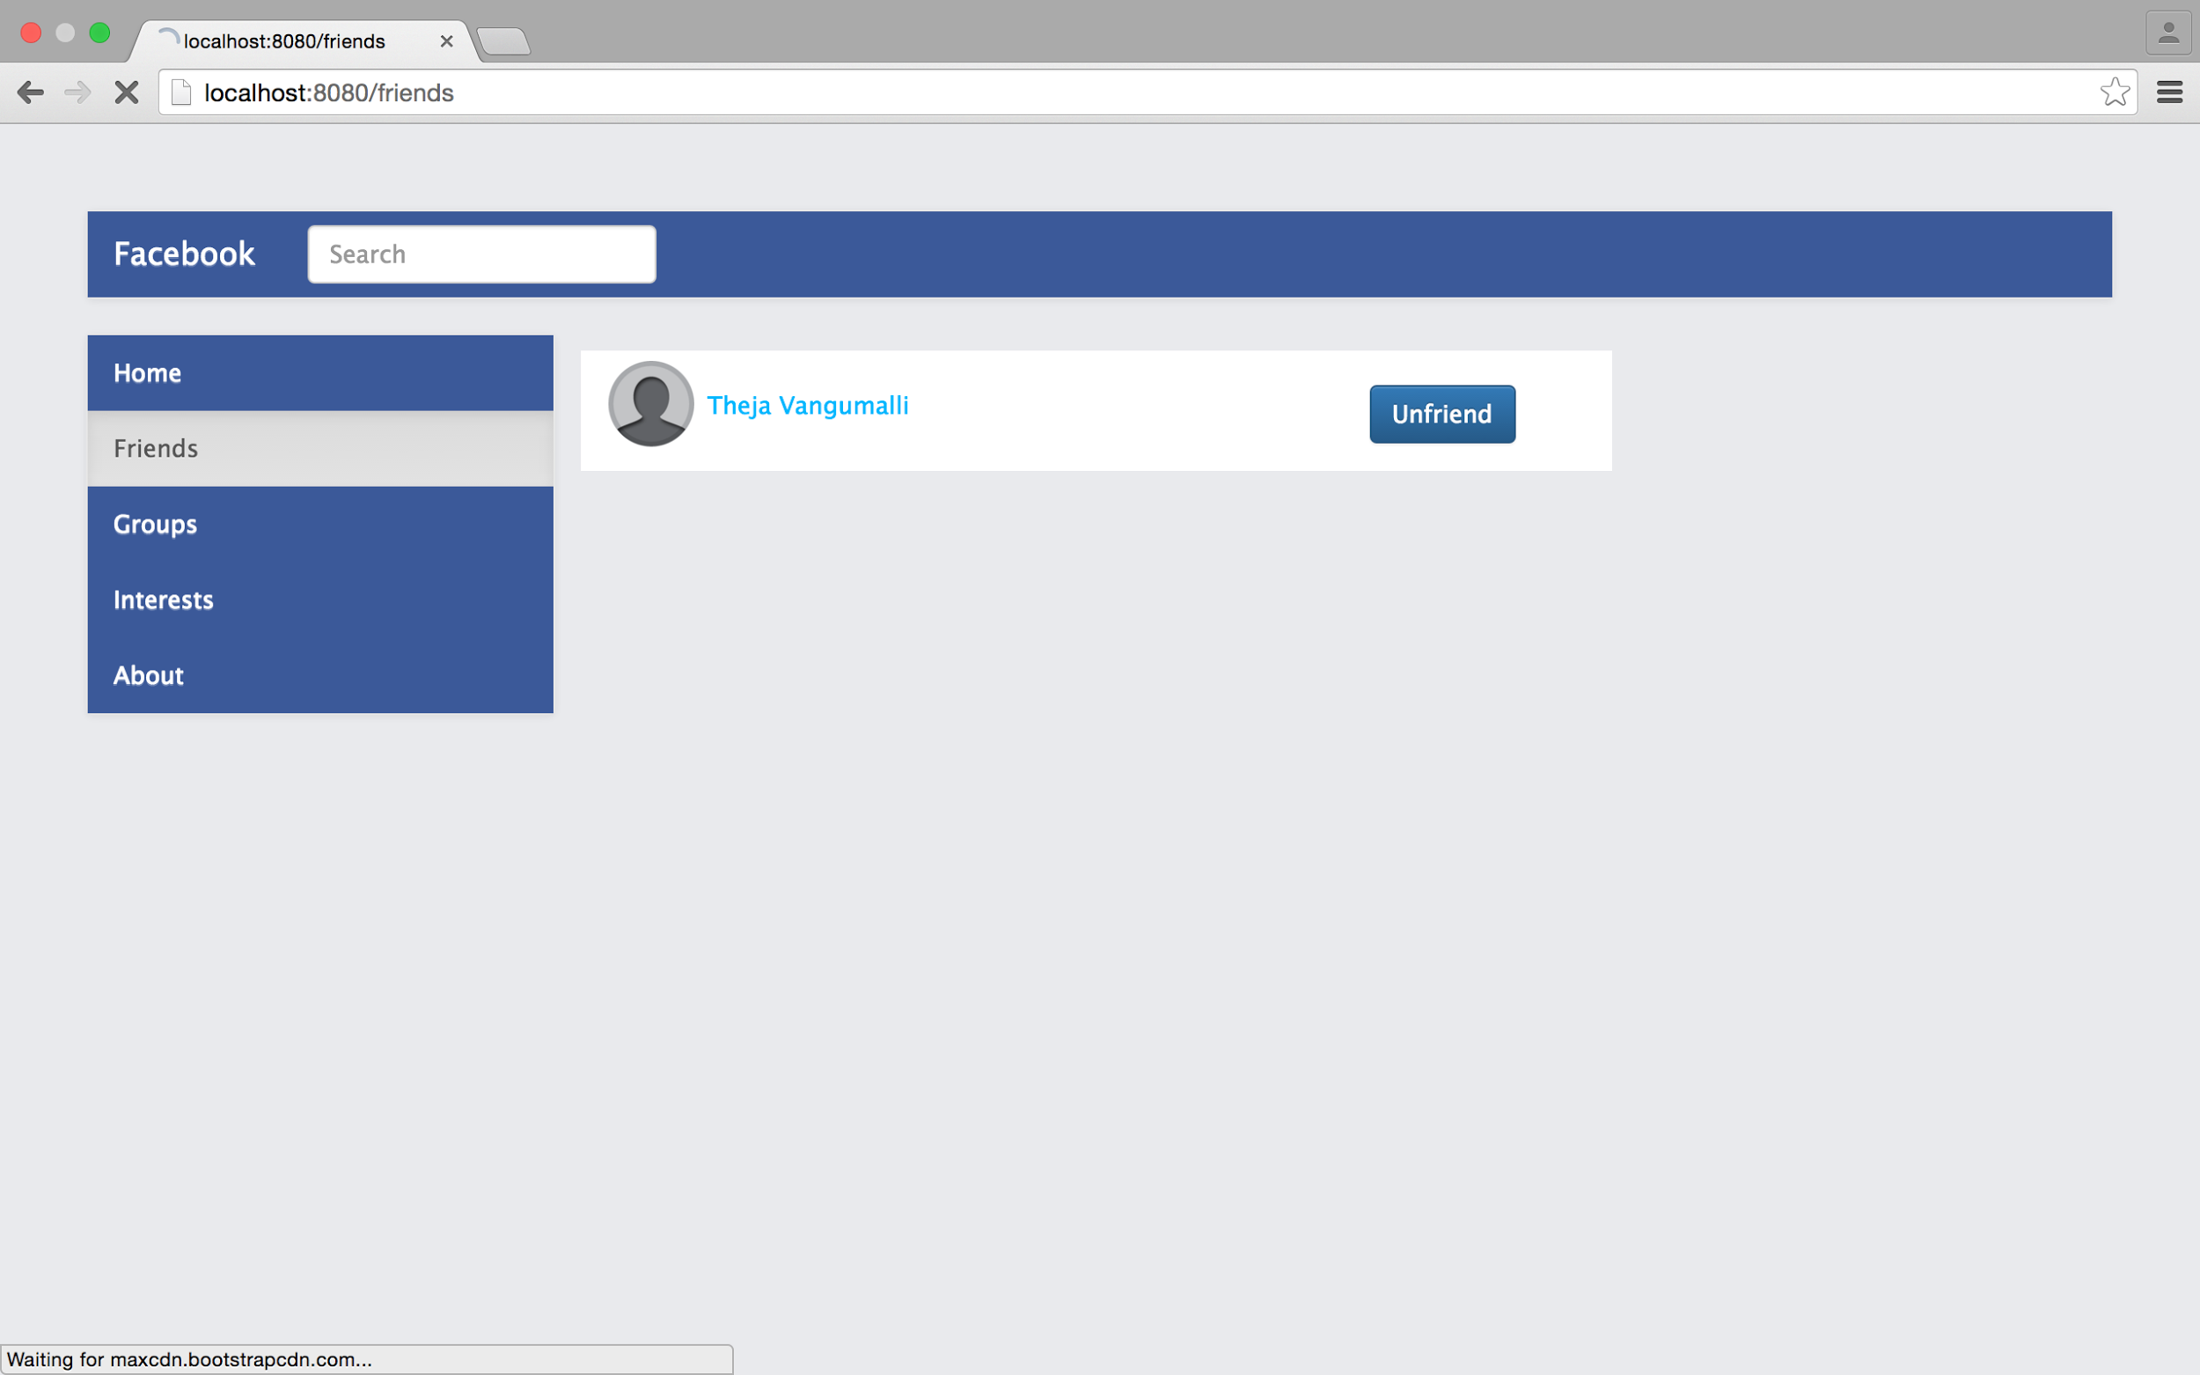

Screenshot:Friends page after a friend is removed from friends list

* User will be redirected to updated Friends page after unfriending a user.
* User can search a friend by typing the first or last name of any user in the search box.
* Users are displayed when a name is entered in the search box that may match the string in the search box.

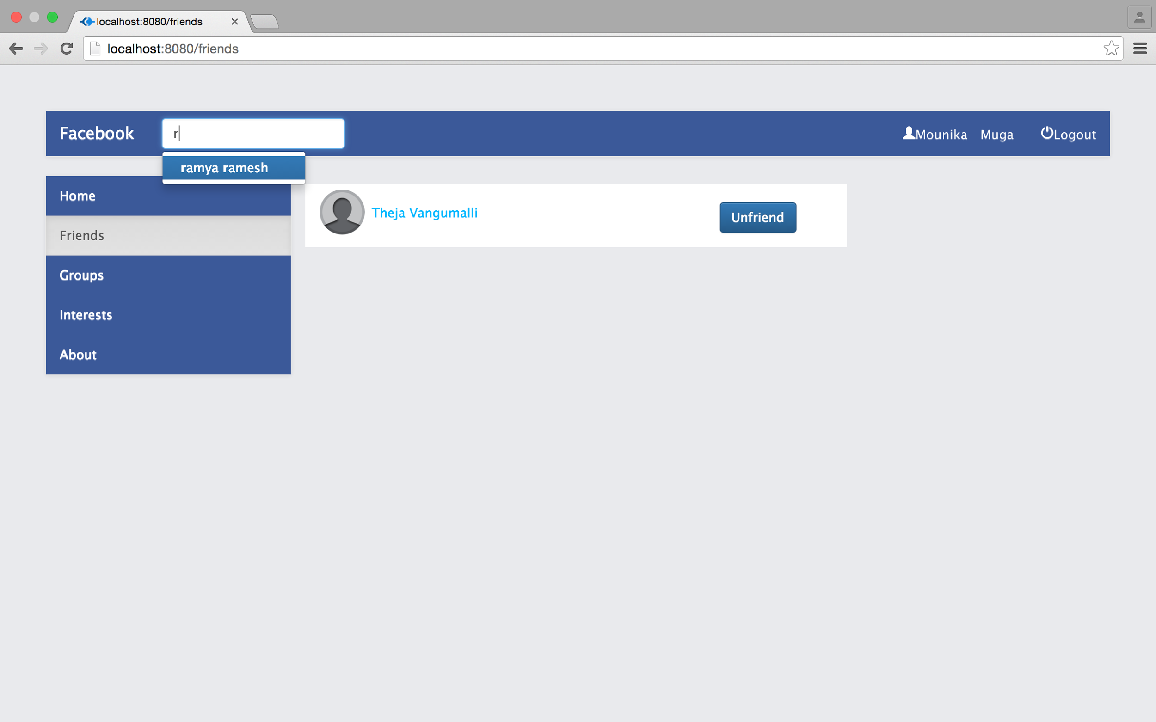

Screenshot:Users names that may match the search string are displayed

* When user selects a name and clicks on it, the selected user’s About page is displayed to the user with Add Friend option if the user is not a friend.

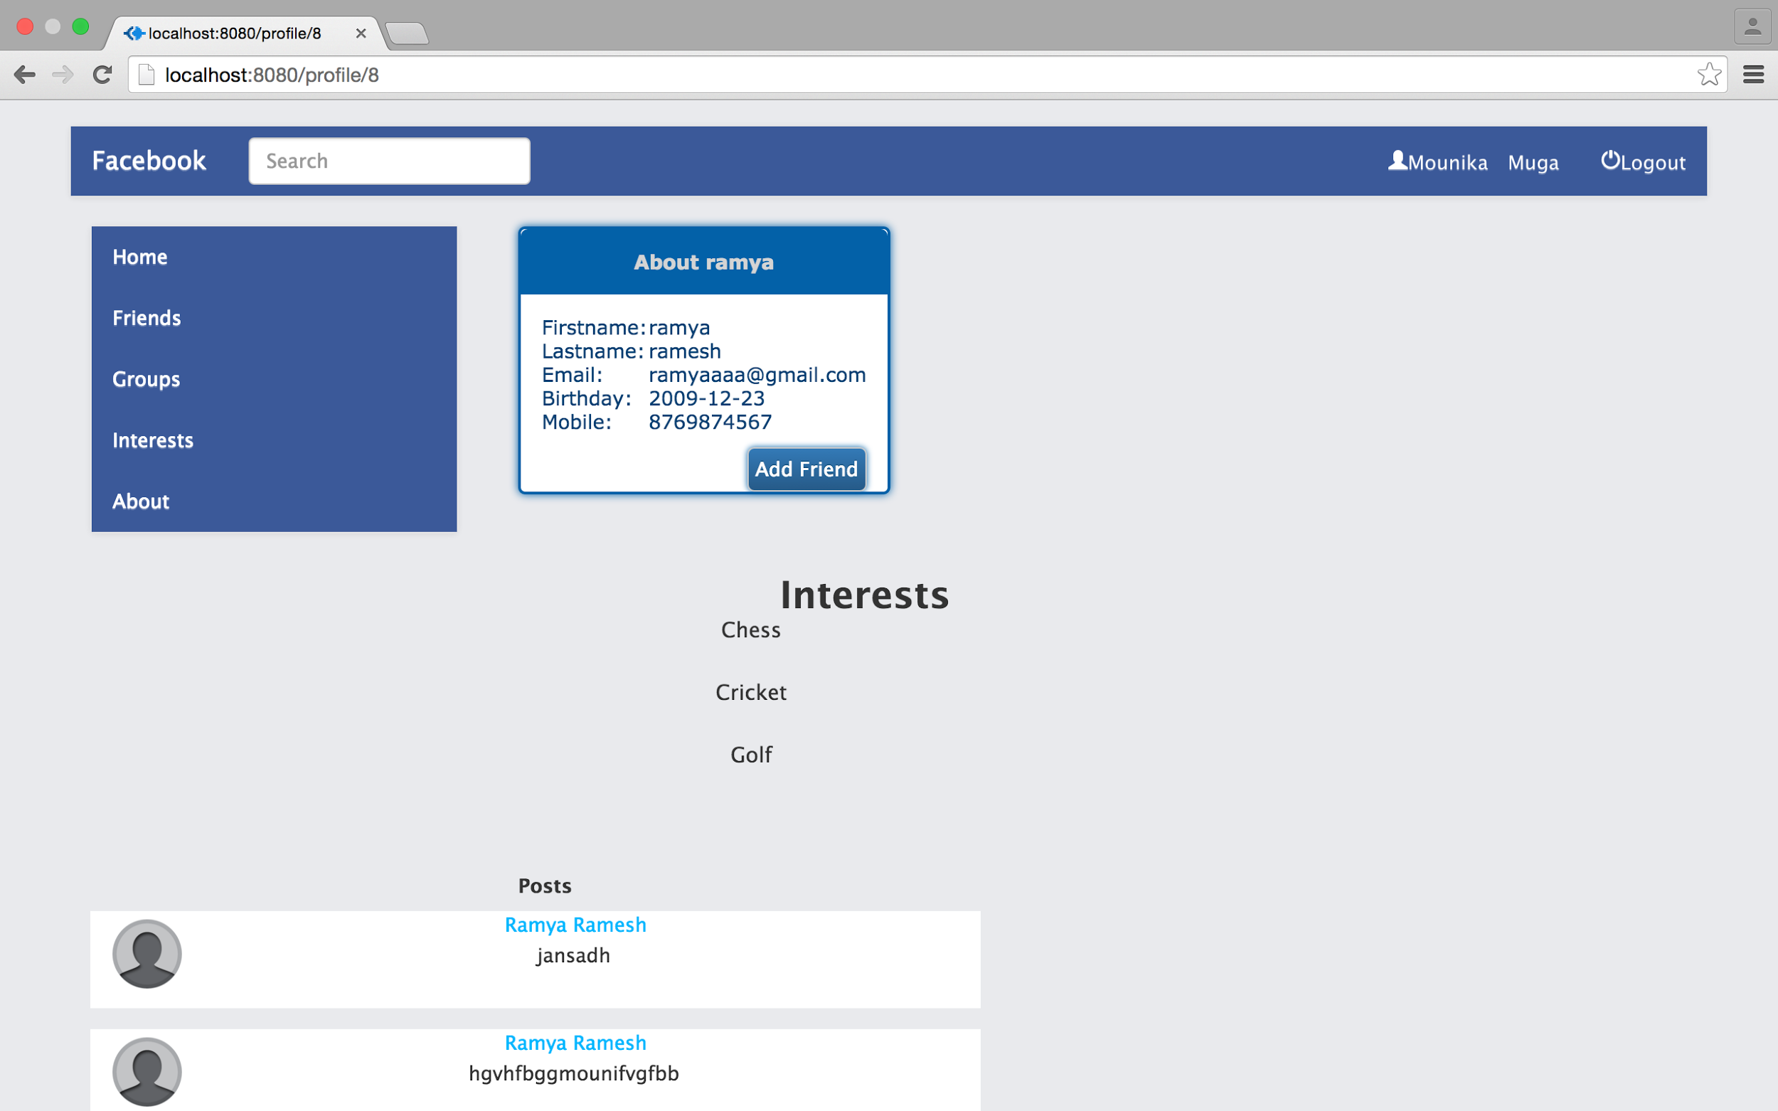

Screenshot:Other user’s details page

* Clicking on Add Friend button will let the user to send friend request to the other user.
* Clicking on Cancel Request will again cancel the sent friend request.

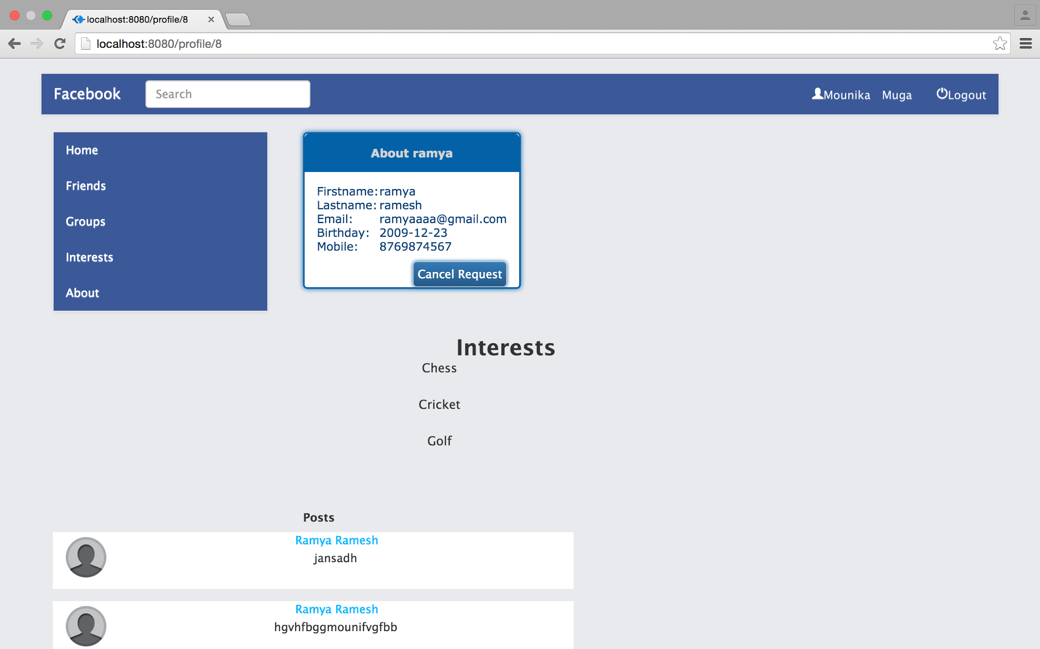

Screenshot:Friend request sent



Screenshot: Request again cancelled

* User can accept or deny a request from another user.

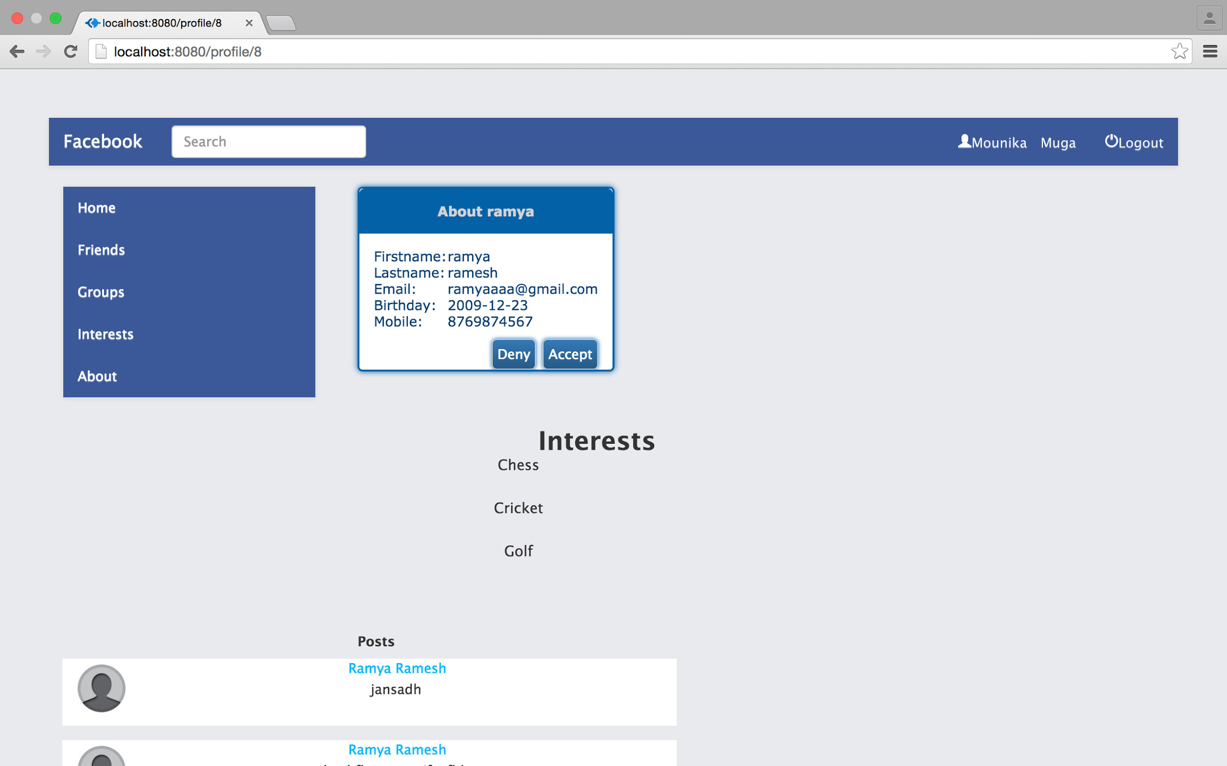

Screenshot: Friend request received from another user

* Clicking on Group button will redirect the user to his Groups page where all the groups of the user are displayed.

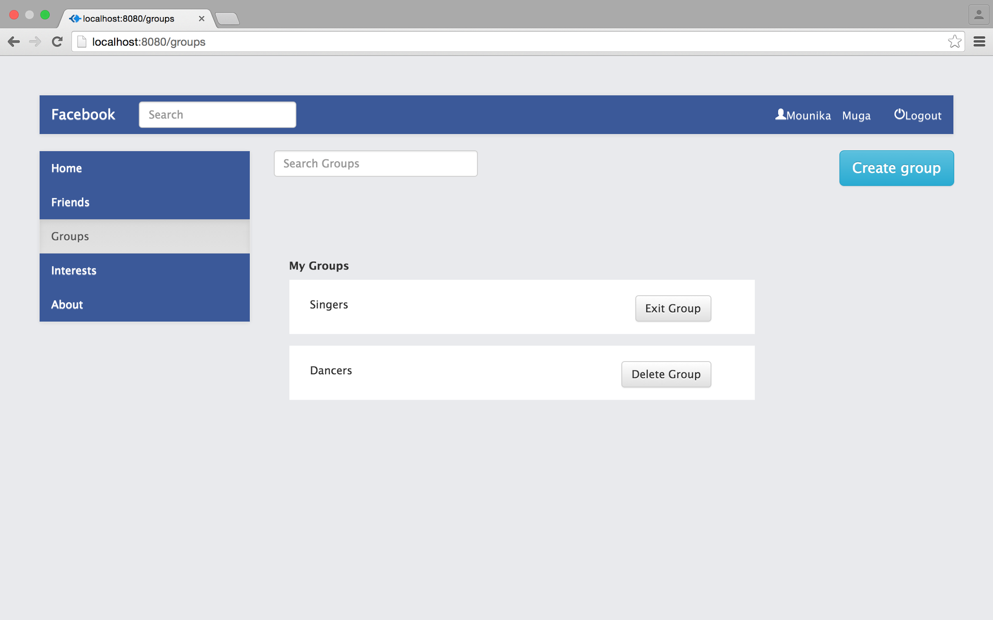

Screenshot:User’s Groups page

* User can create a group by clicking on Create Group button.
* Details of the group like group name have to be entered to create a new group.

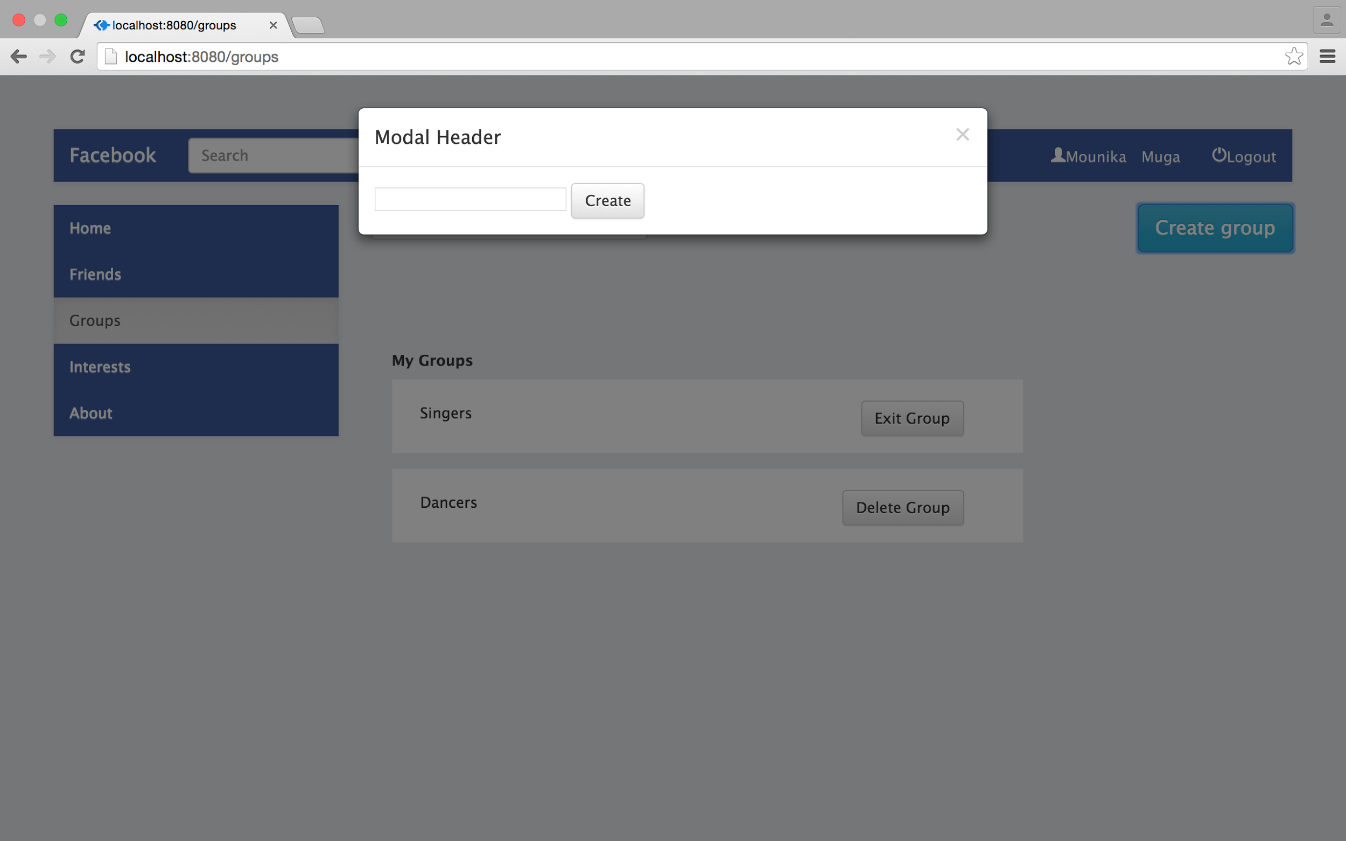

Screenshot:Pop-Up to enter group details

* After group details are entered, the Create button is clicked to create a new group.
* This will be displayed in the user’s Groups page.

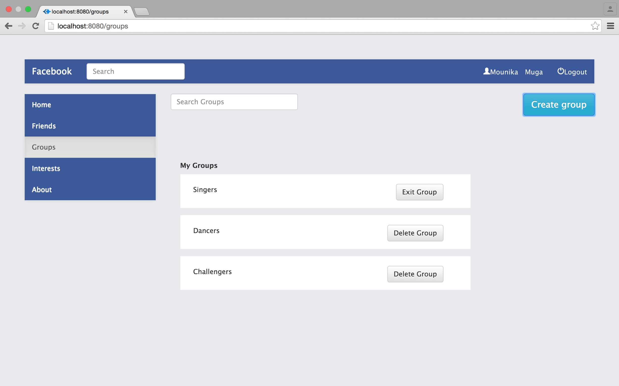

Screenshot:New group is displayed

* User can exit group by clicking on Exit Group button beside group name.

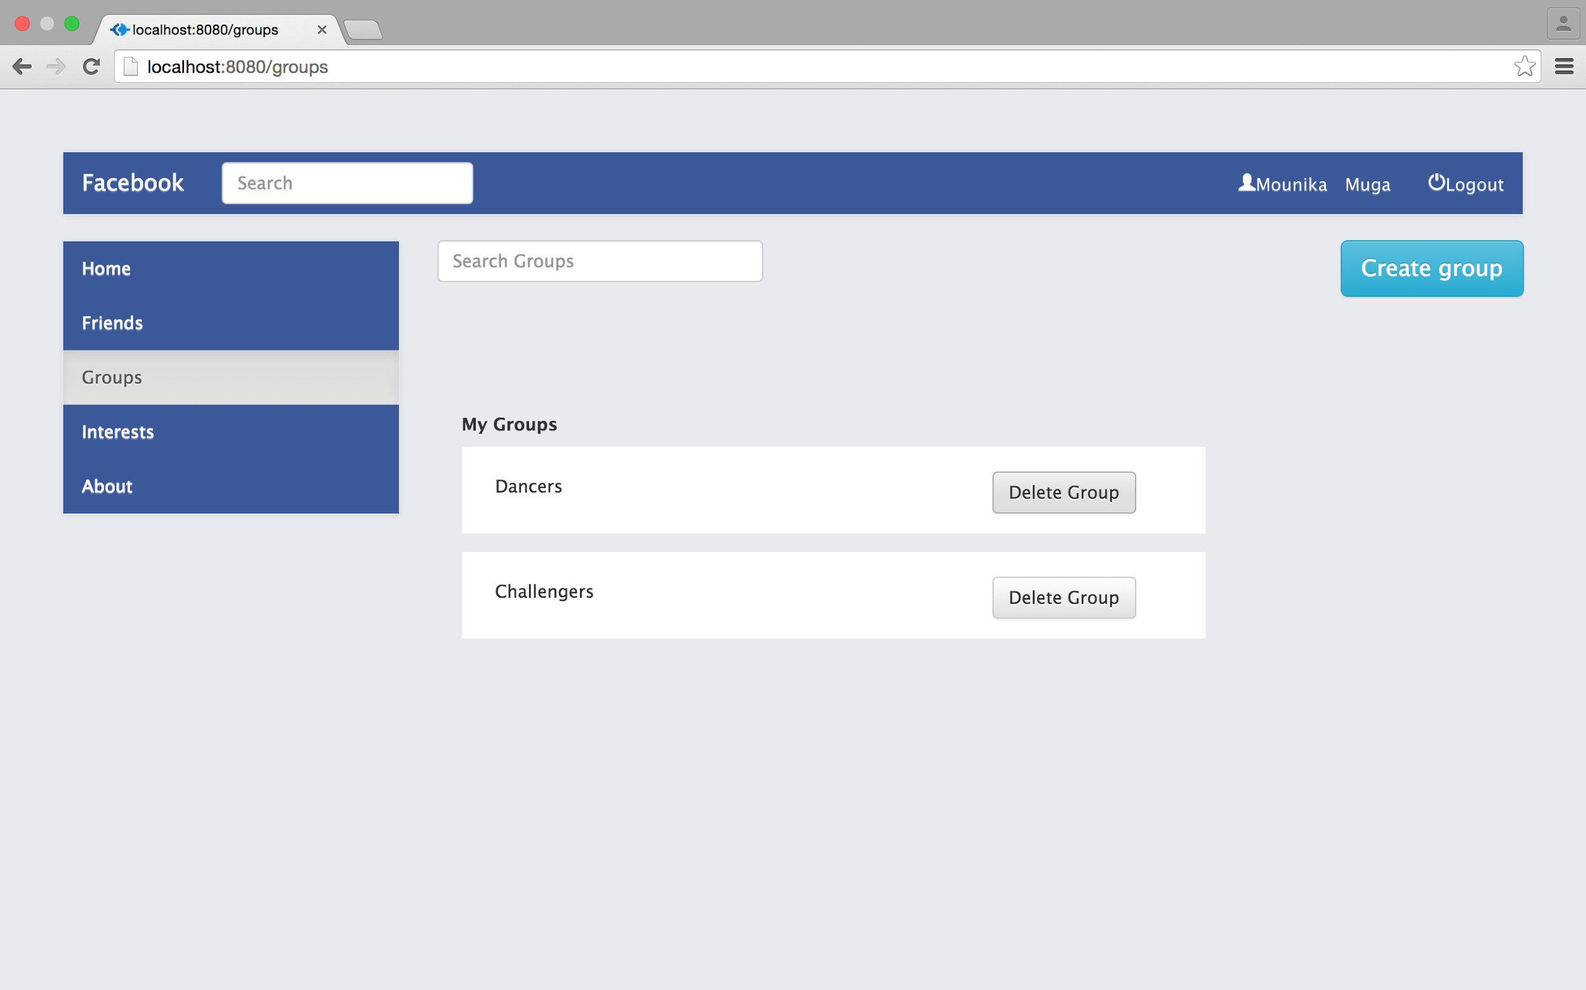

Screenshot:Exited from group Singers

* Only the user who created the group can delete it by clicking on Delete Group button

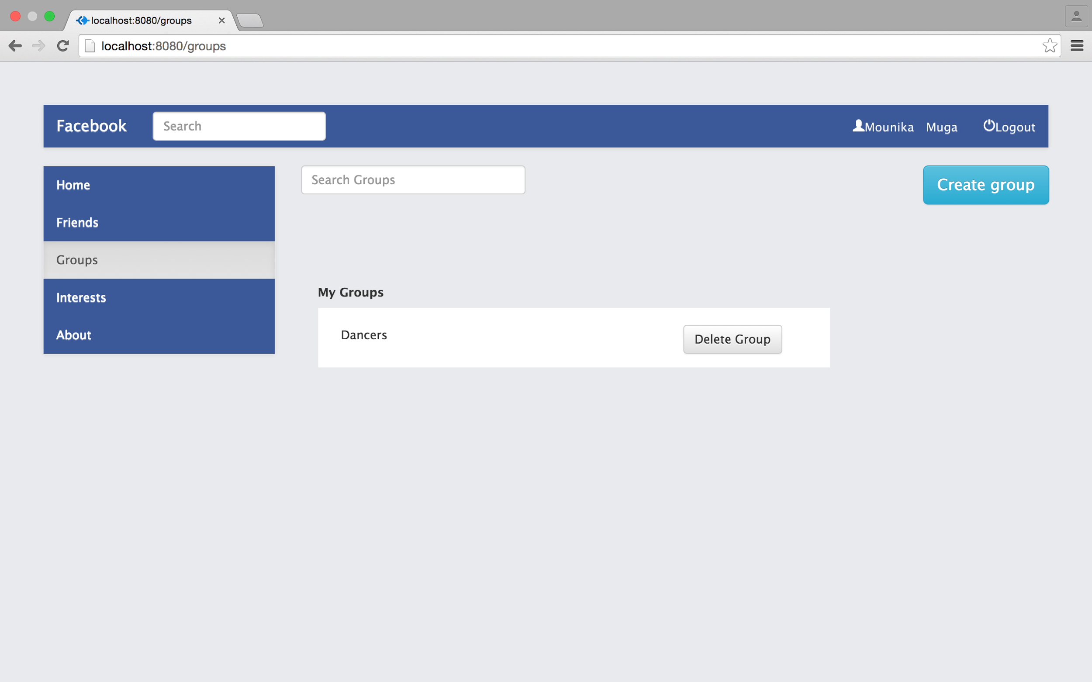

Screenshot:Group Challengers is deleted by the user

* Only the admin of the group gets to delete the group.
* Interests page shows the interests of the user.
* User can add or delete the interests.
* User can go to Interets page by clicking on Interests.

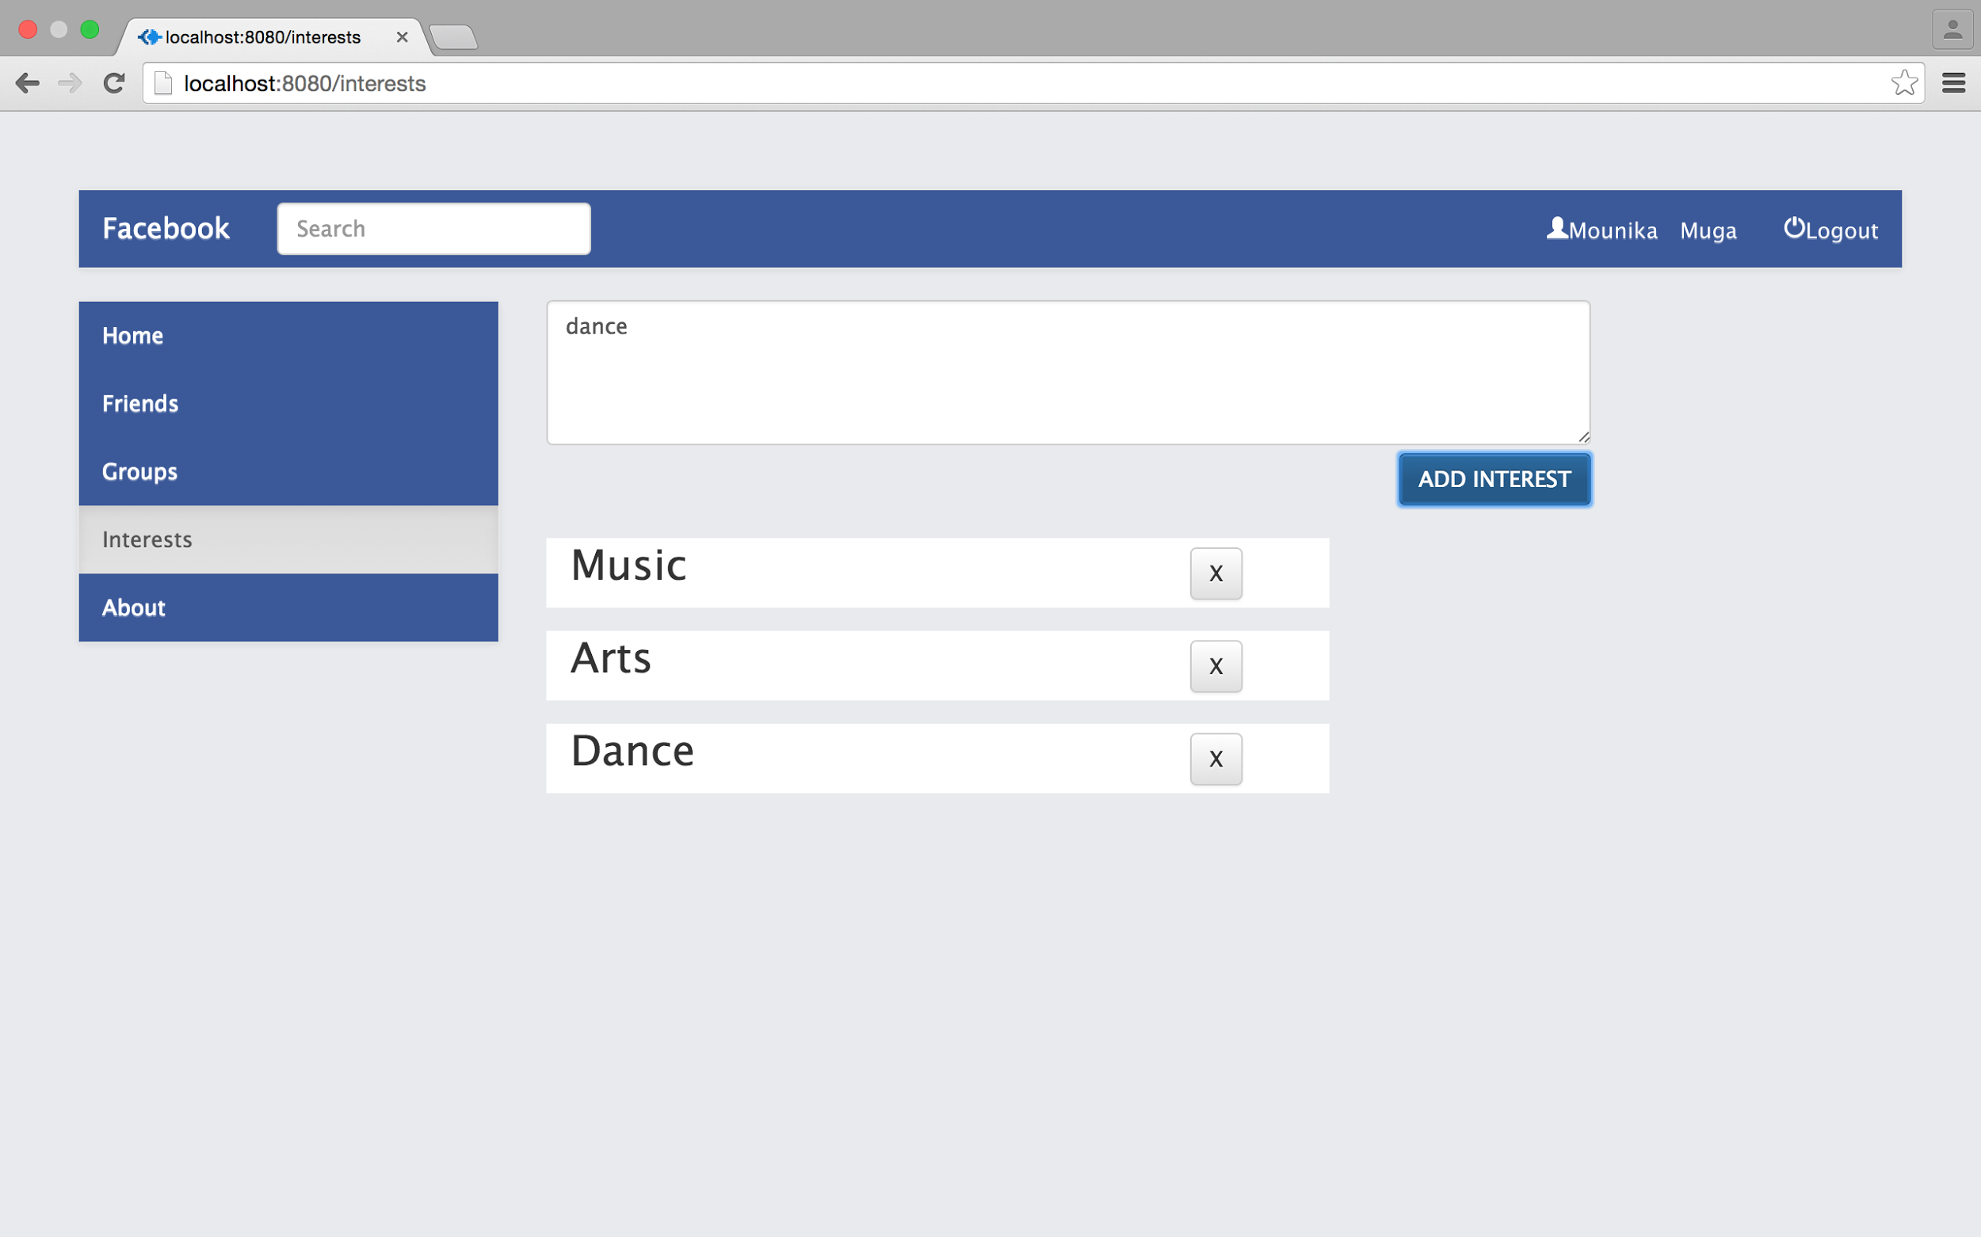

Screenshot:User’s Interests page

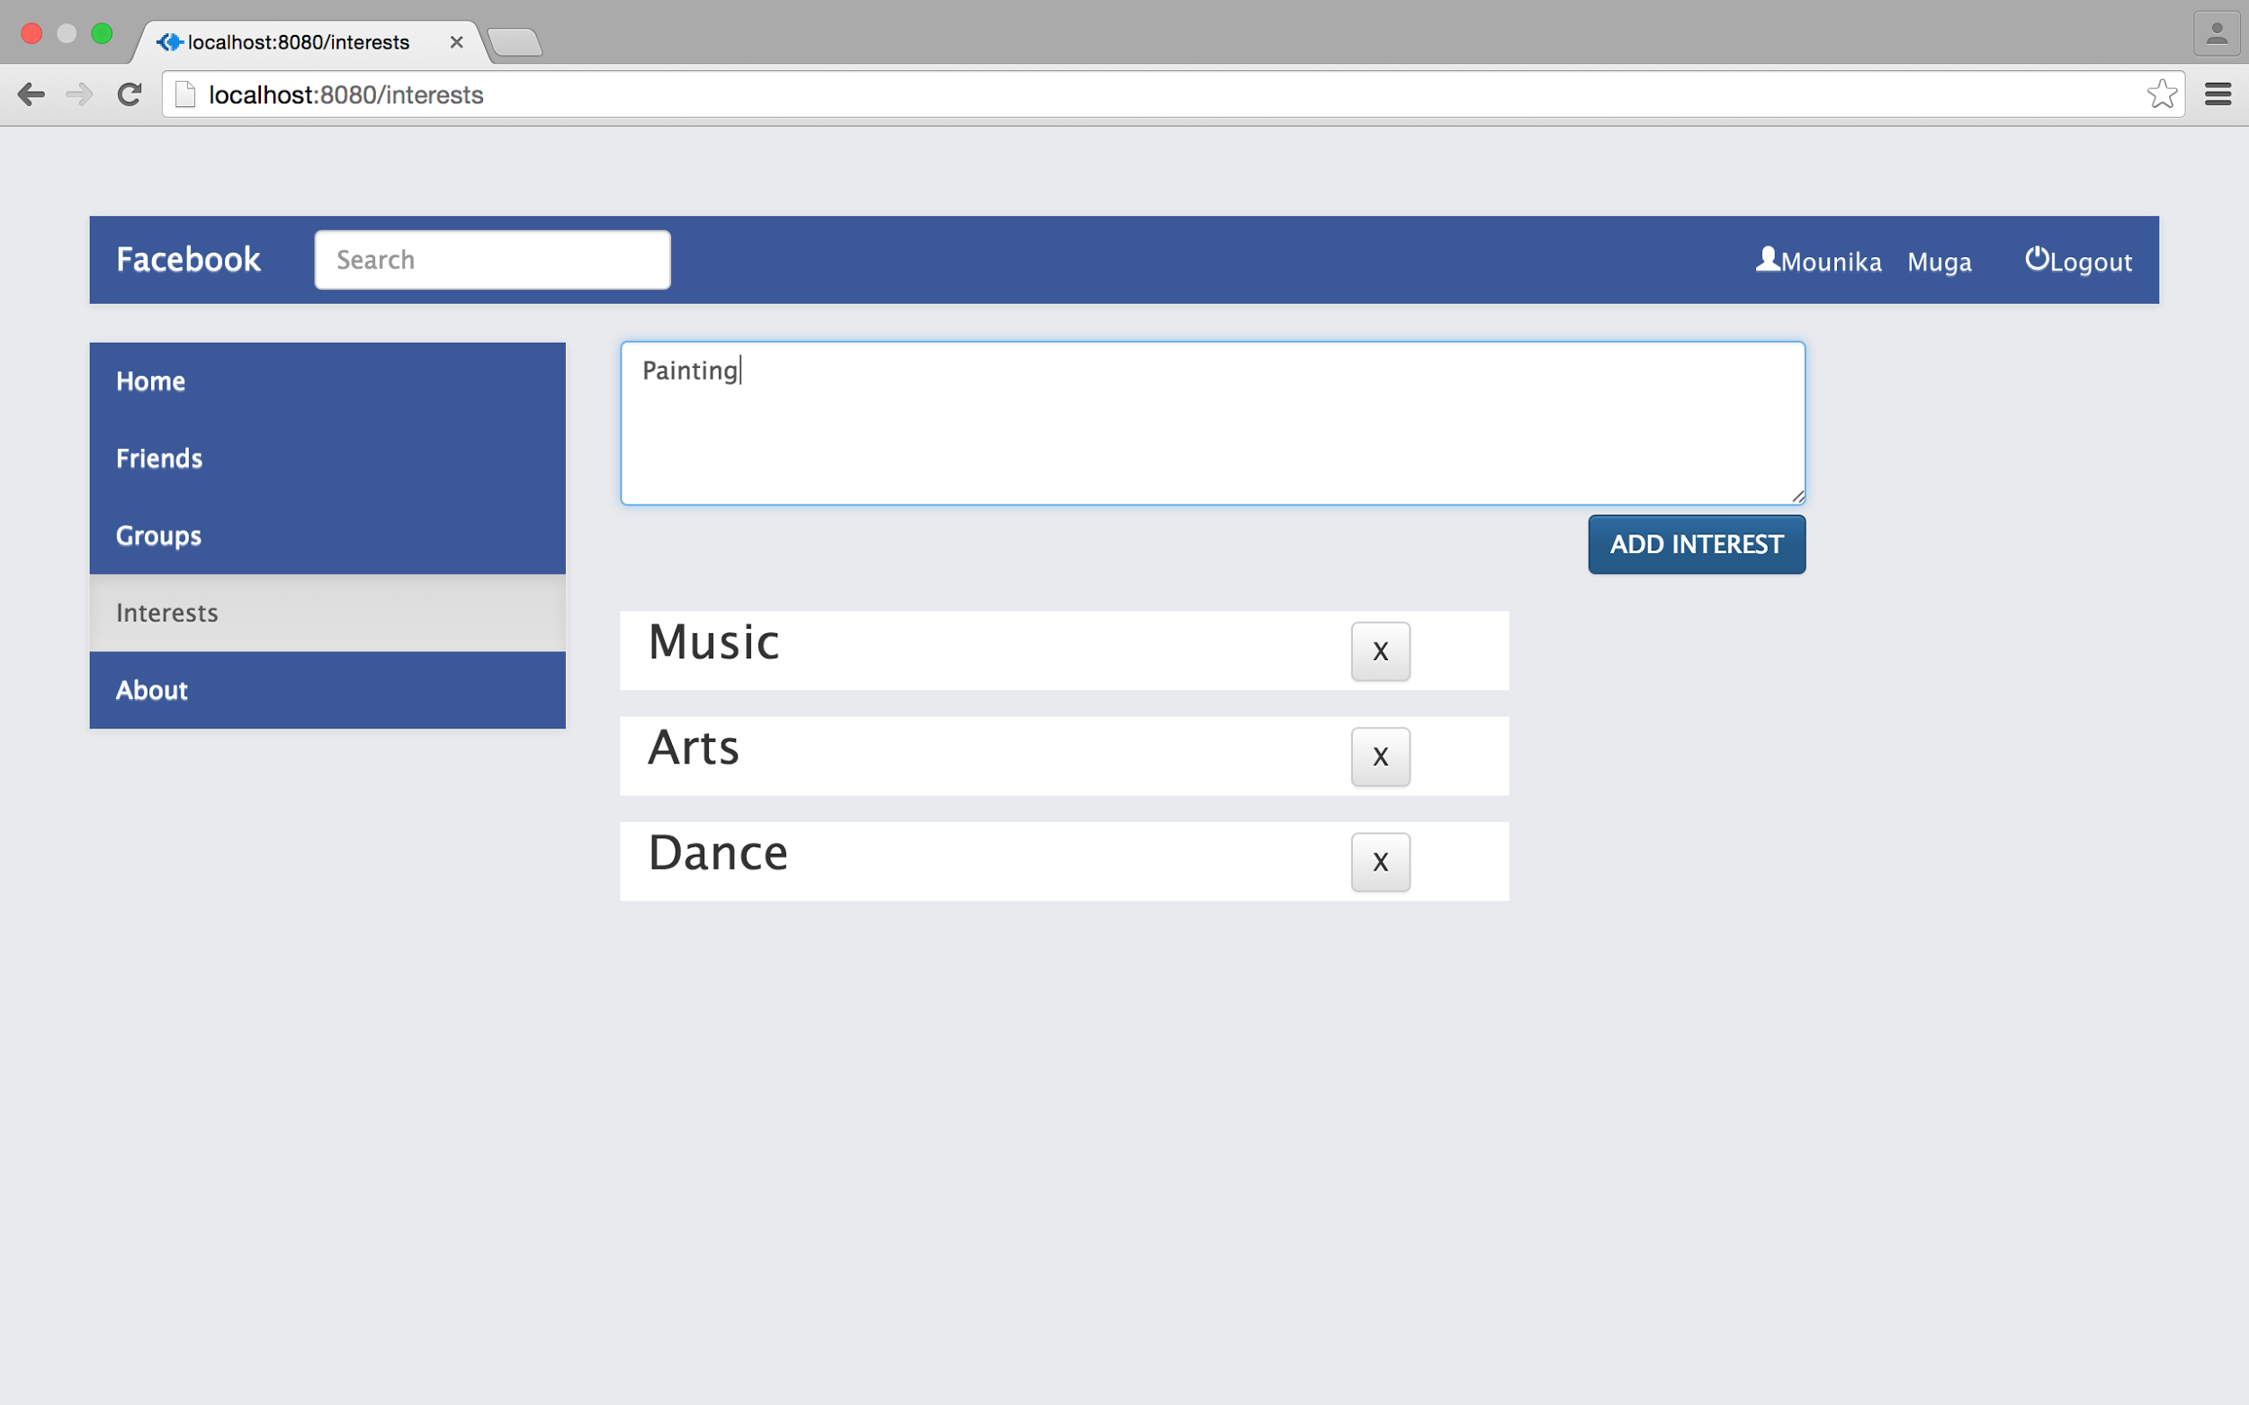

Screenshot:Adding new interest

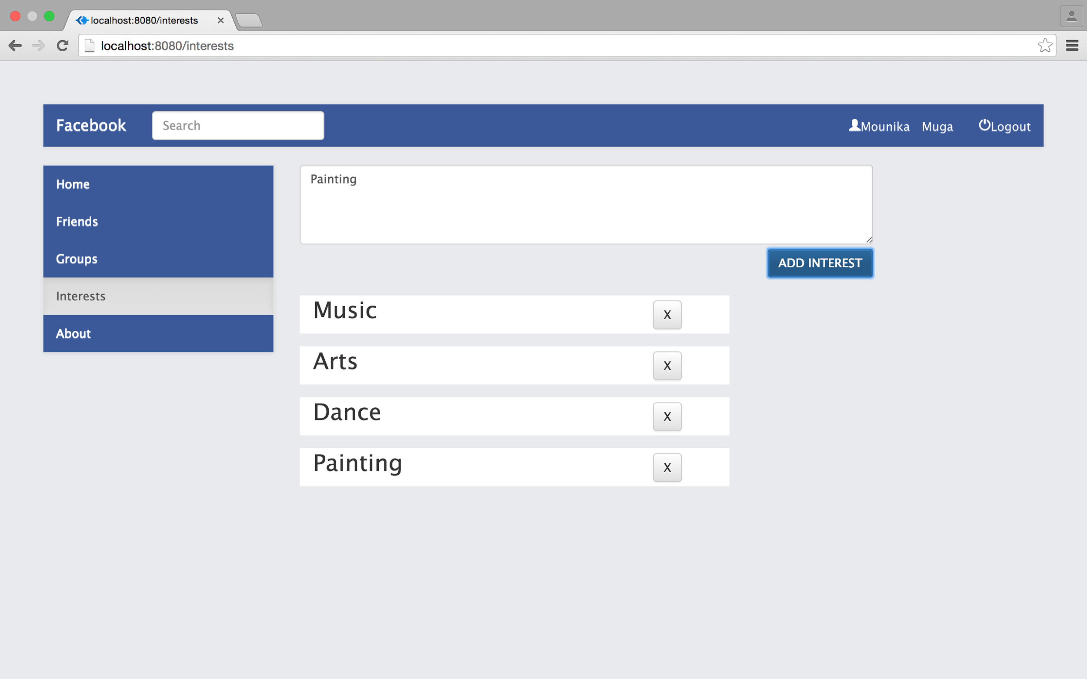

Screenshot:New interest is added

* Interests can be removed by clicking on X button beside each one of them.

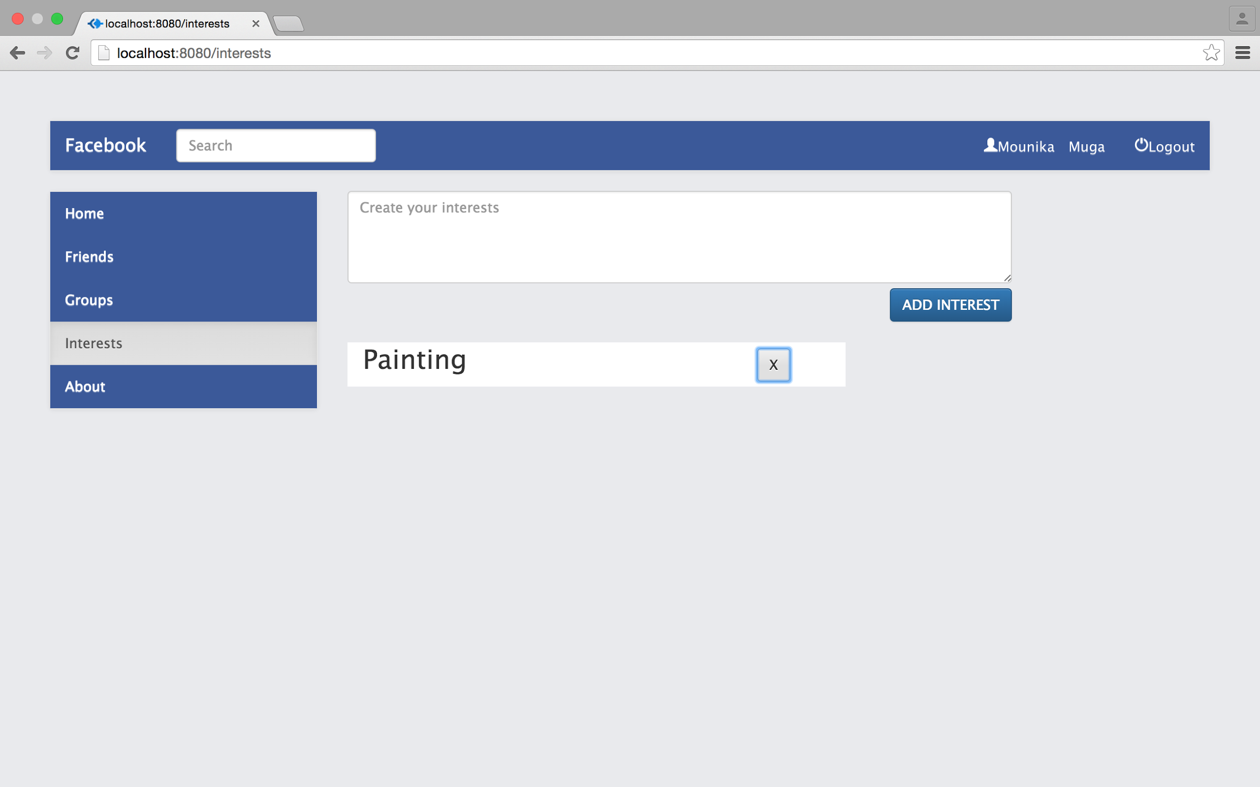

Screenshot:Interests page after removing interests in the previous list

* About page of the user displays details of the user.
* Clicking About button in a page will open the user’s About page.

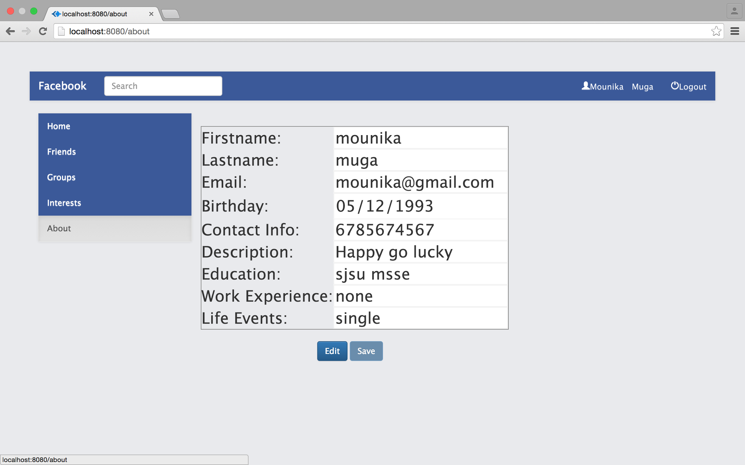

Screenshot:User’s About page

* User can edit his details by clicking on Edit button and then save them by clicking on Save button.

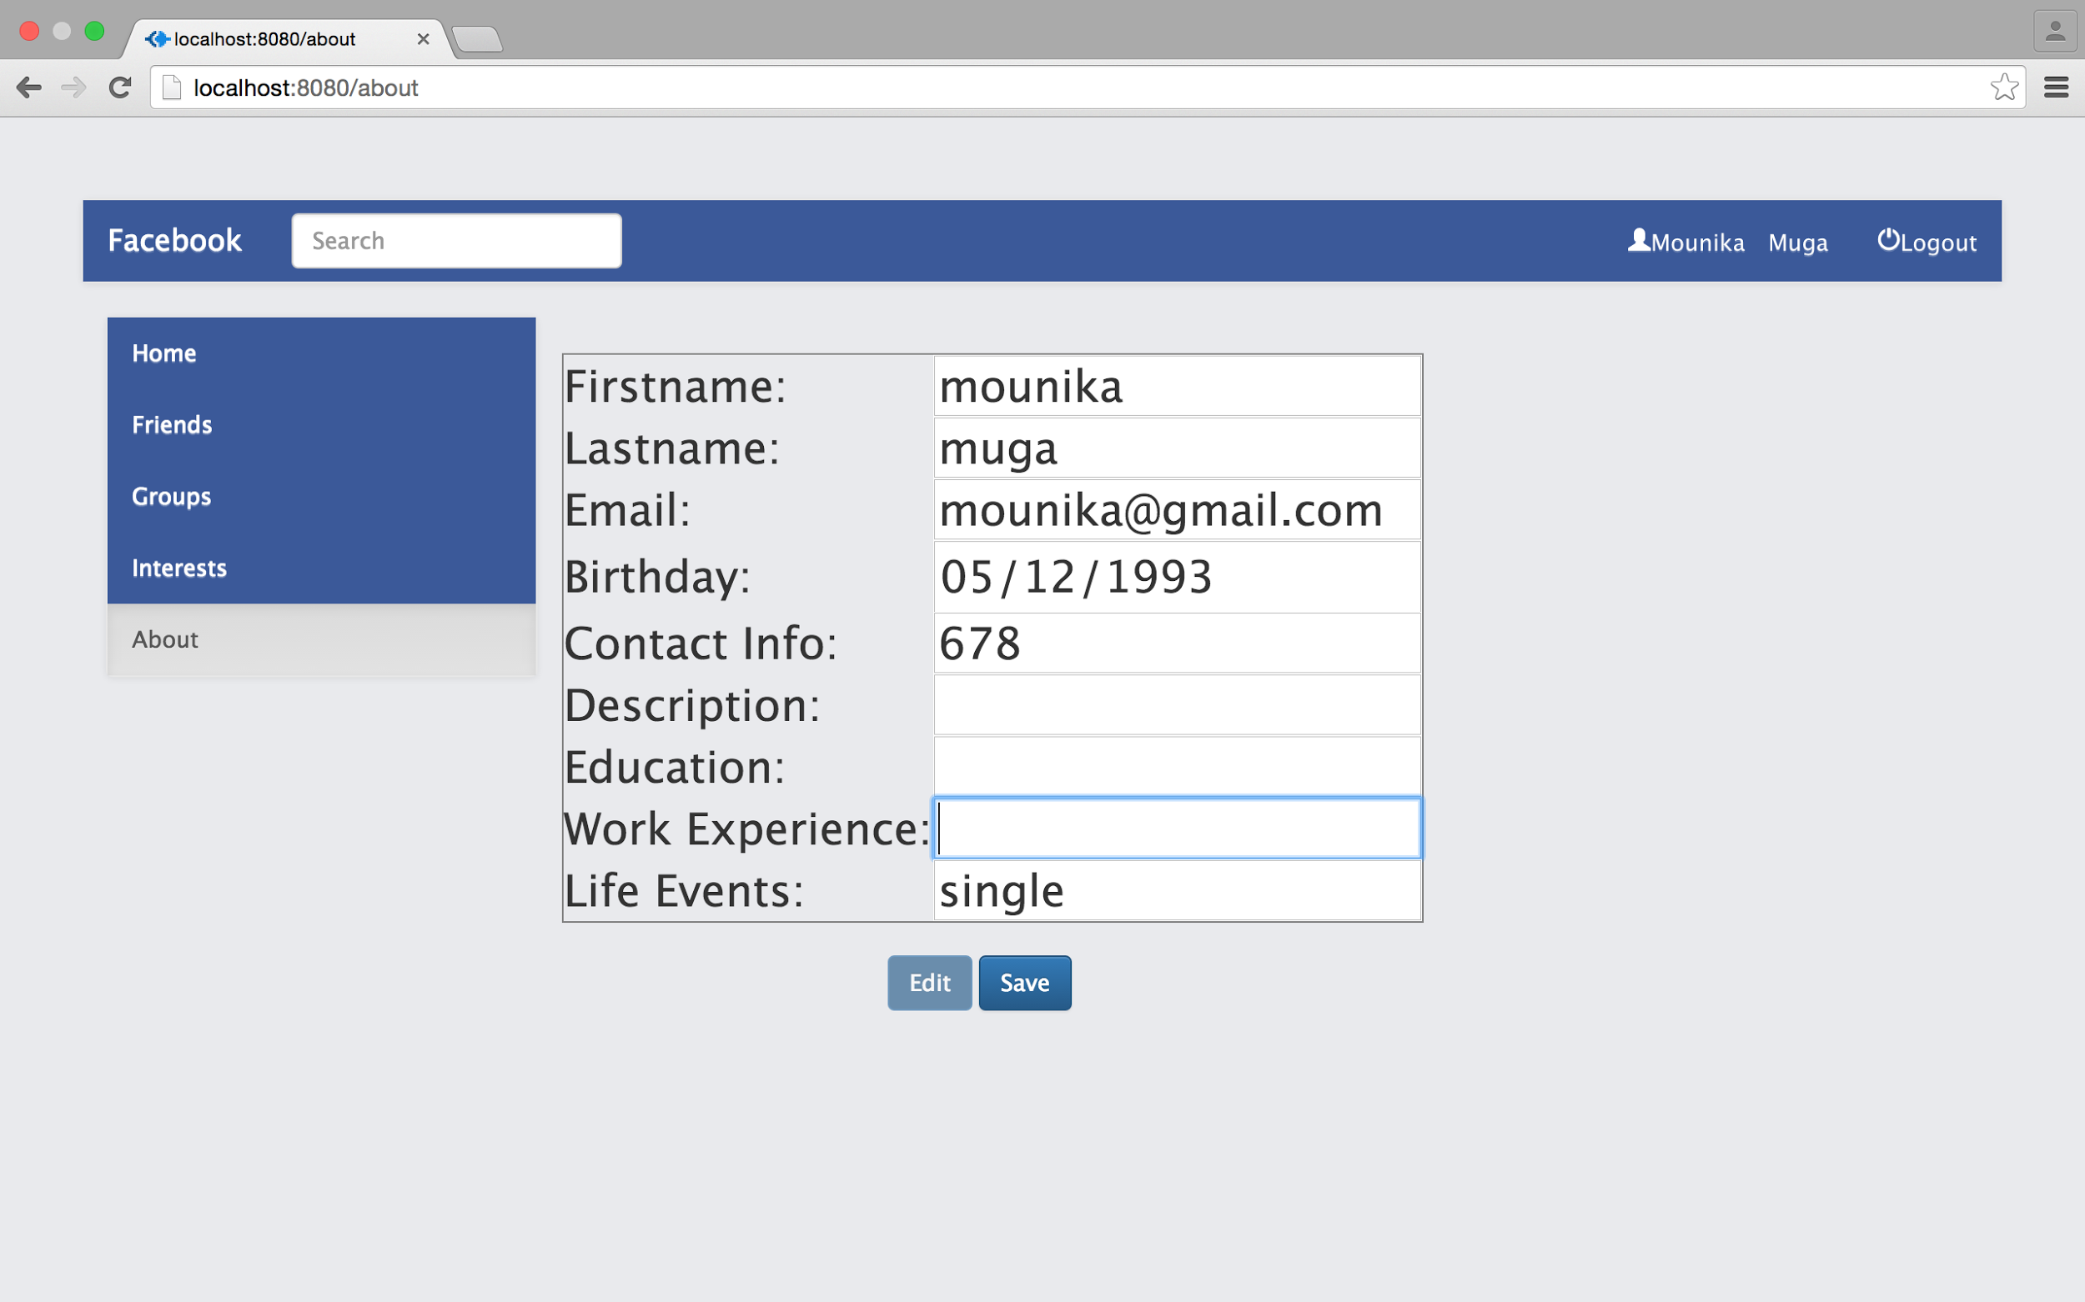

Screenshot:Editing user details

* Clicking on Facebook icon or on user’s name will redirect the user to the home page.
* Logout button in the page will enable the user to logout from the application and end the session.
* User will be redirected to login page after logging out.

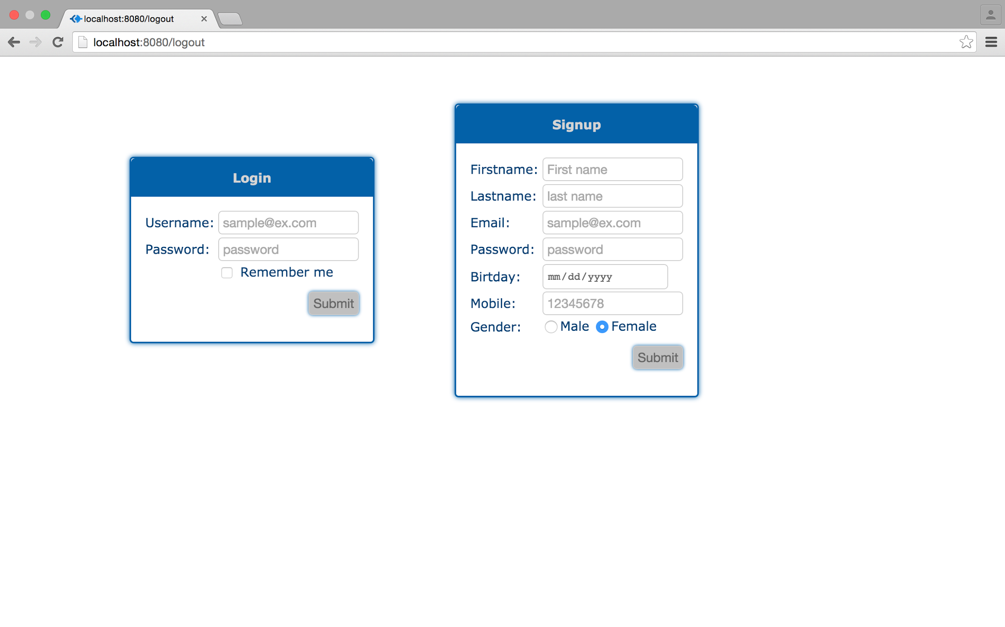

Screenshot:Login page

* Once logged out user cannot go to the last page without re-entering the login details.
* The sessions will be cleared as soon as the user is logged out.

Performance:

1.With connection pooling:

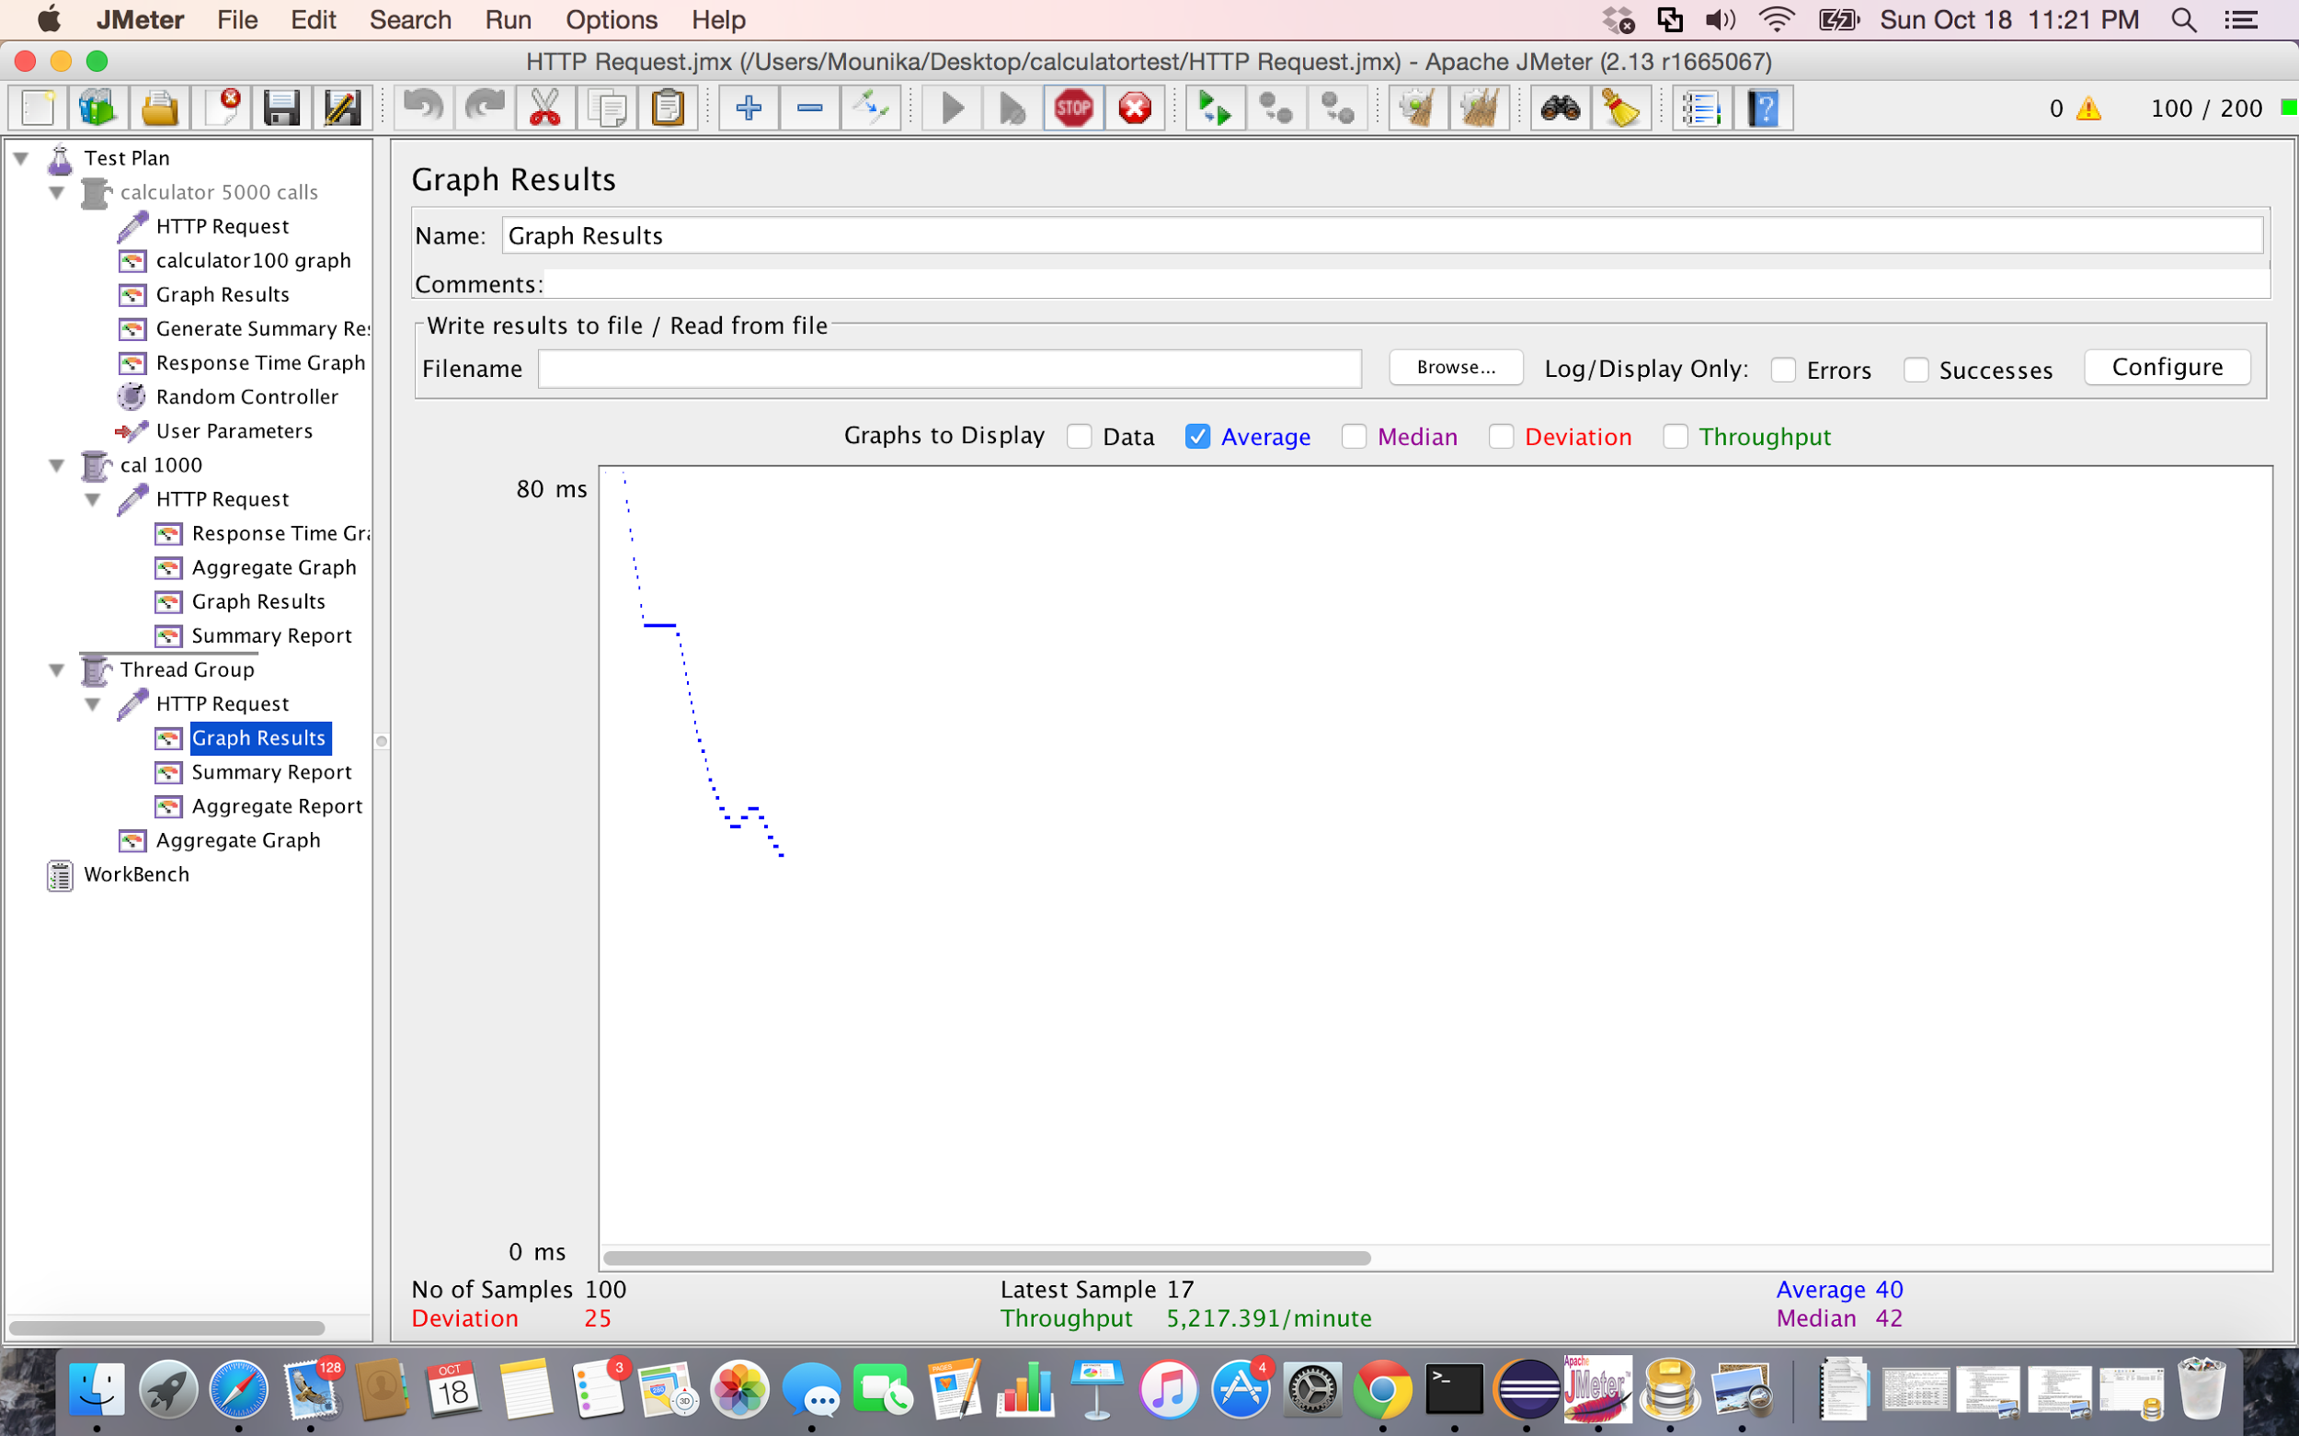

Screenshot:Graph Results for 100 concurrent users using connection pooling using Apache JMeter

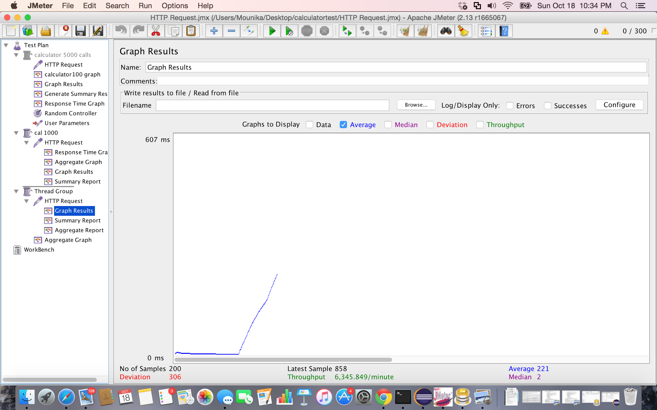

Screenshot:Graph Results for 200 concurrent users using connection pooling using Apache JMeter

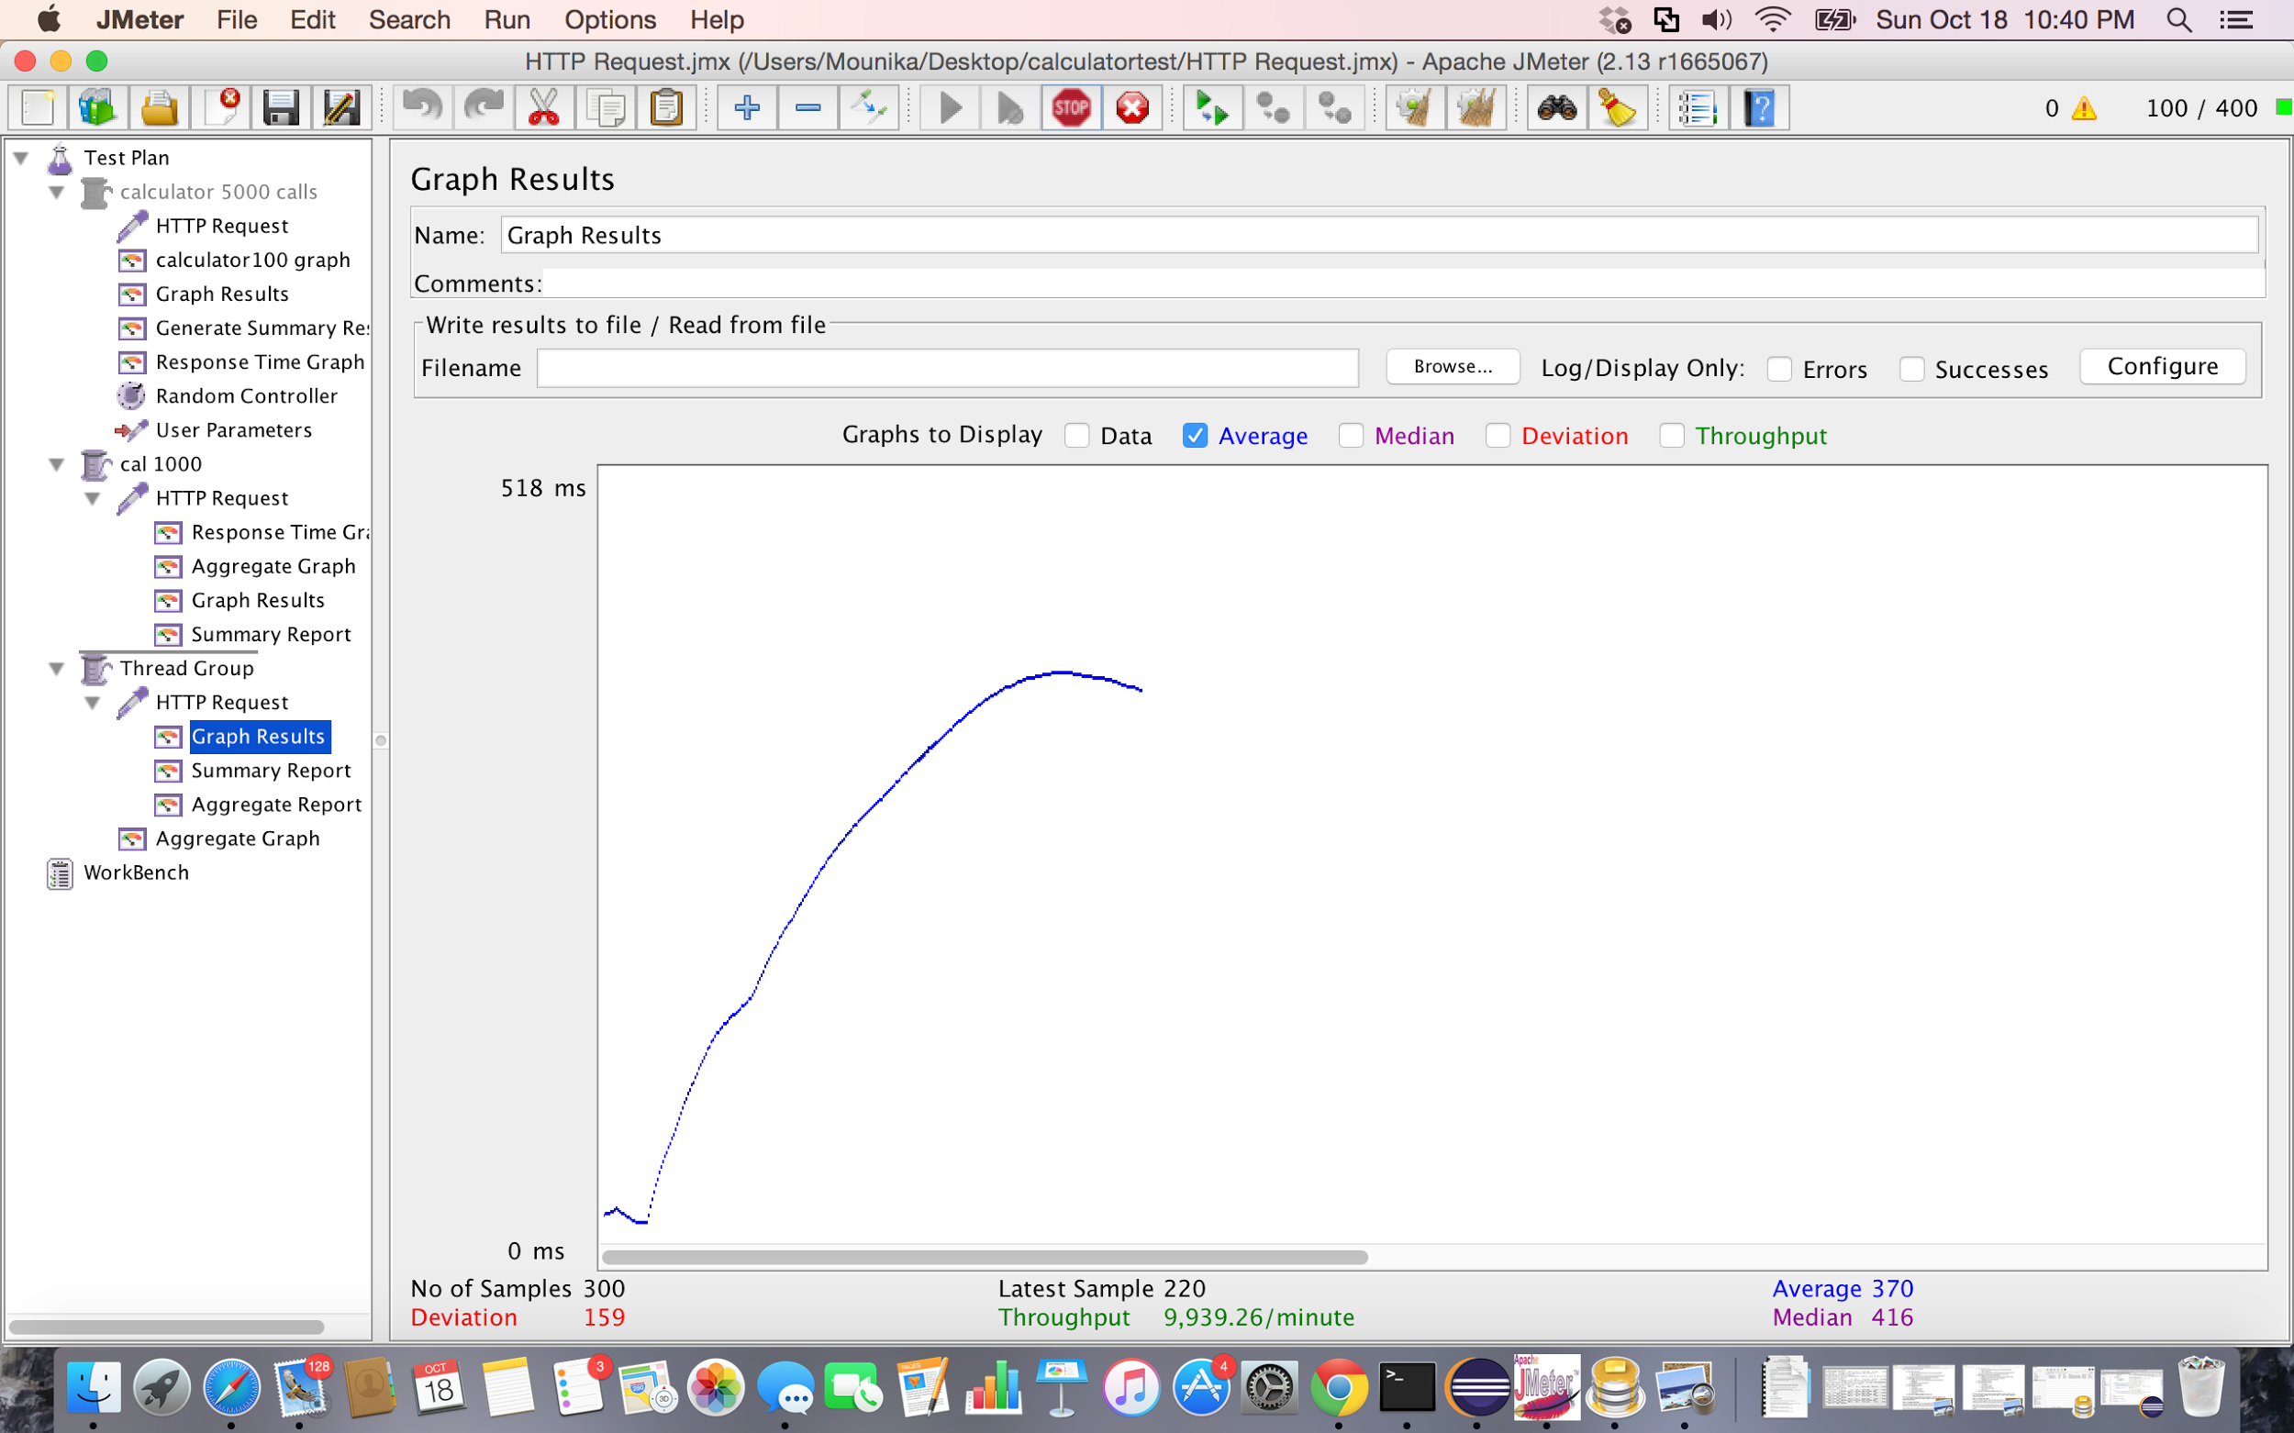

Screenshot:Graph Results for 300 concurrent users using connection pooling using Apache JMeter

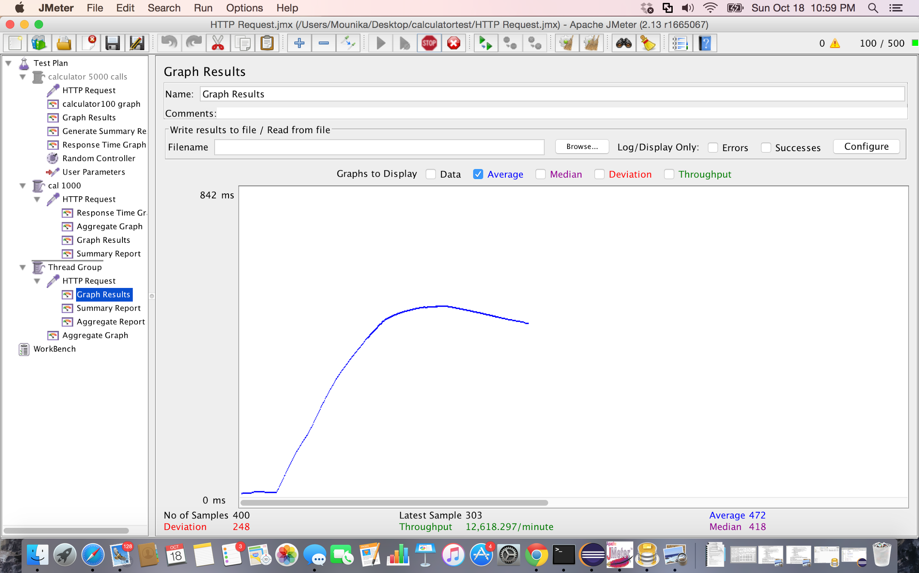

Screenshot:Graph Results for 400 concurrent users with connection pooling using Apache JMeter

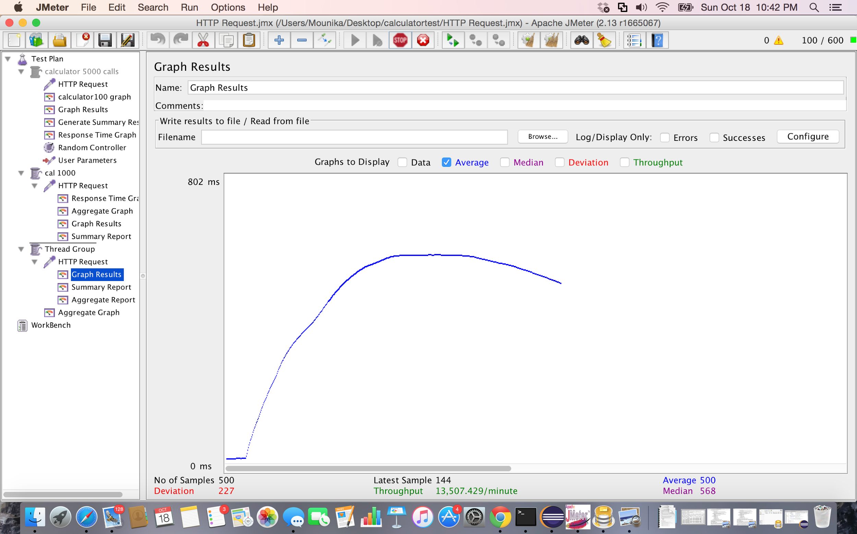

Screenshot:Graph Results for 500 concurrent users with connection pooling using Apache JMeter

2.Without connection pooling:

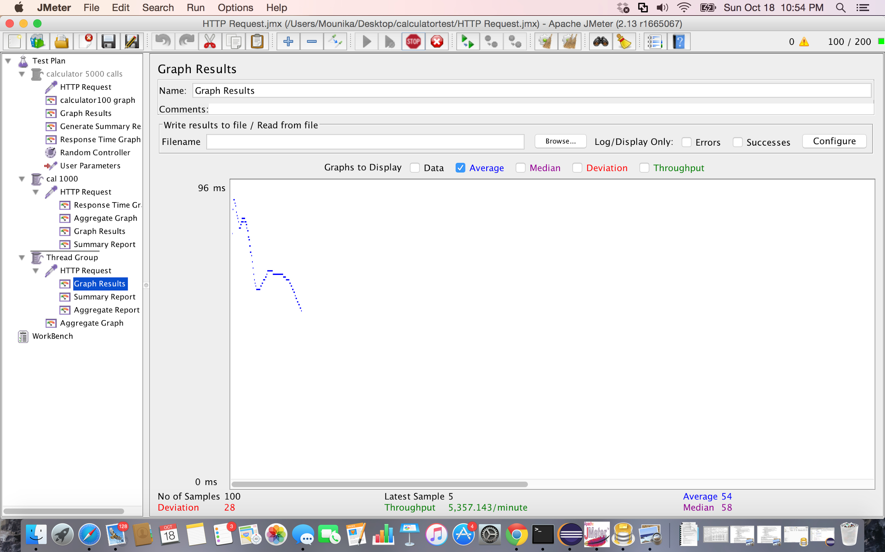

Screenshot:Graph Results for 100 concurrent users without connection pooling using Apache JMeter

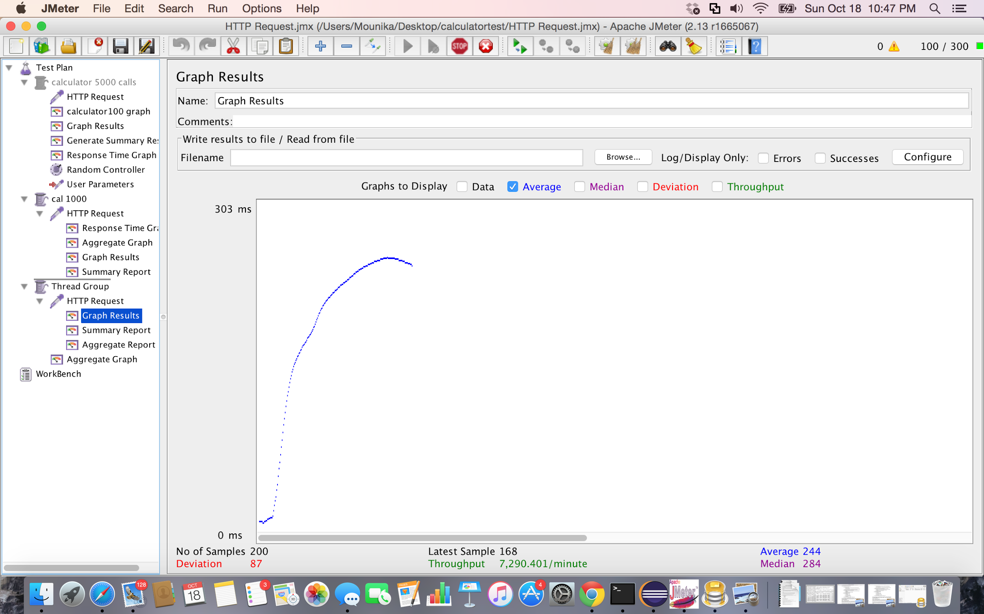

Screenshot:Graph Results for 200 concurrent users without connection pooling using Apache JMeter



Screenshot:Graph Results for 300 concurrent users without connection pooling using Apache JMeter

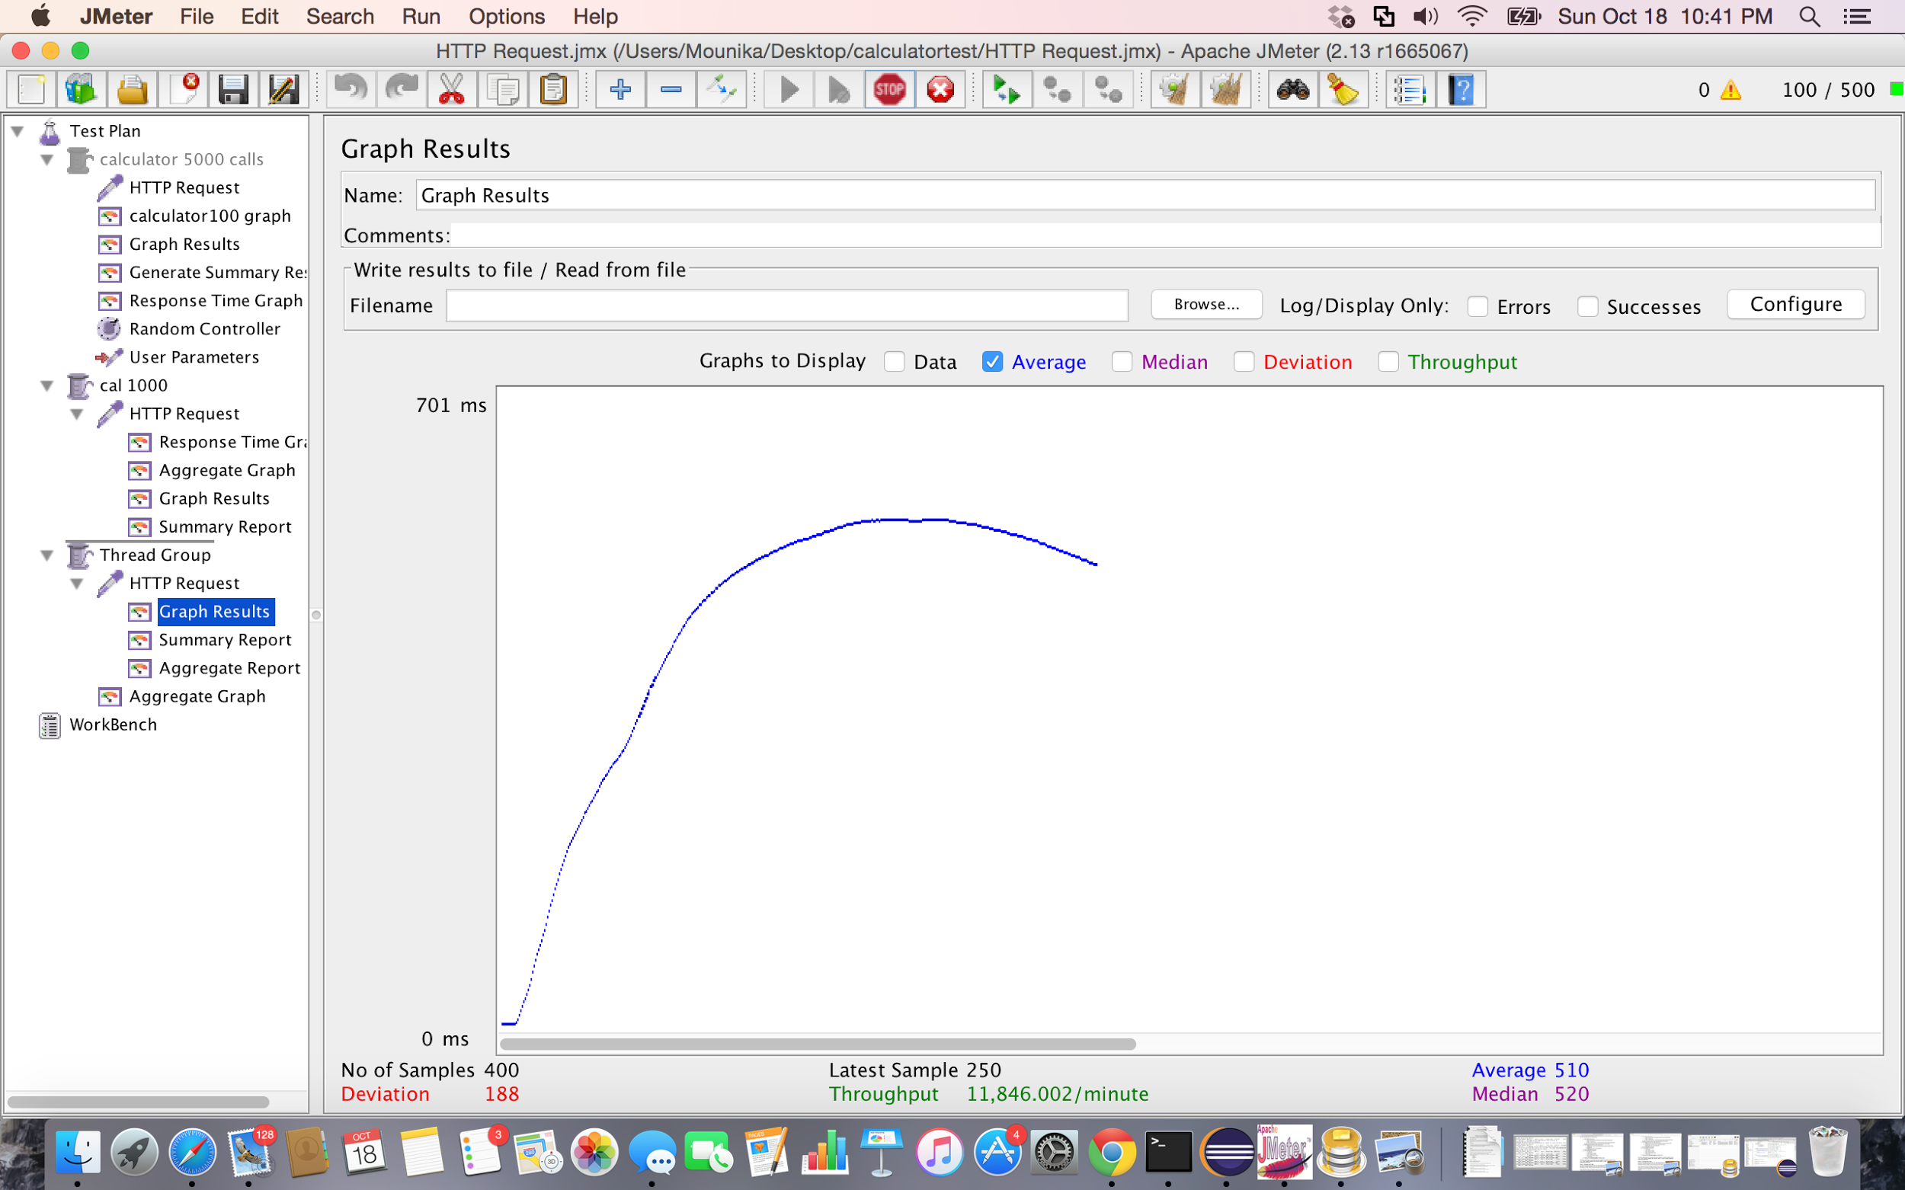

Screenshot:Graph Results for 400 concurrent users without connection pooling using Apache JMeter

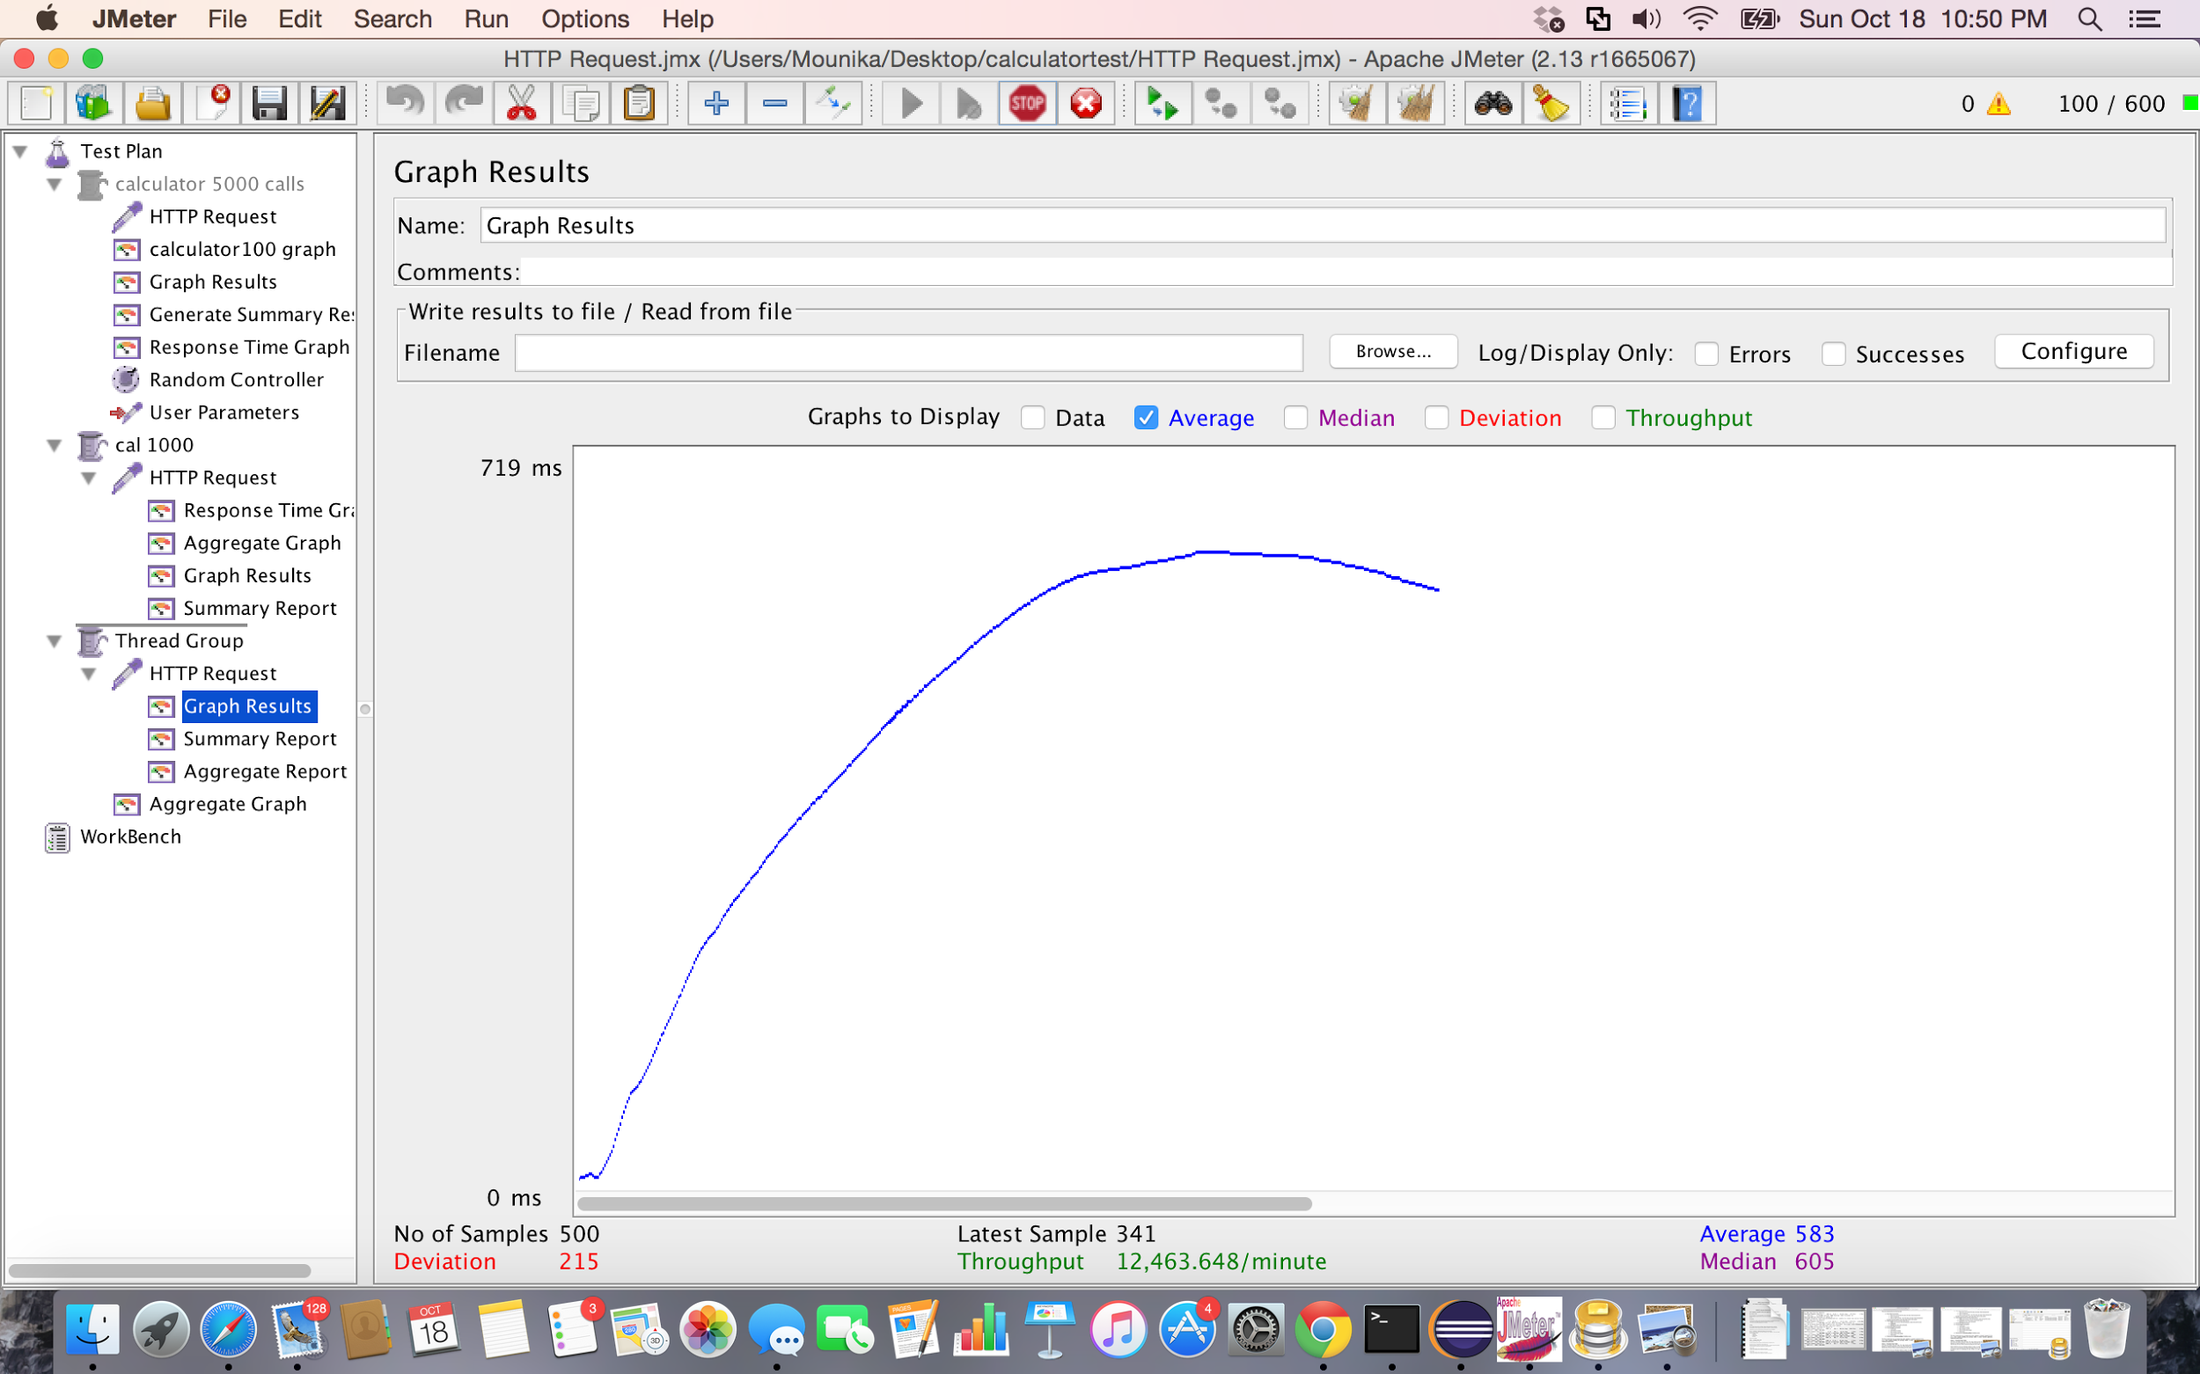

Screenshot:Graph Results for 500 concurrent users without connection pooling using Apache JMeter

Performance Analysis:

|  |  |  |
| --- | --- | --- |
| **Number of**  **Concurrent Users** | **Average Time without Connection pooling** | **Average Time with**  **connection pooling** |
| **500** | 583 | 500 |
| **400** | 510 | 472 |
| **300** | 370 | 259 |
| **200** | 244 | 221 |
| **100** | 54 | 40 |

Table : Facebook performance analysis

* By analysing the values from the above graph, we can see that the average time taken increases with increase in the number of concurrent users.
* Moreover, the performance of the application is good when connection pooling is used for connecting with database instead of not using the connection pooling.

**Answers for the given Questions:**

1. Describe your algorithm and strategy for data caching. Discuss why you choose the algorithm/ strategy.

A.

Data caching strategies:

* Node-caching
* Node-cache-manager

Node-cache manager strategy provides better caching because, it is can be used whenever we want. The functions can be easily wrapped.

**Traditional Approach:**

function get_cached_usr(id, b) {

mem_cache.get(id, function (err, result) {

get_usr(id, function (err, result) {

if (err) {

return b(err);

}

mem_cache.set(id, result);

b(null, reslt);

});

});

}

**After caching:**

function get_cached usr(id, b) {

memory_cache.wrap(id, function (cache_callbck) {

get_usr(id, cache_callbck);

}, b);

}

Functions to access built in cache.

set(key, value, b)

get(key, b)

del(key, b)

2. Compare the performance characteristics (draw graphs) of the servers without connection pooling and with connection pooling. Repeat the same with data caching. Use a graph or table to chart your results visually. Explain why you see such results.

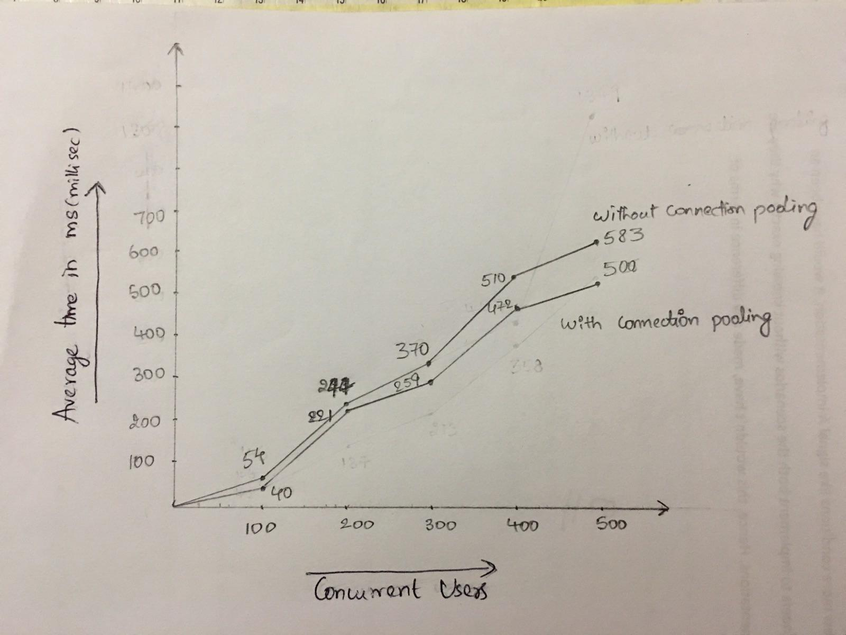

**Performance (Average Time) comparison graph for 100, 200, 300, 400, 500 concurrent users with and without connection pooling.**

* By analysing the values from the above graph, we can see that the average time taken increases with increase in the number of concurrent users.
* Moreover, the performance of the application is good when connection pooling is used for connecting with database instead of not using the connection pooling.

**Reason for the above results**:

* Connection pooling standard technique that is used to maintain long running connections for efficient re-use.
* It also provides management for the total number of connections an application might use simultaneously.
* Whenever a connection is created, it is placed in a connection pool and this connection can be reused. Hence a new connection doesn’t have to be made.
* It cuts down the time a user must wait to establish a new connection to the database.
* If all the connections in the pool are being used, then a new connection is added.
* This improves the performance when compared to calls to the database without connection pooling.

3.Considering data caching, how you would implement **Request Caching** strategy. Explain in detail. You do not need to implement this new function – pseudo code or a detailed description will be fine.

A. **SQL Request Caching strategy:**

Data caching improves data access read/write performance and reduces load on the database. It is used for faster process. The cache strategy for SQL is as follows:

* Objects to be cached are identified . The objects that are used frequently are cached.
* The place where caching is done should be decided. Eg:MemCached , Browser Cache etc.
* When a SQL query is fired, the main memory is checked first for the data. If it is not there then database is checked.
* The cached objects must be tracked. The updated values have to be updated immediately in the cache.
* The objects that not used frequently must be removed from main memory.

4. Is your session strategy horizontally scalable? If yes, explain your session handling strategy. If no, then explain how you can achieve it.

A. Yes, my session strategy is horizontally scalable.

* Client-side sessions are used in the application.
* Pushing the session data to the browser will give some advantages like:
  + The data is always available not depending on the machine serving the user.
  + No extra load on the database.
  + nothing needs to be replicated between the web servers
  + new web servers can be added instantly
  + no state to manage on servers

5. Explain how node.js handles multiple client requests simultaneously even though it is single threaded.

A. Node.js handles multiple client requests as follows:

* The client sends the HTTP requests to Node.JS server.
* OS will wake the event loop and passes the request-response objects as JavaScript closures with callbacks to the worker functions.
* Event loop runs on a single thread and there is no parallel code execution.
* Node cannot handle parallel client calls using event loops as it is a queue of events that executes on first come first served basis, so I/O calls provide Node.JS a way to switch from one request to another.
* At an I/O call, code saves callback and the control is returned to the Node.JS runtime environment.
* The callback is called when the data is available later.
* Non-blocking worker is used to handle long running jobs to avoid blocking in the event loop.
* Event loop will return the results to the clients.

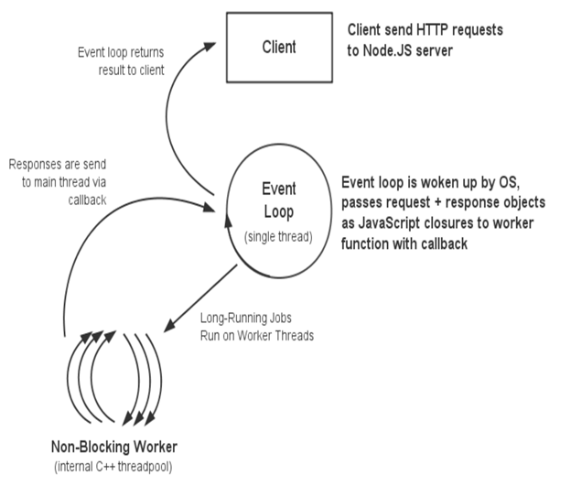

**Fig:** Block diagram that explains how Node JS Event loop handles the request and provides response to the client.